27  Marks Total | ASSIGNMENT 17  The Rutherford and Bohr Models of the Atom  This assignment is worth 27 marks. The value of each question is noted in the left margin in parenthesis. Note: The answer areas will expand to fit the length of your response.

1. | According to Maxwell's Laws of electromagnetism, the orbital frequency (the number of complete orbits per second) of an electron will match the frequency of the emitted radiation.
(1) | - If an electron spirals into the nucleus, what would happen to the electron’s orbital frequency?
Answer:
(1) | - If an electron spirals into the nucleus, what would happen to the frequency of the emitted radiation?
Answer:
(2) | - If an electron spirals into the nucleus, what kind of spectrum would be produced – a continuous spectrum or a line spectrum? Explain.
Answer:
2.  (1) | Review the emission spectrum of hydrogen below and answer the two questions that follow.    - What kind of spectrum is this?
Answer:
(1) | - Does Rutherford’s model predict the correct spectrum?
Answer:
(1) 3. | According to Bohr, why did an atom not collapse in on itself while its electrons traveled around the nucleus?
Answer:
(1) 4. | According to Bohr, what is happening in the atom when a photon of light is emitted?
Answer:
(1) 5. | According to Bohr, what is happening in the atom when a photon of light is absorbed?
Answer:
6.  (1) | When you learned about the energy levels of hydrogen, an energy level diagram was introduced. On this diagram, the n = energy level was represented. Go to the Hydrogen Atom simulation (Unit D), and complete the n = 1 to n = transition. Observe the energy state data.  - What is the energy of the n = energy level?
Answer:
(1) | - If an electron is initially in the ground state, how much energy must be absorbed by the atom for its transition to the energy level?
Answer:

7.  (1) | In a hydrogen atom, the electron jumps from the n = 1 level to the n = 4 level.  - During the transition from n = 1 to n = 4, is a photon emitted or absorbed?
Answer:
(1) | - What is the change in energy of the electron?
Answer:
(1) | - Identify the transition on the energy level diagram below or state in words what the transition is.  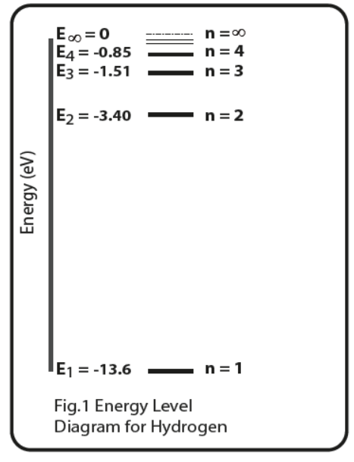
Answer:
(2) | - What is the wavelength of the emitted or absorbed photon?
Answer:
(3) 8. | An electron in the 3rd stationary state around a hydrogen atom has an energy value of  -1.512 eV. What will the electron’s energy be if the hydrogen atom absorbs a photon with a wavelength of 1090 nm?
Answer:
(2) 9. | Calculate the shortest wavelength photon that is emitted in the hydrogen atom.
Answer:
(1) 10. | Regarding the shortest wavelength photon emitted in the hydrogen atom, what energy transition emits this photon?
Answer:
(2) 11. | Rutherford concluded that the nucleus of an atom is very tiny compared to the entire atom. Why did he think this?
Answer:
(2) 12. | Describe the major problem with Rutherford’s Planetary Model.
Answer:
(1) 13. | An absorption spectrum is produced when white light is passed through a cool gas and then is viewed through a diffraction grating. The EMR for an absorption spectrum of an element is produced by _________.  - centripetal acceleration of the electron within the element  - electrons within the element dropping from the exited state as they absorb energy  - electrons within the element moving to an excited state as they absorb energy  - the nucleus of an atom moving from a low energy state to a high energy state as it absorbs energy  Of the four choices above that could complete the statement, which is correct?
Answer:

When you have completed all of the questions in this assignment, submit your work.

