50  Marks Total | ASSIGNMENT 18  Part One: The Nucleus and Radioactive Decay  Part One of this assignment is worth 32 marks. The value of each question is noted in the left margin in parenthesis. Note: The answer areas will expand to fit the length of your response.

(1) 1. | Provide the equation when U-238 emits an alpha particle. If you wish, you may use the Nuclear Decay Gizmo (Unit D) to confirm your answer. Once in the Gizmo, select “Show Equation” then press the play button ►.
Answer:
2.  (1) | Regarding your response to question one above, answer the following three questions.  - Is the atomic mass (number of nucleons) conserved on both sides of the equation? How can you tell?
Answer:
(1) | - Is the atomic number (number of protons or positive charges) conserved on both sides of the equation? How can you tell?
Answer:
(1) | - What is the common name of the particle that is always produced in alpha decay?
Answer:
(1) 3. | Write the equation when C-14 emits a (negative) beta particle. If you use the Nuclear Decay Gizmo (Unit D) to check your work, select “show equation.”
Answer:
4. | Regarding your response to question three above, answer the following three questions.
(3) | - In the equation of beta-negative decay for C-14, what happened to one of the neutrons? Specifically, list three things that form from the neutron.
Answer:
(1) | - Is the atomic mass (number of nucleons) conserved on both sides of the equation? How can you tell?
Answer:
(1) | - Is the atomic number conserved on both sides of the equation? How can you tell?
Answer:
5.  (1) | Alpha, gamma, and beta radiation have different energies hence different penetrating abilities.  - What is the least penetrating of these three forms of radiation?
Answer:
(1) | - What is the most penetrating of these three forms of radiation?
Answer:
(2) 6. | Use the conservation of nucleons and the conservation of charge to complete the following transmutation equation.  _________________ 15/8 O + 0/1 beta + ______________
Answer:
(2) 7. | What is the nuclear equation when curium 240 undergoes alpha decay?  _________?_______ _________?_______ + _________?_______
Answer:
(2) 8. | What is the nuclear equation when plutonium 244 undergoes negative beta decay?  _________?_______ _________?_______ + _________?_______
Answer:
9.  (2) | The following seven questions relate to nuclear radiation.  - What is radiation sickness?
Answer:
(2) | - How does radiation cause damage to living tissue?
Answer:
(2) | - All forms of ionizing radiation can be dangerous. Identify which form of radiation is always dangerous and the circumstances under which it is dangerous.
Answer:
(2) | - Contrast ionizing and non-ionizing radiation in terms of their effects on the human body.
Answer:
(2) | - How is radiation exposure measured?
Answer:
(2) | - How much radiation exposure is deemed to be safe?
Answer:
(2) | - In this section of the course you have learned about radiation emitted by nuclear transformations. Identify two other forms of EM radiation that can cause ionization.
Answer:

STOP!
When you have completed all of the questions in Part One, save your work to your desktop. You will return to this assignment to complete Part Two after you have completed the remainder of the content in the next section.

Part Two: Decay Rates and Radioactive Dating

Part Two of this assignment is worth 18 marks. The value of each question is noted in the left margin in parenthesis. Note: The answer areas will expand to fit the length of your response.

1.  (1) | The rate of decay of a radioactive isotope is described by its half-life. For the next two questions assume the half-life of the substance is 20 seconds.  - If there are 128 atoms of the substance initially, how many atoms remain after 20 seconds?
Answer:
(1) | - If there are 128 atoms of the substance initially, how many atoms remain after 40 and 60 seconds?
Answer:
(1) | - If there are 128 atoms of the substance initially, how many atoms remain after 80 and 100 seconds?
Answer:
(1) | - What pattern of decay do you notice happening after every 20 seconds?
Answer:
2.  (3) | An ancient wood sample is known to be 2500 years old.  - Knowing that the half-life of carbon is 5730 years, calculate the percentage of remaining carbon-14 in the wood sample.
Answer:
(1) | - Explain how the calculation you made in 3a could be used to measure the accuracy of radiocarbon dating?
Answer:
3.  (3) | Molybdenum-99 is radioactive. A 100 gram sample decays according to the table below.  Time (h) Sample (g)  0 100  10 90  100 35  152 20  - Graph the data in the table.
Answer: |   Horizontal Text  0.00  0.00  0.00  0.00  0  Vertical text  Horizontal Text  0.00  0.00  0.00  0.00  0  0.00  0.00  0.00
(1) | - From your graph, how much time has elapsed if 60 g of the original 100 g are left?
Answer:
4.  (1) | An unknown substance undergoes radioactive decay according to the graph below.  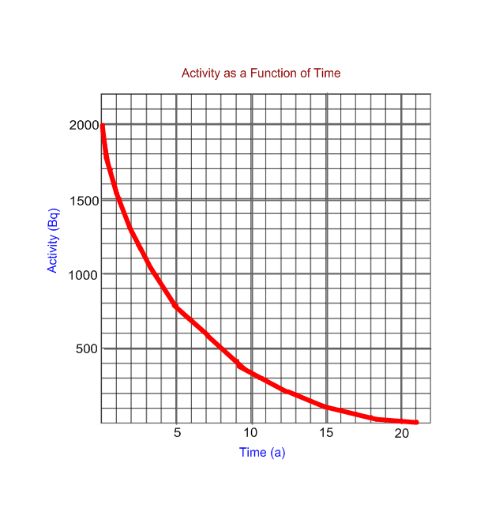  - Using the graph above, determine the half-life of the substance.
Answer:
- Identify the substance using the chart below.

Isotope | Half-life (a) | Decay Mode
204/81 Tl | 3.78 | beta-negative
210/82 Pb | 22.3 | beta-negative
229/90 Th | 7880 | alpha
3/1 H | 12.3 | beta-negative
252/99 Es | 1.29 | alpha

(1)

Answer:
(1) | - Write the nuclear decay equation for the substance.
Answer:
(3) 5. | The half-life of americium-241 is 457.699 years. A typical smoke detector contains 33.1 kBq of americium-241. Determine the amount of americium-241 remaining after 15.0 years. Show all work.
Answer:

When you have completed all of the questions in this assignment, submit your work.

