46  Marks Total | ASSIGNMENT 19  Part One: Fission and Fusion  Part One of this assignment is worth 21 marks. The value of each question is noted in the left margin in parenthesis. Note: The answer areas will expand to fit the length of your response.

1. | Complete the following 12 items regarding nuclear fusion and/or fission.
(1) | - What is observed at the subatomic level when nuclear fission occurs?
Answer:
(1) | - What is observed at the subatomic level when nuclear fusion occurs?
Answer:
(1) | - In what type of nuclear reactions are the nuclei of elements such as hydrogen, helium, and lithium used?
Answer:
(1) | - Nuclei of elements such as americium and thorium would be used to release energy in a _____ reaction.
Answer:
(1) | - Name an element which cannot release energy in a fission or fusion.
Answer:
(1) | - Compare the abundance of fuel for nuclear fusion and fission reactions.
Answer:
(1) | - Describe two considerations when building a nuclear reactor that would minimize the environmental impact of the nuclear fission reaction.
Answer:
(1) | - Why is there virtually no environmental impact in a nuclear fusion reaction?
Answer:
(1) | - Provide an example of a consequence of a nuclear reactor accident on the population of a nearby city or town.
Answer:
(1) | - Currently, only _____ is used in the commercial production of nuclear energy.
Answer:
(1) | - Provide one reason why the “other form” of nuclear reaction is not feasible at this time.
Answer:
(1) | - While the reaction in part 1k is not feasible, the energy of this reaction is important to our planet. Explain why.
Answer:
(3) 2. | Use the following fusion reaction to determine the amount of mass that is converted to energy. Show all work.  2/1 H + 3/1 H 4/2 He + 1/0 n + 17.6 MeV
Answer:
(6) 3. | The mass of a helium-4 nucleus is 4.0026 u. The mass of an individual proton is 1.0073 u and 1.0087 u for a neutron. Determine the binding energy per nucleon in the helium nucleus in units of MeV per nucleon.
Answer:

STOP!
When you have completed all of the questions in Part One, save your work to your desktop. You will return to this assignment to complete Part Two after you have completed the remainder of the content in the next section.

Part Two: The Subatomic World

Part Two of this assignment is worth 25 marks. The value of each question is noted in the left margin in parenthesis. Note: The answer areas will expand to fit the length of your response.

1. | The following diagram of a bubble chamber shows the paths of an alpha particle, beta negative particle, beta positive particle and a gamma ray (labeled 1 -4). The magnetic field is directed downward (into the page).  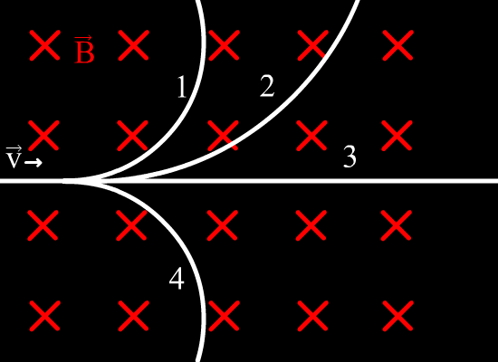
(1) | - Identify the alpha particle (by number) and explain the reason for your choice.
Answer:
(1) | - Identify the beta negative particle (by number) and explain the reason for your choice.
Answer:
(1) | - Identify the beta positive particle (by number) and explain the reason for your choice.
Answer:
(1) | - Identify the gamma ray (by number) and explain the reason for your choice.
Answer:
- 2. | Compare and contrast matter and antimatter.
Answer:
- 3. | Other than the electron-positron, provide an example of a matter-antimatter pair that you have previously studied in Physics 30.
Answer:
4.  (2) | The following two questions refer to up quarks changing into down quarks.  - Write the equation for the conversion of an up quark into a down.
Answer:
(2) | - Show that charges are conserved when an up quark changes into a down quark.
Answer:
5.  (2) | The following two questions refer to down quarks changing into up quarks.  - What particles are involved when a down quark changes into an up quark? (Write the equation.)
Answer:
(2) | - Show that charges are conserved when a down quark changes into an up quark.
Answer:
(2) 6. | High-energy particle accelerators are used to study subatomic particles. Explain why the particle accelerators must be high energy.
Answer:
(1) 7. | Use the charge on quarks to identify the quarks that make up a proton.
Answer:
(1) 8. | Use the charge on quarks to identify the quarks that make up a neutron.
Answer:
(2) 9. | A five quark combination called the pentaquark of theta-plus has been hypothesized to exist. The pentaquark is a combination of two ups, two downs, and one antistrange quark. Determine the net charge on a pentaquark. Show all work and state why the antistrange has the charge it does.
Answer:
(1) 10. | Under the Standard Model, which of the following particles is considered to be an elementary particle?  - Proton  - Neutron  - Electron  - Alpha particle
Answer:
11.  (3) | An isotope emits an electron and an anti-neutrino during radioactive decay. The electron moves east with a momentum of 9.28 x 10⁻²⁶ kg∙ m/s and the anti-neutrino moves north with a momentum of 7.47 x 10⁻²⁷ kg∙ m/s as shown in the diagram below.  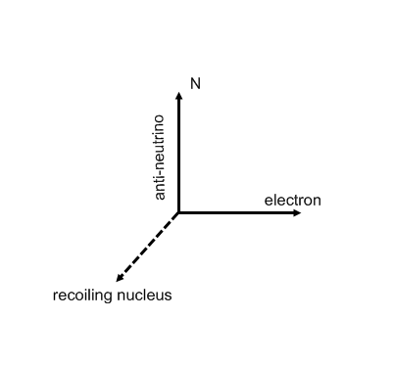  - Determine the momentum of the recoiling nucleus. Determine the angle to the nearest 1/100th degree.
Answer:
(1) | - If scientists only knew where the electron and recoiling nucleus went, which conservation law would lead them to believe another particle must be involved?
Answer:

When you have completed all of the questions in this assignment, submit your work.

