**Introductory Unit** Name: < >

**Worldview** Date: < >

**Introductory Unit, Lesson 3 Activity**

Your task is to present a Canadian worldview on the icon using the seven elements.

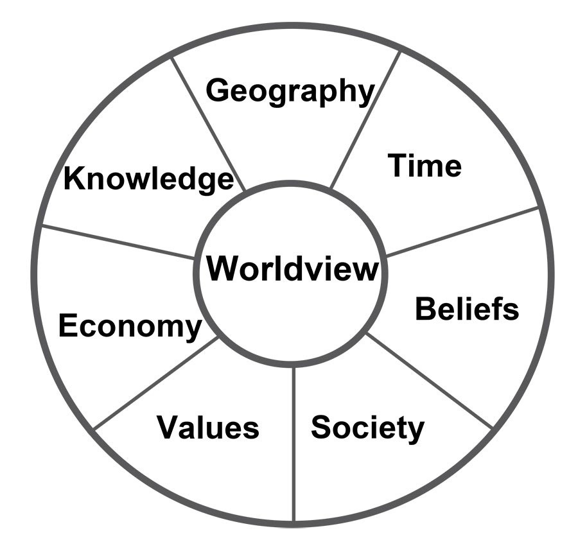

Use words, pictures, or drawings to represent what each element means to you in Canadian terms.

Place these ideas, in whatever form, in the appropriate boxes below.

If using words, type your responses between the blue brackets provided.

|  |  |
| --- | --- |
| Geography:  **Option 1: Words**  < > | **Option 2: Attach or draw an image** |
| Time:  **Option 1: Words**  < > | **Option 2: Attach or draw an image** |
| Society:  **Option 1: Words**  < > | **Option 2: Attach or draw an image** |
| Values:  **Option 1: Words**  < > | **Option 2: Attach or draw an image** |
| Beliefs:  **Option 1: Words**  < > | **Option 2: Attach or draw an image** |
| Economy:  **Option 1: Words**  < > | **Option 2: Attach or draw an image** |
| Knowledge:  **Option 1: Words**  < > | **Option 2: Attach or draw an image** |