**Unit 1** Name: < >

**Renaissance** Date: < >

**Reading/Study Guide Unit 1 Activity**

Chapter 2, Lesson 2

Complete the following. Type your responses between the blue brackets provided.

**Consider** the worldviews icon (see below). Choose **three** elements of the worldviews icon that you think best reflect the reasons the city-states of Italy became so important.

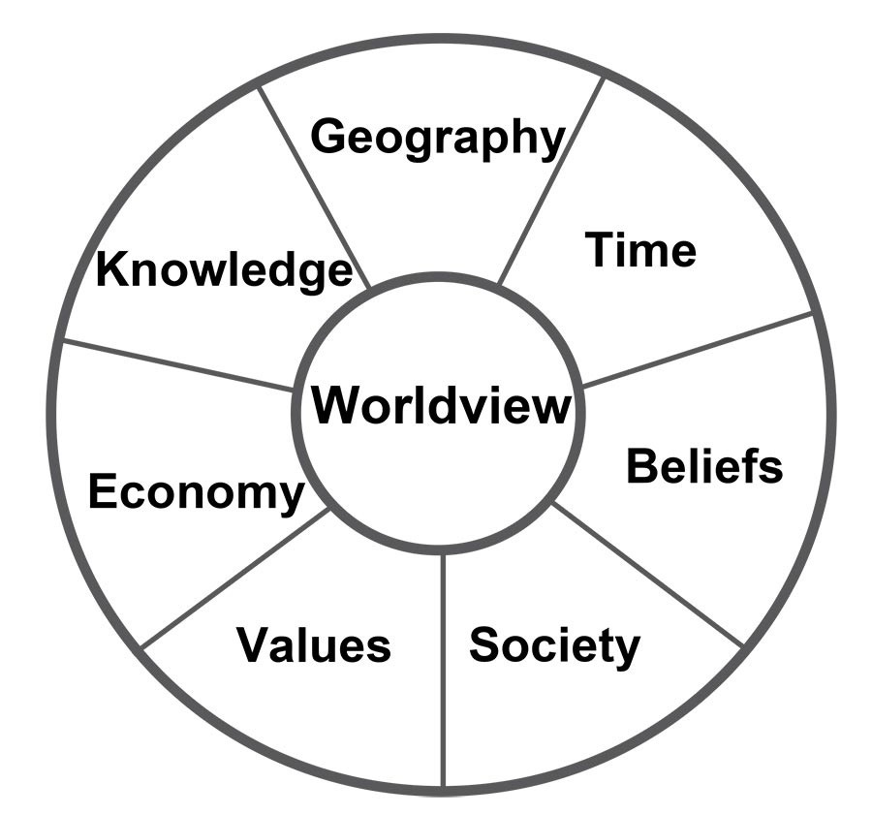

1. List the **three** elements you chose and explain why you chose them. Why do you think they best reflect the reasons the city-states became so important?

< >