**Unit 2** Name: < >

**Worldviews in Conflict** Date: < >

**Unit 2**

Pre-Assessment Activity

Venn Diagram

Do **one** of the following:

• Print the **Venn Diagram Template** at the end of the document.

• Complete the following **Aztecs and Spanish Chart**.

Venn Diagram Template

• If you are using the printable template to complete the **Venn Diagram**, then, print the page containing the template at the end of this document.

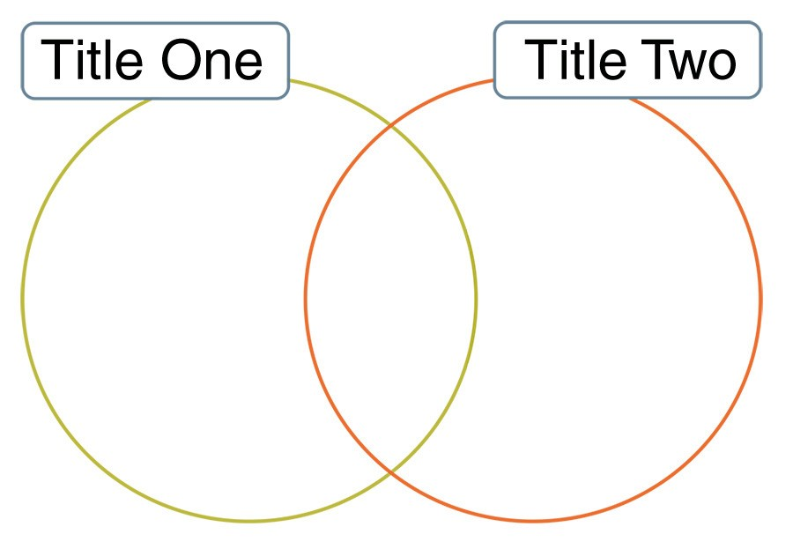

○ In the first title space, write *Aztecs.*

○ In the second title space, write *Spanish*.

○ The overlapping space will be where you enter information that is the *Both*.

Proceed to the next page.

**1**

For Option 2, complete the following chart. Type your responses between the blue brackets provided.

Aztecs and Spanish Chart

|  |  |  |
| --- | --- | --- |
| **Aztecs** | **Both** | **Spanish** |
| < > | < > | < > |

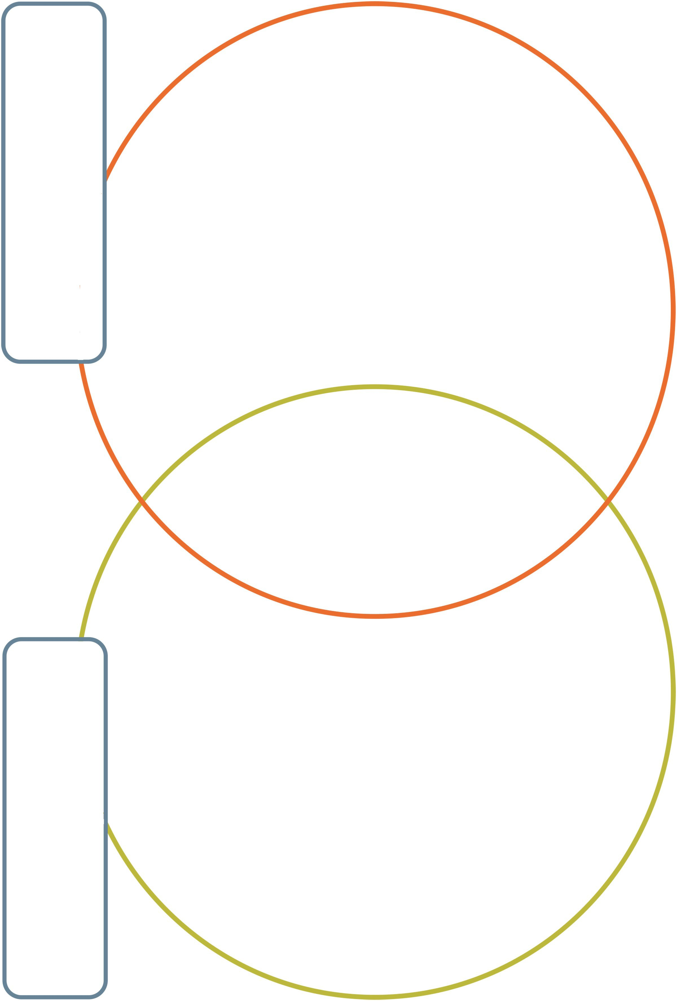

**3**