**Unit 3** Name: < >

**From Isolation to Adaptation** Date: < >

**Unit 3**

Pre-Assessment Activity

Instructions for this Activity

Complete the **Venn Diagram** by identifying what you know about Japan in its early days (in the left circle) and in modern times (in the right circle).

In the centre, suggest some ideas to explain why these changes might have occurred.

Venn Diagram

Do **one** of the following:

• Print the **Venn Diagram Template** at the end of this document.

• Complete the following **Japan Past and Present Chart**.

Venn Diagram Template

• If you are using the printable template to complete the **Venn Diagram**, print the page containing the template.

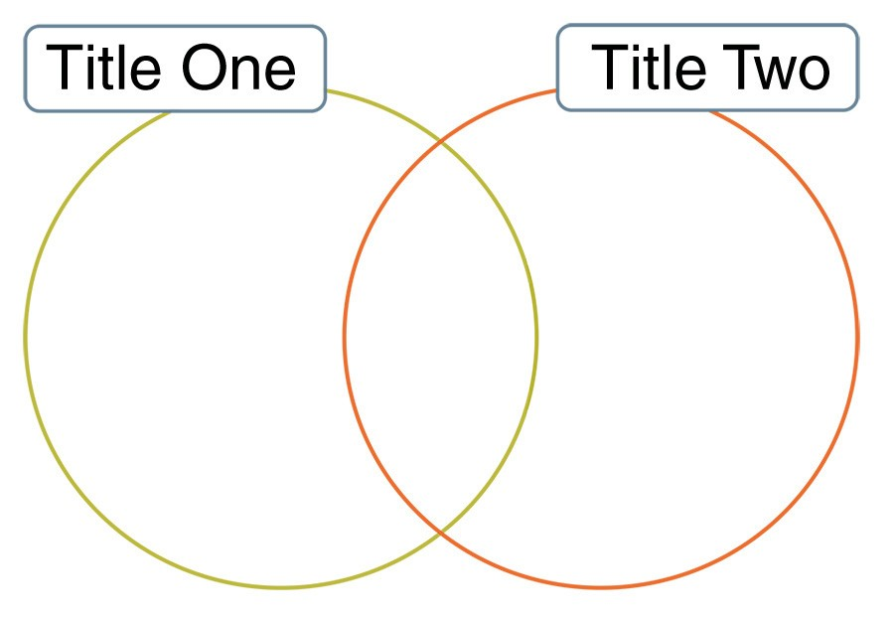

○ In the first title space, write *Japan Long Ago*.

○ In the second title space, write *Japan Today*.

○ The overlapping space will be where you enter information that explains the *Causes for Change*.

Proceed to the next page.

If completing Option 2, complete the following chart. Type your responses between the blue brackets provided.

Japan Past and Present Chart

|  |  |  |
| --- | --- | --- |
| **Japan Long Ago**  < > | **Causes for Change**  < > | **Japan Today**  < > |

