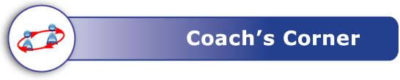

|  |  |  |  |  |
| --- | --- | --- | --- | --- |
| Review the outcomes assessed on this quiz.  *I can…* | Circle the questions you got correct on this Quiz. | Check the rating you think reflects your understanding of each outcome. | | Circle the items you will study to improve your understanding of each outcome. |
| explain what a specified region in a Venn diagram represents, using connecting words (and, or, not) or set notation | 1, 4, 7, 9 |  |  | Guide for Learning Example 1  Textbook p.26-28 Examples 2, 3  Textbook p.32-33 Questions 3b, 5a, 10 |
| determine the elements in the intersection or union of two sets | 2, 3, 5, 6 |  |  | Guide for Learning Examples 2, 3, 4  Textbook p.24-28 Examples 1, 2, 3  Textbook p.32-35 Questions 3a, 4, 5b, 8, 12, 13, 14, 15, 18 |
| identify and correct errors in a solution to a problem that involves sets | 8, 10 |  |  | Guide for Learning Example 5  Textbook p.29-30 Example 4  Textbook p.38 Question 6 |
| Record any questions you have about Lesson 1B. Then, contact your teacher. | | | | |

Mathematics 30-2: 1B – Exploring Relationships Between Sets