Unit 1 Name:

Date:

1-1 Types of Government

**Answer the following questions.**

**Instructions:**

1. What is government and why do we need it? ( /2)

|  |
| --- |
|  |

1. Who makes the decisions in a **monarchy**? What is one advantage and one disadvantage of this system of government? ( /3)

|  |
| --- |
|  |

1. Who makes the decisions in an **oligarchy**? What is one advantage and one disadvantage of this system of government? ( /3)

|  |
| --- |
|  |

1. Who makes the decisions in a **democracy**? What is one advantage and one disadvantage of this system of government? ( /3)

|  |
| --- |
|  |

1. Who makes the decisions in a **tyranny**? What is one advantage and one disadvantage of this system of government? ( /3)

|  |
| --- |
|  |

1. In your opinion, which type of government is the most fair (monarchy, tyranny, oligarchy, democracy etc.). Explain. ( /2)

|  |
| --- |
|  |

**Total of Section1: /16 marks**

1-1 Pillars of Democracy

Assessment 1: Pillars of Democracy

**Beside each image,** tell what pillar of democracy it represents and what it means.

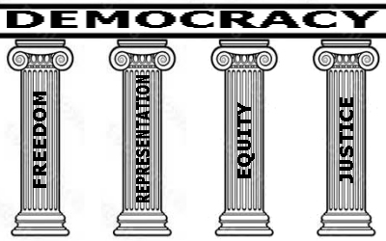

|  |  |  |
| --- | --- | --- |
| **Pillars of Democracy Chart** | | |
| **Symbol** | **Which Pillar Does This Symbol Represent? /1 mark** | **What Does This Symbol Mean? /2 marks** |
| Image result for scales of justice |  |  |
| Related image |  |  |
| Image result for ballot box icon black and white |  |  |
| Image result for bird icon black and white freedom |  |  |

**Total of Section 2: /12 marks**

**Overall Total: /28 marks**

**Submit your worksheet to your teacher.**



**Save Your File**

Name your file in this format: jsmithss6_1-1-pillars and save your file to your Documents folder.