Unit 3 Name:

Date:

3-2 Who Were The Ancient Greeks?

**Map**

1. **Identify the following places on the map below.** (/11 marks)

Cities: Sparta, Athens, Corinth, Delphi, Argos, Troy,

Features: Mount Olympus, Aegean Sea, Ionian Sea, Crete, Mediterranean Sea

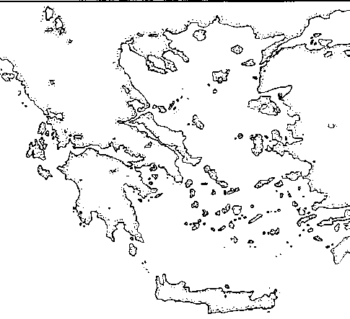

Use the Insert Textbox feature to locate each item on the map, or print the map, locate each place, take a picture, and upload to the submission folder.

Answer these questions during your inquiry:

1. Identify two ways Greek language has impacted society today. (/2marks)

|  |
| --- |
|  |

1. Identify two ways Greek science and math has impacted society today. (/2marks)

|  |
| --- |
|  |

Total of Section 1: /15 marks

Section 2: Choice Board

Complete the items of your choice below that add up to 10 Points.

|  |  |  |
| --- | --- | --- |
| **3 Points – Cartoon**  Construct a 6-8 frame cartoon telling a story from the life of one Ancient Greek person. Choose a significant figure such as (Pythagorus, Thales, Socrates, Homer etc.) Show why this figure is important to modern society. Ensure you have a beginning, middle, and end.  /10 marks | **3 Points – Brochure**  Construct a brochure to provide information on one of the wars in which Athenians were involved such as the Peloponnesian or Trojan War.  On a map depict one key battle. Describe the soldiers of that time.   * Identify their weapons and armour. * What strategies did they use to fight battles? * In this particular war, who was fighting? Who won the war? How did they win?   /10 marks | **3 Points – Venn Diagram**  Construct a Venn diagram showing the differences between men, women, and children’s lives in Ancient Greece.  /5 marks |
| **3 Points – Advertisement**  Construct an advertisement for tourists to the Ancient Greek world. Identify significant features of Greek architecture (Athenian temples, agora, bouleutrion, Pnyx, Acropolis, arts (pottery), sculture, etc.) How has Greek architecture influenced modern architecture?  /10 marks | **4 Points – Game**  Construct a game in which players learn about   * Culture * Education * Warfare * Lifestyle * Art * Mythology * Architecture * Language * Sports   of the Ancient Greeks.  (Hint: Many video games and stories are based on Greeks.)  /10 marks | **1 Point – Language**  In English it is common to have words with Greek roots. Greek prefixes (go at the beginning of the word). Greek suffixes (go at the end of the word). Identify ten words that use Greek prefixes, suffixes, or roots. You may use the following to help you:  -auto  -arch  -ology  -fer  /5 marks |
| **2 Points – Trading Cards**  Create four trading cards for four Greek gods. Provide four key pieces information for each.  /5 marks | **4 Points – Newsletter**  Construct a newsletter introducing the Athenians. Include their   * impact on education, math, science, art, philosophy, literature, sports, entertainment, and religion   /10 marks | **2 Points – Venn Diagram Olympic Games**  Identify four ways in which the Olympic games and modern games are different. Identify three ways in which they are similar.  /7 marks |

|  |
| --- |
| Choice Board Response (Newsletter/Cartoon/Brochure/Trading Cards/Game) Rubric |

|  |  |  |  |  |  |
| --- | --- | --- | --- | --- | --- |
| Criteria | Excellent  5 | | Proficient  4 | Satisfactory  3 | Limited  2 |
| **Content /5** | * I developed *insightful* ideas with *perceptive* information. * I used *precise* details. | | * I developed *thoughtful* ideas with *reasonable* information. * I used *logical* details. | * I developed *appropriate* ideas with *basic* information. * I used *general* details. | * I *underdeveloped superficial* ideas with *limited* information. * I used *vague* details. |
| **Presentation /5** | * I communicated *effectively* and *accurately*. | | * I communicated *thoughtfully* with *few* errors. | * I communicated *clearly* with *some* errors. | * I communicated *ineffectively* with *many* errors. |
| **Insufficient** | Your attempt to respond is *insufficient*. **Contact your teacher** to discuss suggestions for improvement. | | | | |
| **Total: /10** | | | | | |
| **Assessment** | | **Areas of Strength:** | | | |
| **Target for Improvement:** | | | |

|  |
| --- |
|  |

1. What do you think was the most important Greek contribution to culture today? Explain.

|  |  |  |
| --- | --- | --- |
| Math  Science  Architecture  Boating | Religion  Language  Food  Government | Entertainment  Arts  Sports  Wars |

|  |
| --- |
| Athens Rubric |

|  |  |  |  |  |  |
| --- | --- | --- | --- | --- | --- |
| Criteria | Excellent  5 | | Proficient  4 | Satisfactory  3 | Limited  2 |
| **Definition of the Issue and Support for Ideas /5** | * I stated my opinion *perceptively* and developed *insightful* ideas about which aspect of ancient Athenian life has most impacted modern society. * I used *precise* supporting details. | | * I stated my opinion *thoughtfully* and developed *logical* ideas about which aspect of ancient Athenian life has most impacted modern society. * I used *reasonable* supporting details. | * I stated my opinion *generally* developed *adequate* ideas about which aspect of ancient Athenian life has most impacted modern society. * I developed *appropriate* supporting details. | * I stated my opinion *vaguely* developed *underdeveloped* ideas about which aspect of ancient Athenian life has most impacted modern society. * I used *imprecise* supporting details. |
| **Insufficient** | Your attempt to respond is *insufficient*. **Contact your teacher** to discuss suggestions for improvement. | | | | |
| **Total: /5** | | | | | |
| **Assessment** | | **Areas of Strength:** | | | |
| **Target for Improvement:** | | | |

|  |
| --- |
|  |

(/5 marks)

Total of Section 2: /5 + ?

Overall Total: /20 + ? marks

**Submit your worksheet to your teacher.**



**Save Your File**

Name your file in this format: jsmithss6_3-2-Athens and save your file to your Documents folder.