Unit 4 Name:

Date:

4-3 Comparing Democracies

**Map**

1. **Identify the following places on the map below.** (/26 marks)
2. New York, Michigan, Delaware, Maine, Vermont, Massachusetts, New Hampshire, Rhode Island, Connecticut, Vermont, Pennsylvania, Ohio, Indiana, Illinois , New Jersey, Wisconsin The United States
3. New Brunswick, Quebec, Ontario Canada
4. Historical Territory of Seneca, Cayuga, Onondaga, Oneida, Tuscarora, Mohawk (the Six Nations)

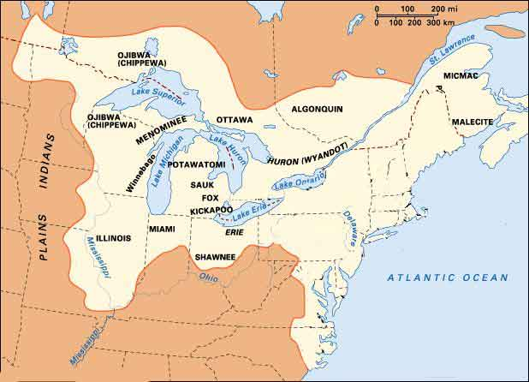

Use the Insert Textbox feature to locate each item on the map, or print the map, locate each place, take a picture, and upload to the submission folder.

Answer these questions during your inquiry:

1. To which democratic models did Americans look for information about what type of government to form? (/2marks)

|  |
| --- |
|  |

1. What do the words republic, confederacy, and constitution mean and where do they come from? (/4 marks)

|  |
| --- |
|  |

1. Identify one way the Iroquois confederacy has impacted society today. (/2marks)

|  |
| --- |
|  |

Total of Section 1: /34 marks

Section 2: Venn Diagram

Compare Athenian and Iroquois democracies. In the circle on the left identify unique features of Athenian Democracy. In the circle on the right identify unique characteristics of Iroquois Democracy. In the middle identify characteristics of democracy that are the same in both.

|  |
| --- |
| Venn Diagram Rubric |

|  |  |  |  |  |  |
| --- | --- | --- | --- | --- | --- |
| Criteria | Excellent  5 | | Proficient  4 | Satisfactory  3 | Limited  2 |
| **Content /5** | * I developed *insightful* ideas with *perceptive* information. * I used *precise* details. | | * I developed *thoughtful* ideas with *reasonable* information. * I used *logical* details. | * I developed *appropriate* ideas with *basic* information. * I used *general* details. | * I *underdeveloped superficial* ideas with *limited* information. * I used *vague* details. |
| **Insufficient** | Your attempt to respond is *insufficient*. **Contact your teacher** to discuss suggestions for improvement. | | | | |
| **Total: /5** | | | | | |
| **Assessment** | | **Areas of Strength:** | | | |
| **Target for Improvement:** | | | |

Total of Section 2: /5 marks

Overall Total: /39 marks

**Submit your worksheet to your teacher.**



**Save Your File**

Name your file in this format: jsmithss6_4-3-Iroquois and save your file to your Documents folder.