Grade 5 Science Kit
You may order the kit from ADLC at $19.55.
The list below will allow you to find and purchase the materials yourself if you wish.

Item | Where Found
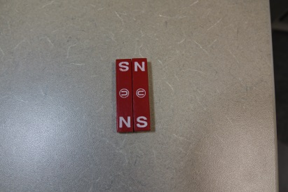  2 bar magnets (1 set) | Online such as Amazon
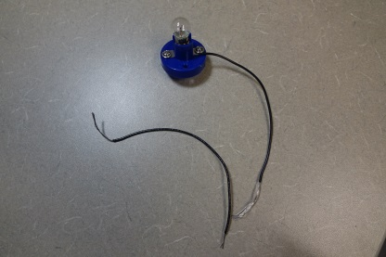  2 1.5 v lightbulbs with holders | Amazon – Ajax Scientific Miniature Light
(See photo above)  8 pieces of  8 inches or  20 cm stripped insulated wire (#20 or #22 solid or stranded wire for example) | Local hardware store
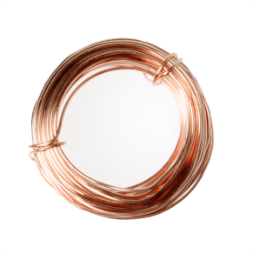  1.5 m of thin copper wire 26 guage | Local hardware store
1 microelectronic passive buzzer with leads  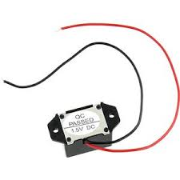 | Online such as Amazon (some buzzers sound like flappers rather than beepers and require a tight connection such as alligator clips).
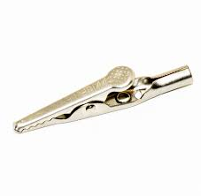  At least 2 alligator clips to make a tight connection with buzzer (or other circuit elements) | Hardware store
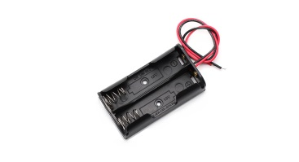  1 AA 1.5 v parallel battery holder with leads or anything | Online (you can use a thick rubber band instead)
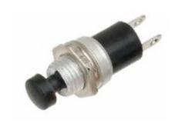  1 On-off push button switch to break | Online such as Amazon
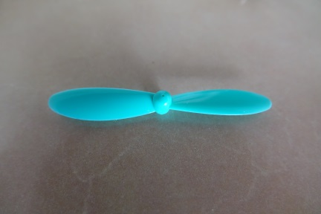  1 Propeller – something like HBZ8703 to fit on the end of a 1.5 v motor | A hobby shop
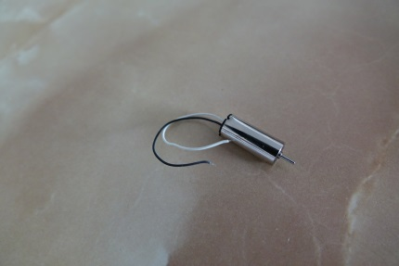  1 -1.5 v motor with leads for example Zugo HBZ8705 | A hobby shop
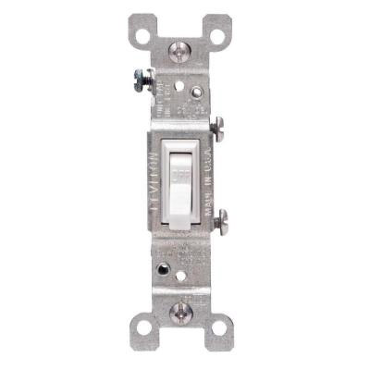Additional Switches as needed | Local hardware store such as Rona, Home Depot, Lowes, Canadian Tire
2 AA batteries  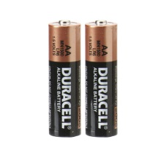 | Not included in ADLC kit
Small Nail  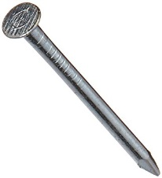 | Not included in ADLC kit
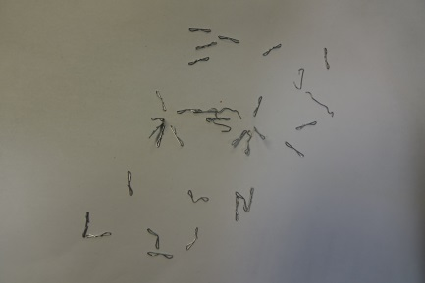Staples | Not included in ADLC kit

