**Unit 1 Notebook: Classroom Chemistry**

 **Exit Pass: Lesson 1**

Complete the parts of the *Water Wheel Graphic Organizer* with what you know about water.

# Questions

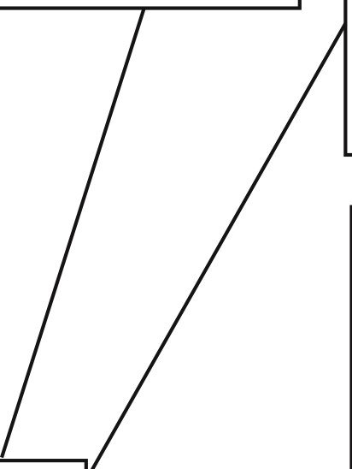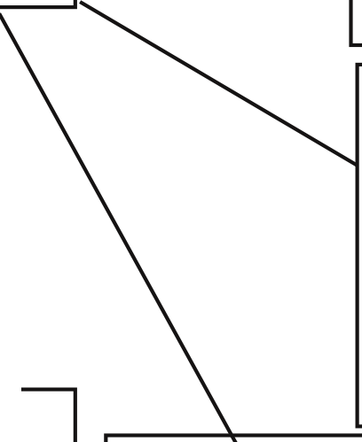

What is a solution? Give an example.

What is an example of a solute?

What is surface tension?

What should be added to water to make it change states?

When water changes from a gas to a liquid, this process is called

Why is water called the universal solvent?

# Water

When water changes from a liquid to a gas, this process is called

18

What are two substances that are soluble in water?

What are two substances that are insoluble in water?

|  |  |  |  |
| --- | --- | --- | --- |
|  |  |  |  |
| When water | | | |
| changes from a liquid to a solid, this process is called | | | |

**ADLC Science 5**