**Unit 1 Notebook: Classroom Chemistry**

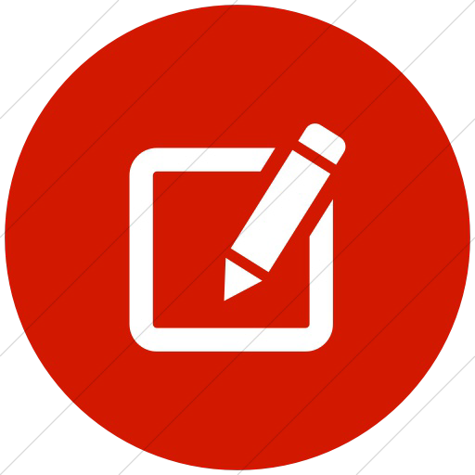 **Activity 9: Hold the Salt**

# How can fresh, drinkable water be produced from a saltwater solution? Resources

* large bowl
* heavy glass cup

•teaspoon

* clear plastic food wrap
* any coin
* clear cellophane tape
* blue food colouring
* salt
* Solar Water Purifier Videos

https[://www.youtube](http://www.youtube.com/watch?v=4sqRvUzqDCE).[com/watch?v=4sqRvUzq](http://www.youtube.com/watch?v=4sqRvUzqDCE)DC[E](http://www.youtube.com/watch?v=4sqRvUzqDCE) https[://www.](http://www.youtube.com/watch?v=GF9yYGwPcNw)you[tube.com/watch?v=GF9yYGwPcNw](http://www.youtube.com/watch?v=GF9yYGwPcNw)

# Procedure

1. Pour tap water in a bowl to a depth of about two inches.
2. Add ten drops of blue food colouring and 2 to 3 teaspoons of salt. Mix well until the salt is dissolved.
3. Place the heavy glass cup (opening up) in the centre of the bowl so it is surrounded by the blue salt-water solution.
4. Put a loose covering of plastic food wrap over the top of the bowl. Tape the plastic wrap to the sides of the bowl so that no air can get in or out. Be sure the plastic wrap is not pulled tightly across the bowl.
5. Tape a coin to the outside of the plastic wrap directly over the centre of the glass. The weight of the coin must make the plastic wrap slant down toward the centre of the glass.
6. Put the bowl on a flat surface outside where it will get lots of sunshine on a warm day.
7. Leave the bowl in the sun for about four hours. After four hours, take off the plastic wrap and lift the glass from the salt-water solution.

Note: When moving the bowl, be sure that none of the blue salt-water solution splashes

34 **ADLC Science 5**

**Unit 1 Notebook: Classroom Chemistry**

into the glass.

Note: Check on the bowl every hour to see if any changes are occurring or in case you need to make adjustments. Do not leave the bowl outside for more than four hours because mold may grow in the water.

Another option for making a water purifier is to make two holes in two lids from 2-litre pop bottles.

1. Recap the pop bottles.
2. Glue the lids together so that both pop bottles are connected.
3. Fill one bottle with salt water.
4. Leave the bottles in the sun. The pop bottle without water should be slightly elevated so that purified water can form in it.

# Note: This activity is part of Assignment 1-2.

**ADLC Science 5** 35