**Unit 1 Notebook: Classroom Chemistry**

**Activity 10: Crystal Candy**

# How are crystals formed? Resources

* wooden dowel or skewer

•clothespin

* 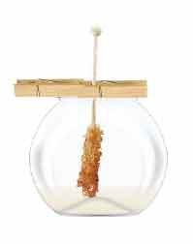wide mouth jar
* food colouring (optional)
* boiling water
* sugar
* small wooden rod or pencil
* paper towel

# Procedure

1. Fill your jar with water; then, pour the water into a pot.
2. Boil the water in a pot using adult help.

**Safety Warning:** Working with boiling water is very dangerous. Have an adult complete Step 4 and 5 with you.

1. Stir the sugar into the boiling water one teaspoon at a time. Continue to add sugar until it no longer dissolves. Keep stirring your solution to get as much sugar to dissolve as you can.
2. Add a few drops of food colouring if you wish to make a coloured candy crystal.
3. Allow the water to cool slightly before asking an adult to help you pour the water back into the jar. If undissolved sugar crystals are in the bottom of the pot, try to avoid pouring those into your jar.
4. Clip the clothespin to the wooden skewer, and place the clothespin on top of the jar so that the wooden skewer does not touch the bottom or sides of the jar. Your completed set up should look like this:
5. Place a paper towel over your jar to keep dust from falling in. Be patient! Check the jar the next day, and you will see the crystals starting to form. Leave the crystal until it has formed to the size you desire. (A large piece of rock candy can take a few weeks to form.) into the glass.

**ADLC Science 5** 37