**Unit 1 Notebook: Classroom Chemistry**

**Exit Pass: Lesson 4**

# What are Physical and Chemical Changes?

**Questions**

This simulation shows how to tell the difference between acids and bases using pH. https://phet.colorado.edu/sims/html/ph-scale-basics/latest/ph-scale-basics_en.html Use the simulation and the pictures to answer the following questions:

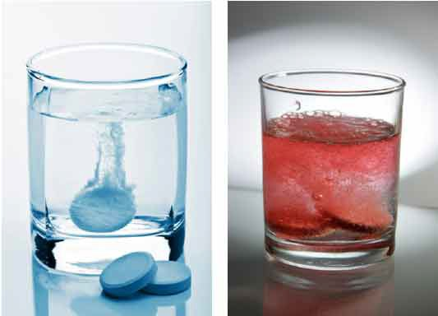

Before After

1. What kind of change (physical or chemical) do you think happened in the pictures?
2. Explain what signs you used to decide if a chemical change or a physical change occurred in the picture.

**ADLC Science 5** 57

**Unit 1 Notebook: Classroom Chemistry**

1. How could you tell for sure that a chemical change occurred?
2. How might you test the starting substances to see if the reaction was an acid-base reaction?
3. How might you test to see if the bubbles produced are carbon dioxide?

58 **ADLC Science 5**