**Unit 2 Notebook: Electricity and Magnetism**

 **Exit Pass: Lesson 2**

# Electricity

**Complete the following. Questions**

Play a magnet game. Flash is required. When you have finished the simulation, answer the following questions.

<http://www.sciencekids.co.nz/gamesactivities/detectivescience/magnets.html>

1. How is a permanent magnet different from an electromagnet?
2. Your friend Balveer brings a big magnet to the beach and says to you, "I'm going to use this magnet to find gold coins in the sand!" Will Balveer's plan work? Explain.
3. You have been challenged to make a car powered by magnetism. Your first step is to attach a small bar magnet to the back of a toy car with the "S" pole facing backwards. You now have to make the car go forward, but the rule for the challenge is you must make the car move with another magnet, without touching it.

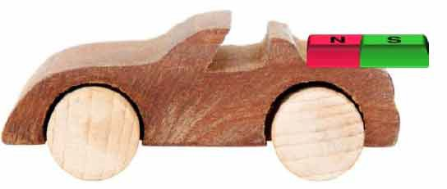How would you make the car move forward?

20 **ADLC Science 5**