**Activity 13: Using Electricity and Magnetism**

Name:

Date:

How Can We Understand, Design, and Control

Electrical Pathways?

Discover: Switch On, Switch Off

**Question**

How can you control the current in an electric circuit?

**Materials**

● Electricity Kit Items: four connecting wires, battery holder, push button switch, lamp holder and lamp

● cardboard, two paper fasteners, paper clip (instead of a switch), thick rubber band

● 2 AA batteries or D-cell battery

● Optional Yenka software

**Instructions - Part A: Build a Circuit With a Switch**

1. Push Build a circuit. Connect one battery holder wire to the lightbulb holder. Connect the other battery holder wire to the switch. Connect a wire from the switch to the lamp. Push the button on the switch and observe how you can control the light bulb.

**Or, if you do not have an ADLC kit,**

**1** Connect the two paper fasteners through the holes in the cardboard. Turn the cardboard over and place a paper clip on one of the fasteners. Bend open the paper fasteners and attach one wire to each of the paper fasteners.

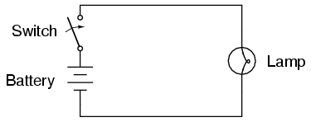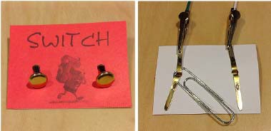

**2** Attach the other end of one of the wires to a D-cell battery using the thick rubber band. Attach one end of a new wire to the other end of the battery, and the other end to the lamp holder. Complete the circuit by attaching the free wire from the switch to the lamp.

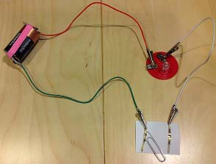

**3** Move the free end of the paper clip on and off the paper fastener and observe how you can control the lamp.

**Instructions - Part B: Toggle and Push-Button Switch Circuit**

**4** Open Yenka software and choose *Electricity & Magnetism*. In the *Circuit Diagrams* folder, choose *Pictorial*. Drag and drop one of each of the following items to the work area: 9V Battery, SPST (toggle) switch, Push-to-make switch, and a filament lamp.

**5** Connect all the items in the work area so that they make one complete loop.

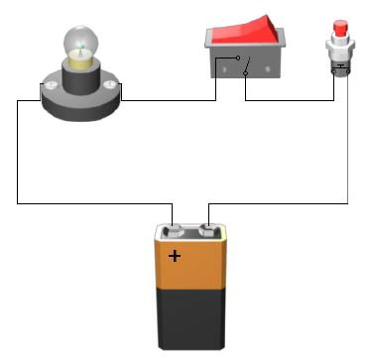

**6** Experiment with the switches until you can make the lamp light.

**7** Open a new Yenka file. Repeat Steps 4 and 5, but this time, use three filament lamps instead of just one.

**8** Scroll down and open the Presentation folder. Drag a text box to the work area. In the text box, type instructions for someone to use the switches to make lamps in the circuit light.

Skill Builder

How to use Yenka Electricity and Magnetism.

If you need to use this Skill Builder, access it from the online course.