**Unit 3 Notebook: Weather Watch**

 **Activity 8: Ouch, That Sand is Hot!**

*Do different substances and surfaces hold heat differently?*

# Resources

* **ADLC Digital Lesson on Heat Capacity**

https://adlc.wistia.com/medias/w17mqftqsb

# Instructions

1. Watch the YouTube Video **ADLC Digital Lesson on Heat Capacity** to help.
2. Review the **Temperature Change Graph** below. It is the same graph from the experiment shown in the video.
3. Use the **Heat Capacity of Substances Chart** to order the substances from the experiment graph from highest heat capacity to lowest heat capacity. Place the substance with the highest heat capacity at top of the right-hand side of the chart, and continue to list the substances down to the lowest heat capacity.

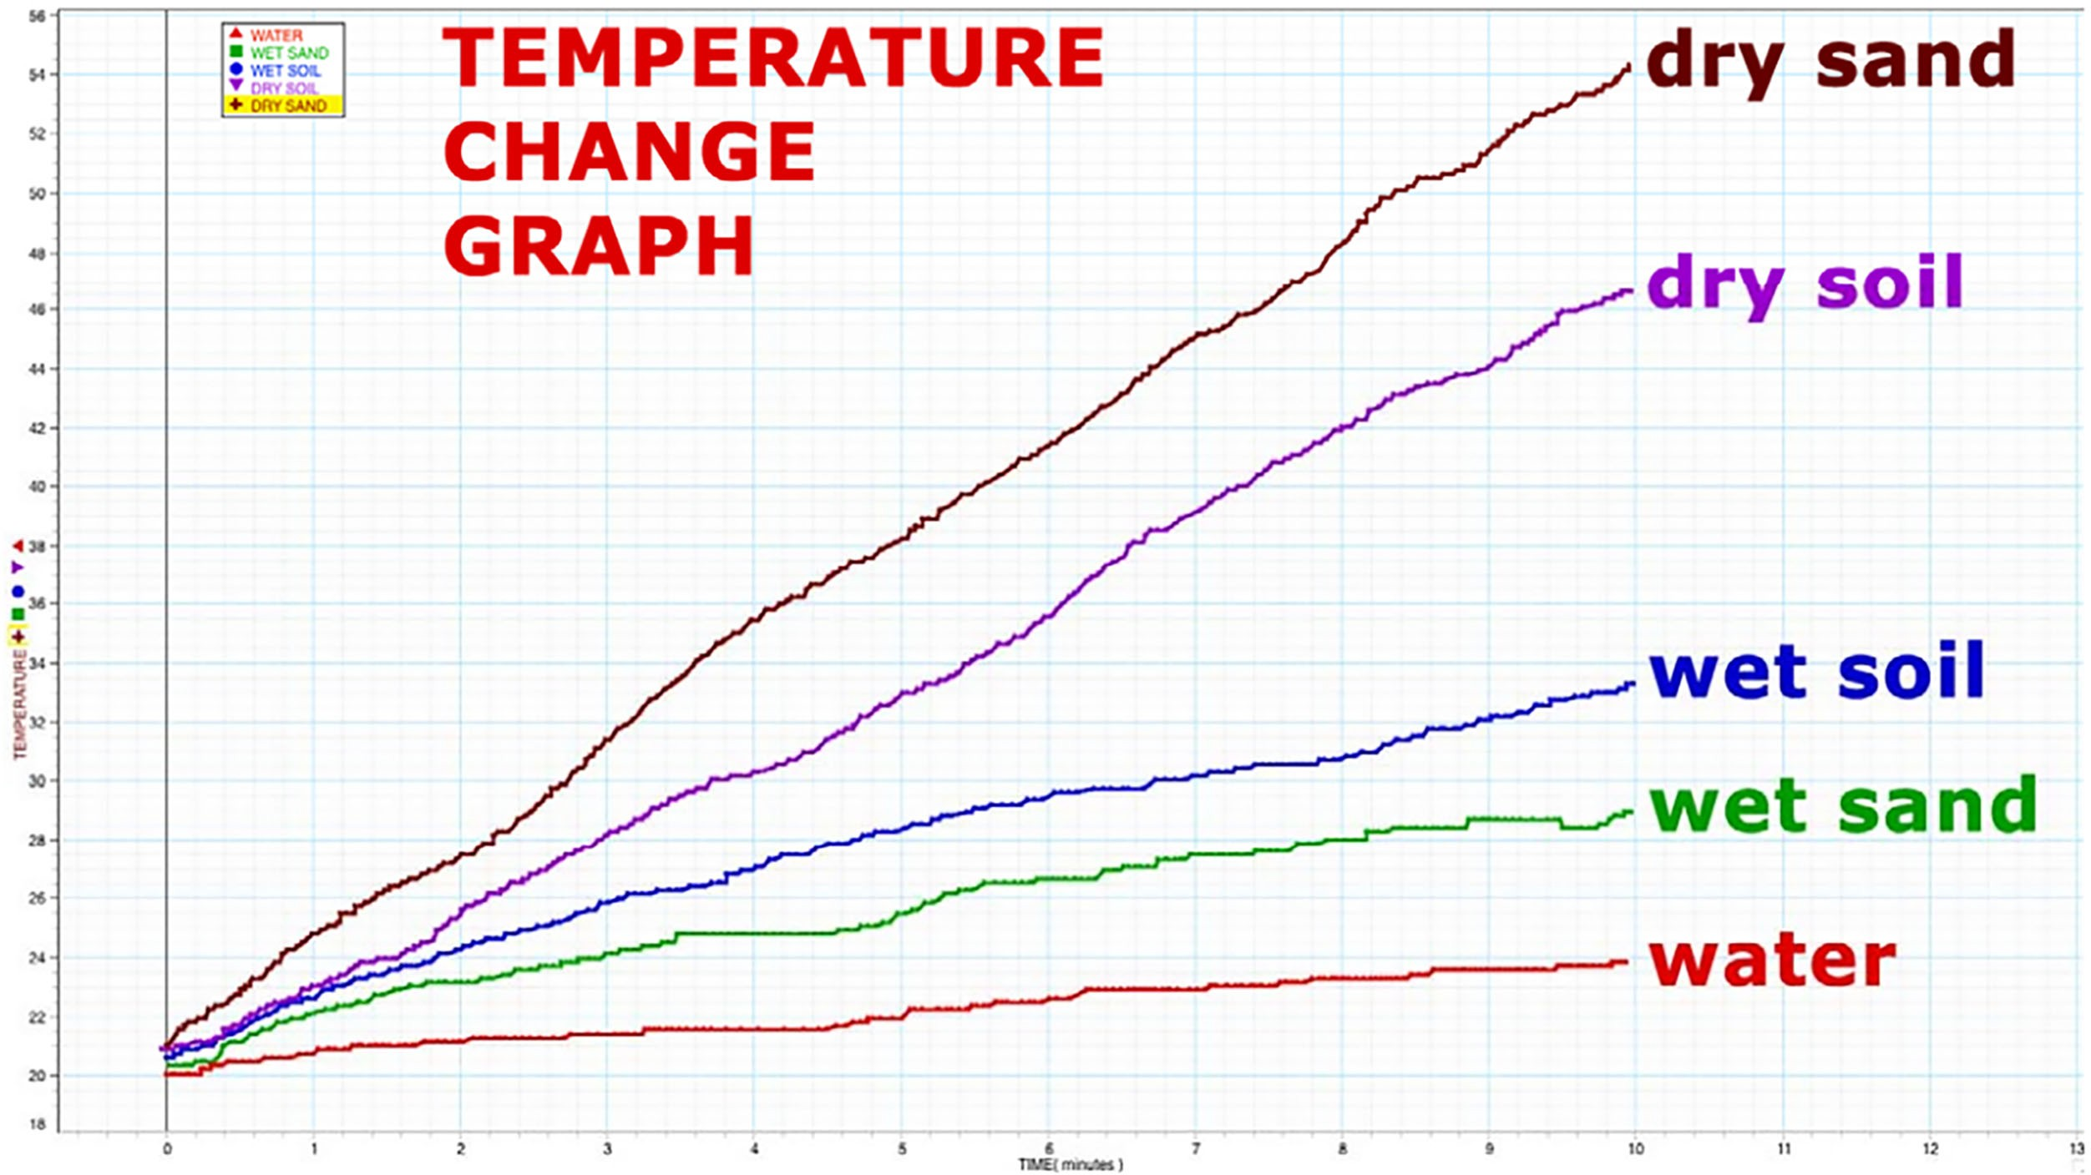

32 **ADLC Science 5**

Unit 3 Notebook: Weather Watch

Heat Capacity of Substances Chart

|  |  |
| --- | --- |
| Highest Heat Capacity |  |
|  |  |
|  |  |
|  |  |
|  |  |
| Lowest Heat Capacity |  |

ADLC Science 5 33