















Note: Data has been given for you in the San Francisco Data Example.

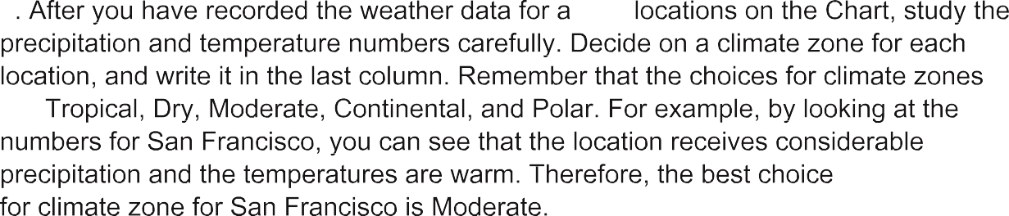





# San Francisco Data Example

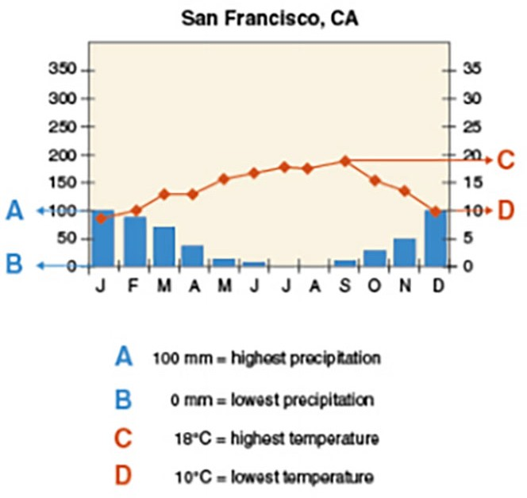

Unit 3 Notebook: Weather Watch

# Climate Data Chart

|  |  |  |  |  |  |
| --- | --- | --- | --- | --- | --- |
| **Location** | **Highest**  **Precipitation (mm)** | **Lowest**  **Precipitation (mm)** | **Highest Temp. (°C)** | **Lowest Temp. (°C)** | **Climate Zone?** |
| San Francisco, CA,USA | 100 | 0 | 18 | 10 | Moderate |
| Nearest City to your location in Alberta |  |  |  |  |  |
| San Jose, Costa Rica |  |  |  |  |  |
| Sydney, Australia |  |  |  |  |  |
| eoul, outh  Korea |  |  |  |  |  |
| Kuala Lampur, Malaysia |  |  |  |  |  |
| Beijing, China |  |  |  |  |  |
| Paris, France |  |  |  |  |  |
| Antartica |  |  |  |  |  |
| Phoenix, AZ, USA |  |  |  |  |  |
| Cairo, Egypt |  |  |  |  |  |
| Istanbul, Turkey |  |  |  |  |  |

42 ADLC Science 5