**Unit 4 Notebook: Wetlands Ecosystems**

**Activity 3: Without Wetlands**

**Why do Wetlands Matter? Activity One**

Read the following sections of the **Wetlands Digital Field Trip Resource** before you start

the activity.

Complete the relevant background information on the following chart.

**Wetlands Background Information Chart**

|  |  |
| --- | --- |
| **Section of Wetlands Digital Field Trip Resource** (Hint: Use the map to find these sections) | Answer the following questions: |
| **Wetland Mechanisms: Erosion** | What happens to the open coast when you remove the marsh by clicking the bottom button? |
| **Wetland Mechanisms: Groundwater** | How does a wetland beside a river affect the groundwater? |
| **Wetland Mechanisms: Flooding** | What happens when you flood the two rivers? |

**ADLC Science 5** 9

**Unit 4 Notebook: Wetlands Ecosystems**

|  |  |
| --- | --- |
| **Wetland Mechanisms: Habitat** | What are five animals that rely on the wetlands for habitat? |
| **Wetland Mechanisms: Migration** | For what do migratory birds use wetlands? |

**Activity Two**

You will discover how such a simple landform can do so many important jobs.

**Materials**

* plastic rectangular container
* sponge
* scissors
* measuring cup
* water
* tinfoil
* potting soil or dirt
* pepper
* watering can

**Hypothesis**

List three things you think might happen if there were no wetlands. (Hint: Reread the introduction to the Unit.)

10 **ADLC Science 5**

**Unit 4 Notebook: Wetlands Ecosystems**

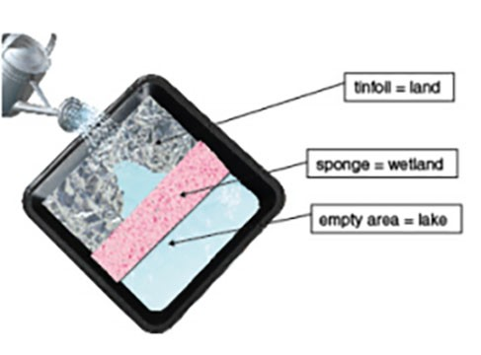

**Instructions**

1. Crumple a sheet of tinfoil and spread it to construct an area of land in your plastic container. Be sure to leave one side of the container empty for the lake. Your landform should be higher on one side so that the water drains into your lake.
2. Cut your sponge so that it fits into the container between your landform and your lake. This is your wetland.

Your model wetland should look like this:

1. Measure one cup of water into your watering can. Use this water to "rain" gently on your landform. Keep "raining" until you have used all the water. Record your observations.
2. Let your wetland sit for a few minutes so most of the water can drain from the land to the lake. (This time represents a "drought".) Now, squeeze the sponge (wetland) gently by pushing on it with your fingers. Record what happens.
3. Dump the water from the container.
4. Again, measure one cup of water into your watering can, but add a small pinch of pepper. (This will act as a "pollutant" in the water.)
5. Rain on your landform with the "polluted" water. Record your observations.
6. Dump the water again.
7. Now, add a thin layer of potting soil or dirt over the land area.
8. Use another cup of water to "rain" over you land. Record you observations.
9. Now, remove the "wetlands" (sponges) and repeat Steps 3 to 9. Record your observations.

**ADLC Science 5** 11

**Unit 4 Notebook: Wetlands Ecosystems**

**Observations Table**

|  |  |  |
| --- | --- | --- |
|  | **Observations WITH Wetlands** | **Observations WITHOUT Wetlands** |
| What happened during the first heavy rainfall?  Need a Hint? Wher |  |  |
| What happened during your "drought"?  Need a Hint?  Were you able to get water from another place? |  |  |
| What happened during the "polluted" rainfall?  Need a Hint?  What happened to the "pollutant" (pepper) in the rain?  Did it go into the lake? |  |  |
| What happened to the soil during the rainfall?  Need a Hint?  Did the soil wash away into the lake? Explain. |  |  |

12 **ADLC Science 5**

**Unit 4 Notebook: Wetlands Ecosystems**

**Conclusion**

Go back and check your hypothesis. Does your hypothesis match any of the results you observed?

If so, which one(s)?

**ADLC Science 5** 13