**Unit 4 Notebook: Wetlands Ecosystems**

 **Activity 4: Life Cycle Scramble: Adaptations**

# What are life cycles of some wetland plants and animals? Materials

**Wetland Videos:** <https://www.youtube.com/watch?v=rJOOxlFs9Is> *The Life Cycle of a Frog, <https://www.youtube.com/watch?v=Uja_QE4cZV0> *Stunning Close-Ups: Meet These Frogs Before They Go Extinct/National Geographic, and <https://www.youtube.com/watch?v=Fa_I68L_APY> *World’s Most Famous Frog!

# Instructions

1. Unscramble the life cycle stages to construct the correct life cycle diagrams for the animals shown.
2. Enter the correct life cycle stage in the correct spot.

# Need a Hint?

# Watch the wetlands videos, listed under the materials, to help you to find out more about the frog life cycle and characteristics about them.

* Read about each of these animals in the "Organism Screens" section of the **Wetlands Digital Field Trip** resource to find out more about their life cycles.

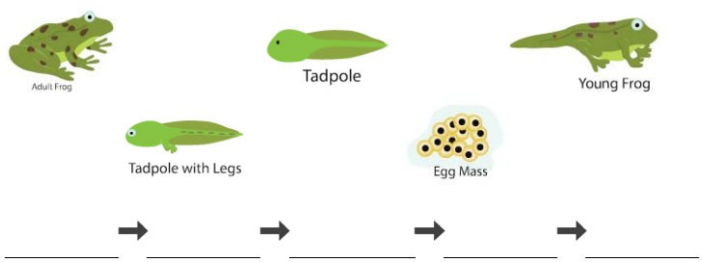

16 **ADLC Science 5**