**Unit 4: Wetlands Ecosystems**

Name:

Date:

|  |
| --- |
| Assignment 4-3 Food Pyramid |

How can I use a food pyramid to show information?

**Instructions**

1. Identify one **key** difference **in the type of information** provided by the ecological pyramid and the food chain diagram below. ( /1 mark)

|  |  |
| --- | --- |
|  | Food Chain |

|  |
| --- |
|  |

1. What idea does the pyramid shape represent in the food pyramid diagram below? ( /1 mark)[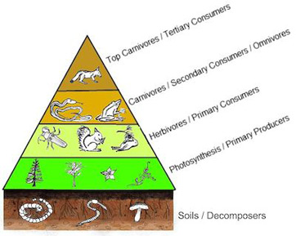](http://www.google.ca/url?sa=i&rct=j&q=&esrc=s&source=images&cd=&cad=rja&uact=8&ved=0ahUKEwjtqdqAyLzXAhVMyVQKHYgrC88QjRwIBw&url=http://study.com/academy/lesson/what-is-an-energy-pyramid-definition-examples.html&psig=AOvVaw1PK14FEd8v1r1O-XeKgzQ3&ust=1510697248079082)

|  |
| --- |
|  |

Use this Numbers Pyramid to answer the questions below.

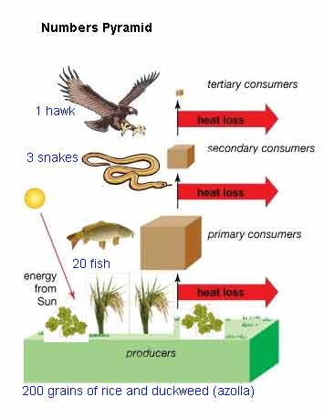

1. What would happen to the food chain if only 100 grains of rice were available instead of 200? ( /1 mark)

|  |
| --- |
|  |

1. What would happen to the rest of the food chain if the hawk died? What would happen to the other populations if the hawk population increased? Identify two other food sources that might be available to the hawk. ( /3 mark)

|  |
| --- |
|  |

1. Why might it be useful to have more than one food source? ( /1 mark)

|  |
| --- |
|  |

1. If you introduced a disease into the snake population, what would happen to other populations? ( /1 mark)

|  |
| --- |
|  |

1. Identify two situations or events that might cause a reduction in the amount of rice available. ( /1 mark)

|  |
| --- |
|  |

1. Four hectares of rice will support 1000 people for one day. If those same hectares of rice were fed to ducks and then the ducks were eaten by people, there would only be enough ducks to feed 50 people for one day.

How does this knowledge help people make decisions about how to use the land, especially in countries such as Vietnam where food is in short supply? ( /2 marks)

|  |
| --- |
|  |

1. A balanced food diet means that one eats food from each of the following categories to get enough nutrients (meats and alternates, dairy, grains and cereals, fruits and vegetables). If a country only relies on one food source such as rice to maximize production, what is the cost to people? ( /1 mark)

|  |
| --- |
|  |

1. Play one of the following simulation games and comment on what you learned. ( /2 mark)
2. http://fergusonfoundation.org/hbf-kids-zone/lets-take-a-dip/
3. <https://coast.noaa.gov/estuaries/curriculum/estuary-food-pyramid.html>
4. https://www.explorelearning.com/index.cfm?method=cResource.dspView&ResourceID=381&ClassID=631125
5. https://www.nationalgeographic.org/game/top-crop/

|  |
| --- |
|  |

**Overall Total: ( /14 marks)**

Save Your File

Name your file in this format: 4-3_(jsmith)sc5-pyramid and save your file to your Wetlands Ecosystems folder. Submit to the appropriate Submission folder when completed.