**Unit 4 Notebook: Wetlands Ecosystems**

 **Activity 9: Effects of Changes in the Wetlands**

*How can changes to an ecosystem affect various organisms?*

**Instructions**

Look at the image below and complete the *Wetland Chain Reaction Worksheet.*

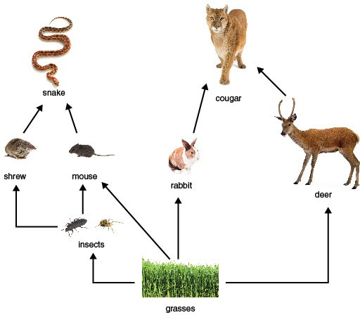

**ADLC Science 5** 39

**Unit 4 Notebook: Wetlands Ecosystems**

**Wetland Chain Reaction Worksheet**

1. List the correct order of organisms in your wetland food chain:
2. What is (are) the producer(s) in the food chain?
3. What is (are) the consumer(s) in the food chain?
4. Removing which part(s) of the food chain would cause the number of insects to increase?
5. Removing which part(s) of the food chain would cause the number of all other organisms to decrease?

40 **ADLC Science 5**