## Unit 4 Notebook: Wetlands Ecosystems

**Exit Pass: Lesson 6**

# Changes in Environments

**Read the dominoes and put them in order. Questions**

**Domino Order**

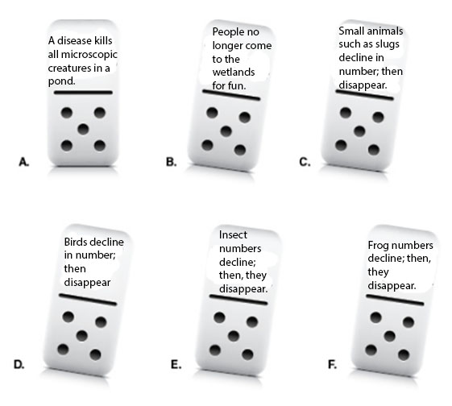

## 42 ADLC Science 5