**Unit A Section 1 Project – FOR MARKS**

**Project – Compare the Bears**

|  |  |
| --- | --- |
| project_snapshot.jpg | In this project, you compare two different types of bears. You are required to submit this project to your teacher for marks. Very carefully, read the whole project and how to do it. Be sure to read the requirements and rubric, they explain the expectations for this project and how it will be marked. |

|  |  |
| --- | --- |
| **AS1-project-02_panda_GettyImages-815047602.jpg** |  |

**Situation**

A young elementary school friend recently told you that giant pandas and grizzly bears are almost identical to each other, because they are both bears.

However, you know that giant pandas and grizzly bears look quite different. Do they actually have much in common? How similar and how different are these two types of bears?

**Project Task**

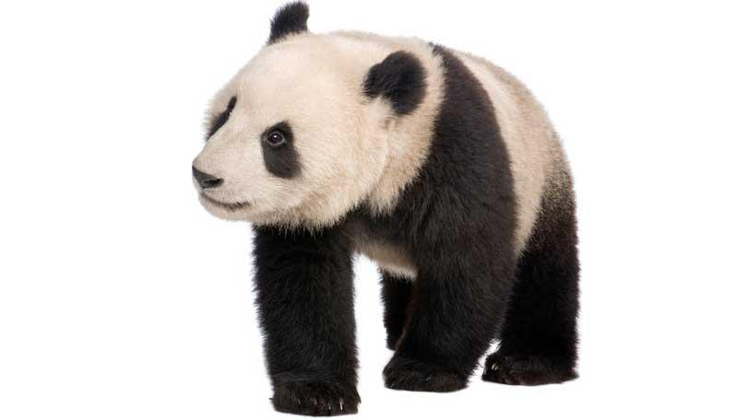

Research the classification, niche, and adaptations of both giant pandas and grizzly bears.

Then, design a imaginative and creative way to teach children aged 5 to 9 the similarities and differences between giant pandas and grizzly bears.

Before you begin designing your teaching method, ask yourself these questions:

* How can I find out more information about giant pandas and grizzly bears?
* How can I communicate this information in a way that is easy for young children to understand?

**Method**

1. Research both giant pandas and grizzly bears. Sources of information include the following:
   * Reference books
   * News articles in newspapers and magazines or other publications
   * Websites
   * YouTube videos
2. 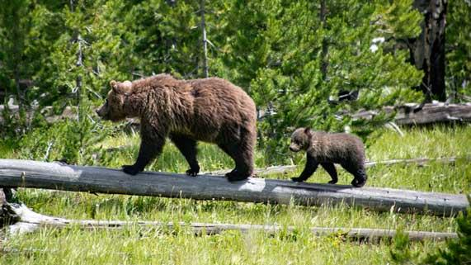Construct two tables to collect information. There is a download link at the bottom of this page if you wish to use tables that have been prepared for you.

One table will contain information about giant pandas; the other will contain information about grizzly bears. Make sure to complete the required categories listed in the sample tables below.

The tables must contain information summarized **in your own words**. Beside each piece of supporting information, list the source of the information. For example, insert the URL of any websites, book titles and authors, newspaper names and dates of publication or names of people interviewed as your sources.

**You must submit both research tables** with your teaching method about giant pandas and grizzly bears.

|  |  |  |  |
| --- | --- | --- | --- |
| **Information about Giant Pandas** | | | **Source of Information** |
| **Linnaeus Classification** | Kingdom |  |  |
| Phylum |  |
| Class |  |
| Order |  |
| Family |  |
| Genus |  |
| Species |  |
| At what point in the classification does a panda diverge (show a difference) from a grizzly? |  |
| **Niche Description**  (Refer to Page 18 in your textbook, *Science in Action 9*, for more information on niches if needed) | Where does it live (in what type of habitat do you find this bear)? |  |  |
| What is the range of a giant panda (geographically, where are you likely to find this bear)? |  |
| What does it eat? |  |
| Any predators? |  |
| Interspecies competition with other organisms? |  |
| Any symbiotic relationships? |  |
| Does the species have a broad or narrow niche? Why? |  |
| **Generalist or Specialist?** | Is the species generalist or specialist? |  |  |
| What are the advantages of being this? |  |
| What are the disadvantages of being this? |  |

|  |  |  |  |
| --- | --- | --- | --- |
| **Information about Grizzly Bears** | | | **Source of Information** |
| **Linnaeus Classification** | Kingdom |  |  |
| Phylum |  |
| Class |  |
| Order |  |
| Family |  |
| Genus |  |
| Species |  |
| At what point in the classification does a grizzly diverge from a panda? |  |
| **Niche Description**  (Refer to Page 18 in your textbook, *Science in Action 9*, for more information on niches if needed) | Where does it live (in what type of habitat do you find this bear)? |  |  |
| What is the range of a grizzly (geographically, where are you likely to find this bear)? |  |
| What does it eat? |  |
| Any predators? |  |
| Interspecies competition with other organisms? |  |
| Any symbiotic relationships? |  |
| Does the species have a broad or narrow niche? Why? |  |
| **Generalist or Specialist?** | Is the species generalist or specialist? |  |  |
| What are the advantages of being this? |  |
| What are the disadvantages of being this? |  |

3. Choose the way you would like to teach children about the similarities and differences between pandas and grizzly bears. Here are some ideas from which you can choose:

* Write and illustrate a children’s story book. Draw pictures with pencil and paper, or use a computer drawing program such as Adobe Photoshop or Gimp.
* Write a song. Record your song to share with your teacher.
* Make a video or TV show. Use live acting, or stop-motion animations.
* Create a board game.
* Use other creative ideas, but check with your teacher first!

**Requirements**

You must clearly communicate the following information in your teaching method about giant pandas and grizzly bears:

1. Classify **both** the giant panda and grizzly bear using the *Linnaeus Classification System*. Include the Kingdom, Phylum, Class, Order, Family, Genus, and Species. Clearly indicate the point in the classification system where giant pandas and grizzly bears become different from each other.
2. Describe the niche of **both** giant pandas and grizzly bears. You must describe whether each species occupies a broad or narrow niche. You must include the following information in your teaching method:
   * Where the species lives
   * Range of the species
   * What the species eats
   * Predators of the species
   * Interspecies competition with other organisms
   * Symbiotic relationships
3. Classify each species as either a generalist or a specialist. Describe the advantages and disadvantages of being a generalist or a specialist, for **each** species.

****

**Rubric**

This project is worth 24 marks. It explains how your work will be marked. It also explains all the things you need to include. Read the rubric very carefully before starting your work.

**Compare the Bears**

***24 marks***

|  |  |  |  |  |  |
| --- | --- | --- | --- | --- | --- |
| **CRITERIA** | **PERFORMANCE** | | | | |
| **NOT SUBMITTED** | **NOT OK** | **OK** | **GOOD** | **EXCELLENT** |
| **Not Submitted**  **0 marks** | **Does not meet criteria**  **1 mark** | **Minimally meets criteria**  **2 marks** | **Fully meets criteria**  **3 marks** | **Exceeds criteria**  **4 marks** |
| **Research tables completed** | Not Submitted | Research tables are not completed; they lack details and sources of information. | Research tables are somewhat completed; some details and sources of information are confusing or lacking. | Research tables and sources of information are completed; some supporting details are provided. | Research tables and sources of information are completed; many supporting details are provided. |
| **Complete Linnaeus classification listed for both species, clearly indicating point of difference** | Not Submitted | No Linnaeus classification names listed for either species; no point of difference indicated. | Some Linnaeus classification names listed for both species; no point of difference indicated. | Most Linnaeus classification names listed for both species; point of difference indicated. | All Linnaeus classification listed for both species; point of difference clearly indicated. |
| **Niche (broad or narrow) listed and described for both species** | Not Submitted | No niche is listed or described for either species; details lacking. | Niche is listed and minimally described for both species; details lacking. | Niche is listed and described for both species; some supporting details are provided. | Niche is listed and fully described for both species; many supporting details are provided. |
| **Each species listed as generalist or specialist, with advantages and disadvantages explained** | Not Submitted | Neither species listed as generalist or specialist, and no advantages or disadvantages explained; details lacking. | Both species listed as generalist or specialist, but no advantages or disadvantages explained; details lacking. | Both species listed as generalist or specialist, with advantages or disadvantages explained; some supporting details are provided. | Both species listed as generalist or specialist, with advantages or disadvantages explained; many supporting details are provided. |
| **Creativity** | Not Submitted | Teaching method is very simple and lacks imagination | Teaching method is very simple but shows some imagination | Teaching method has a few details and shows some imagination | Teaching method has many details and shows a great deal of imagination |
| **Communication** | Not Submitted | Information is not clearly communicated for children; details lacking | Information is partly communicated for children; some details lacking or confusing. | Information is partly communicated for children; many details included | Information is clearly communicated for children, with much detail |

**Submitting Your Work**

* If you print your work and/or do pencil drawing(s) on another piece of paper, you must scan your work to submit it.
* If you have prepared any other electronic images or documents for this assessment, you must submit them.
* If you have used an Internet location where your work is located, you must submit the URL so your teacher can view your work.

**When you are ready to submit your completed project, return to the project page in the online course and see the instructions at the bottom of the page.**

Note that when you submit anything to your teacher, **PLEASE INCLUDE YOUR NAME IN THE DOCUMENT TITLE**. For example, you might title it something like this:

***UnitA\_section1project\_Jenny\_Smith.doc***