**Unit A Project – FOR MARKS**

**Project – Invent Your Own Organism and Ecosystem**

|  |  |
| --- | --- |
| project_snapshot.jpg | In this project, you compare two different types of bears. You are required to submit this project to your teacher for marks. Very carefully, read the whole project and how to do it. Be sure to read the requirements and rubric, they explain the expectations for this project and how it will be marked. |

|  |  |
| --- | --- |
|  |  |



**Situation**

In the future, genetic engineering could lead to the development of new species on Earth.

If you could invent a new organism on Earth, what would it look like? How would it survive and reproduce? What would its ecosystem be like?

**Project Task**

Use your imagination to invent your own organism and its ecosystem.

Before you begin designing your organism and ecosystem, ask yourself these questions:

* What type of environment does my organism live in?
* What adaptations does my organism need to survive?
* What do I know about organisms and how they interact in ecosystems? How can I use this knowledge as I design a new organism and ecosystem?

**Method**

1. Design your own organism and its ecosystem, making sure to include the information listed in the *Requirements* section below. 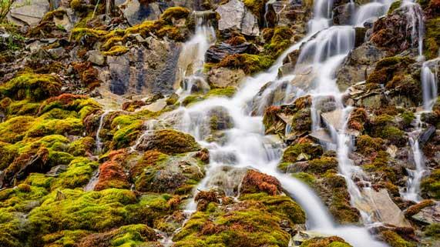
2. Choose the way you would like to communicate your organism and ecosystem design. Here are some ideas from which you can choose:
   * Draw pictures and diagrams of your organism and its ecosystem. Draw with pencil and paper, or use a computer drawing program such as Adobe Photoshop or Gimp.
   * Write a story about your organism and its ecosystem.
   * Build an organism and its ecosystem in Minecraft and take screenshots.
   * Build a model of your organism and its ecosystem. Then, photograph or video various aspects of your model to share with your teacher.
   * Use other creative ideas, but check with your teacher first!

**Requirements**

You must complete the following six requirements to communicate clearly the following information about your organism and ecosystem design.

* You can provide written answers to these questions, or you can include the answers as labels if you produce a drawing or model of your design.
* Another option is to address these questions by recording yourself (and your model or drawings) on video or make an audio recording.

1. Adaptations of Organism

* + Identify two survival adaptations of your organism. Explain how these adaptations help your organism survive in its ecosystem.
  + You may use adaptations already in existence, such as adaptations used for camouflage, adaptations used to avoid predators, or imagine your own.

2. Heredity of Organism

* + List and explain 2 discrete and 2 continuous characteristics in your organism.
  + Describe 2 heritable and 2 non-heritable characteristics in your organism.
  + Describe 1 dominant trait and 1 recessive trait in your organism.

3. Cell Division of Organism

* + Describe the type of cell division your organism uses to produce its muscle cells.
  + Describe the type of cell division your organism uses to produce its gametes.

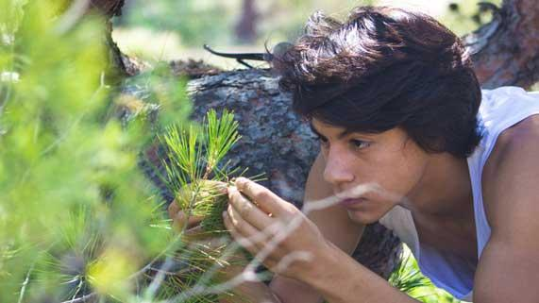

4. Organism’s Relationships in Ecosystem

* + Describe one example of each of the following relationships between your organism and other species in your ecosystem.
    - Interspecies competition
    - Mutualism
    - Commensalism
    - Parasitism

5. Asexual Reproduction in Ecosystem

* + Identify two organisms in your ecosystem that use different but specific forms of asexual reproduction.
  + Describe each form of asexual reproduction.
  + You can use organisms in existence (or imagine your own) in your ecosystem.

6. Organism Variation in Ecosystem

* + Give an example of how artificial selection might benefit your organism.
  + Give an example of how natural selection benefits your organism and describe how this is different from artificial selection.

**Rubric**

This project is worth 32 marks. It explains how your work will be marked. It also explains all the things you need to include. Read the rubric very carefully before starting your work.

(*The rubric is on the next page.*)

**Invent Your Own Organism and Ecosystem**

***32 marks***

|  |  |  |  |  |  |
| --- | --- | --- | --- | --- | --- |
| **CRITERIA** | **PERFORMANCE** | | | | |
| **NOT SUBMITTED** | **NOT OK** | **OK** | **GOOD** | **EXCELLENT** |
| **Not Submitted**  **0 marks** | **Does not meet criteria**  **1 mark** | **Minimally meets criteria**  **2 marks** | **Fully meets criteria**  **3 marks** | **Exceeds criteria**  **4 marks** |
| **Two organism adaptations listed and explained**  ***(from Requirements #1)*** | Not Submitted | No adaptations are listed or explained for organism; details lacking. | One adaptation is listed and minimally explained; details lacking. | Two adaptations are listed and explained; some supporting details are provided. | Two adaptations are listed and explained; many supporting details are provided. |
| **Heredity characteristics of organism listed and explained**  ***(from Requirements #2)*** | Not Submitted | No heredity characteristics are listed or explained for organism; details lacking. | Some heredity characteristics are listed and minimally explained; details lacking. | Heredity characteristics are listed and explained; some supporting details are provided. | Heredity characteristics are listed and explained; many supporting details are provided. |
| **Cell division described for the organism’s muscle and sex cells**  ***(from Requirements #3)*** | Not Submitted | No cell division described in organism; details lacking. | One type of cell division described in organism; details lacking. | Both types of cell division listed and explained; some supporting details are provided. | Both types of cell division are listed and explained; many supporting details are provided. |
| **Relationships in ecosystem described**  ***(from Requirements #4)*** | Not Submitted | No ecosystem relationships described; details lacking. | Some ecosystem relationships are minimally described; details lacking. | All ecosystem relationships are described; some supporting details are provided. | All ecosystem relationships are described; many supporting details are provided. |
| **Two examples of asexual reproduction in ecosystem listed and described**  ***(from Requirements #5)*** | Not Submitted | No examples of asexual reproduction are listed or described; details lacking. | One example of asexual reproduction is listed and minimally described; details lacking. | Two examples of asexual reproduction listed and described; some supporting details are provided. | Two examples of asexual reproduction listed and described; many supporting details are provided. |
| **Benefits of artificial and natural selection described for organism**  ***(from Requirements #6)*** | Not Submitted | No benefits of artificial and natural selection described; details lacking. | One benefit of artificial or natural selection minimally described; details lacking. | Benefits of artificial and natural selection are described; some supporting details are provided. | Benefits of artificial and natural selection are described; many supporting details are provided. |
| **Creativity** | Not Submitted | Organism and ecosystem design is very simple and lacks imagination. | Organism and ecosystem design is very simple but shows some imagination. | Organism and ecosystem design has a few details and shows some imagination. | Organism and ecosystem design has many details and shows a great deal of imagination. |
| **Communication** | Not Submitted | Information is not clearly communicated; details lacking. | Information is partly communicated; some details lacking or confusing. | Information is partly communicated; many details included. | Information is clearly communicated, with much detail. |

**Submitting Your Work**

* If you print your work and/or do pencil drawing(s) on another piece of paper, you must scan your work to submit it.
* If you have prepared any other electronic images or documents for this assessment, you must submit them.
* If you have used an Internet location where your work is located, you must submit the URL so your teacher can view your work.

**When you are ready to submit your completed project, return to the project page in the online course and see the instructions at the bottom of the page.**

Note that when you submit anything to your teacher, **PLEASE INCLUDE YOUR NAME IN THE DOCUMENT TITLE**. For example, you might title it something like this:

***UnitA\_unitendproject\_Jenny\_Smith.doc***