Science 9
Unit B: Matter and Chemical Change
Lesson 1
Practice Worksheet 12: WHMIS Pictograms

Watch the “GHS Pictogram” video and complete the following chart. In the first column, write the name of the pictogram. In the second column, write a brief description of the dangers associated with substances labelled with the pictogram.

The first symbol is not in the video and has been completed for you as an example.

Leave your answers in blue; it will be easier for you and your teacher to see them later.

Pictogram | Name | Description of Dangers
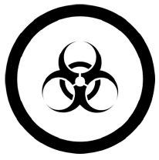 | Biohazardous | Biohazardous infectious materials
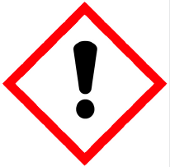 | Type your answer here. | Type your answer here.
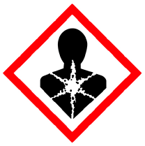 | Type your answer here. | Type your answer here.
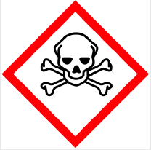 | Type your answer here. | Type your answer here.
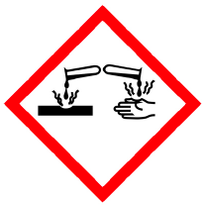 | Type your answer here. | Type your answer here.
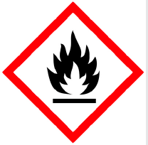 | Type your answer here. | Type your answer here.
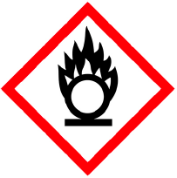 | Type your answer here. | Type your answer here.
 | Type your answer here. | Type your answer here.
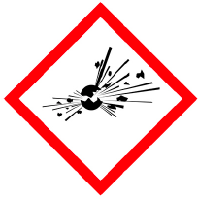 | Type your answer here. | Type your answer here.
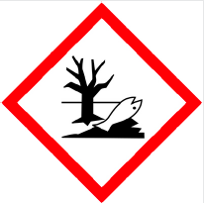 | Type your answer here. | Type your answer here.

Congratulations! You have completed this practice worksheet.

Now it's time to carefully compare your answers to the suggested answers in the online course. When comparing, you should feel free to make changes to your answers or make extra notes.

Keep this practice worksheet for study purposes. Using practice worksheets as a study tool to review for exams is a great idea.

If you unsure about any of the questions or answers, or you just want more feedback, share this practice worksheet with your teacher and ask for assistance. You can do that by emailing the teacher, or by submitting it in the Course Questions Forum in the online course. If you are using this practice worksheet in Google Drive, don’t forget to change the sharing settings so that anyone can view it before sending the link to your teacher.

