**Science 9**

**Unit B: Matter and Chemical Change**

**Lesson 6**

**Practice Worksheet 20: Important Groups and Families**

Use a periodic table to complete the following questions.

*Leave your answers in blue; it will be easier for you and your teacher to see them later.*

**Question 1**

Name three elements that are gases at room temperature (20°C). Write their chemical names and symbols.

*Type your answer here.*

*Type your answer here.*

*Type your answer here.*

**Question 2**

Which two elements are liquids at room temperature (20°C)? Write their chemical names and

symbols.

*Type your answer here.*

*Type your answer here.*

**Question 3**

What element is found in group two, period three? Write its chemical name and symbol.

*Type your answer here.*

**Question 4**

What element has the atomic number of 82? Write its chemical name and symbol.

*Type your answer here.*

**Question 5**

What is the atomic number of arsenic?

*Type your answer here.*

**Question 6**

Match each item on the table with its corresponding letter on the diagram.

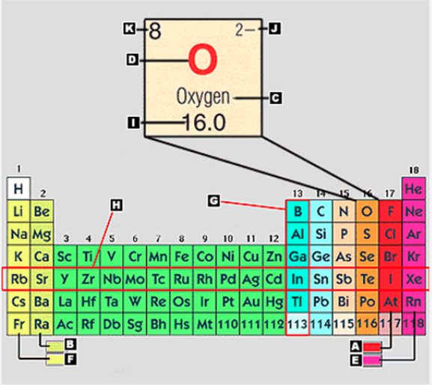

|  |  |
| --- | --- |
|  | **Corresponding letter on diagram** |
| 1. alkaline-earth metals |  |
| 2. element symbol |  |
| 3. element name |  |
| 4. period |  |
| 5. halogens |  |
| 6. alkali metals |  |
| 7. ion charge |  |
| 8. group or family |  |
| 9. atomic mass |  |
| 10. atomic number |  |
| 11. noble gases |  |

**Congratulations! You have completed this practice worksheet.**

Now it's time to carefully compare your answers to the suggested answers in the online course. When comparing, you should feel free to make changes to your answers or make extra notes.

**Keep this practice worksheet for study purposes.** Using practice worksheets as a study tool to review for exams is a great idea.

**If you unsure about any of the questions or answers, or you just want more feedback, share this practice worksheet with your teacher and ask for assistance.** You can do that by emailing the teacher, or by submitting it in the Course Questions Forum in the online course. If you are using this practice worksheet in Google Drive, don’t forget to change the sharing settings so that anyone can view it before sending the link to your teacher.