**Science 9**

**Unit B: Matter and Chemical Change**

**Lesson 14**

**Practice Worksheet 30: How Does the Temperature of the Reactants Affect Reaction Rate?**

Watch the video “[Temperature and Reaction Rate](https://adlc.wistia.com/medias/7atjxzsmu2)”.

As you watch the video, complete the following questions.

*Leave your answers in blue; it will be easier for you and your teacher to see them later.*

**Question 1**

Complete the data table below, based on the experiment in the video.

|  |  |
| --- | --- |
| Initial Water Temperature (oC) | Reaction Time (s) |
| *Type your answer here.* | *Type your answer here.* |
| *Type your answer here.* | *Type your answer here.* |
| *Type your answer here.* | *Type your answer here.* |
| *Type your answer here.* | *Type your answer here.* |

**Question 2**

1. Identify the **manipulated variable** in the experiment. The manipulated variable is what the experimenter chooses to change in the experiment.

*Type your answer here.*

1. Identify the **responding variable** in the experiment. The responding variable occurs as a result of changes in the experiment. The experimenter measures the responding variable.

*Type your answer here.*

1. Identify **controlled variables** in the experiment. Controlled variables are anything that stays the same throughout the experiment, to make it a fair test.

*Type your answer here.*

**Question 3**

Use the graph to answer Questions 3a and 3b.

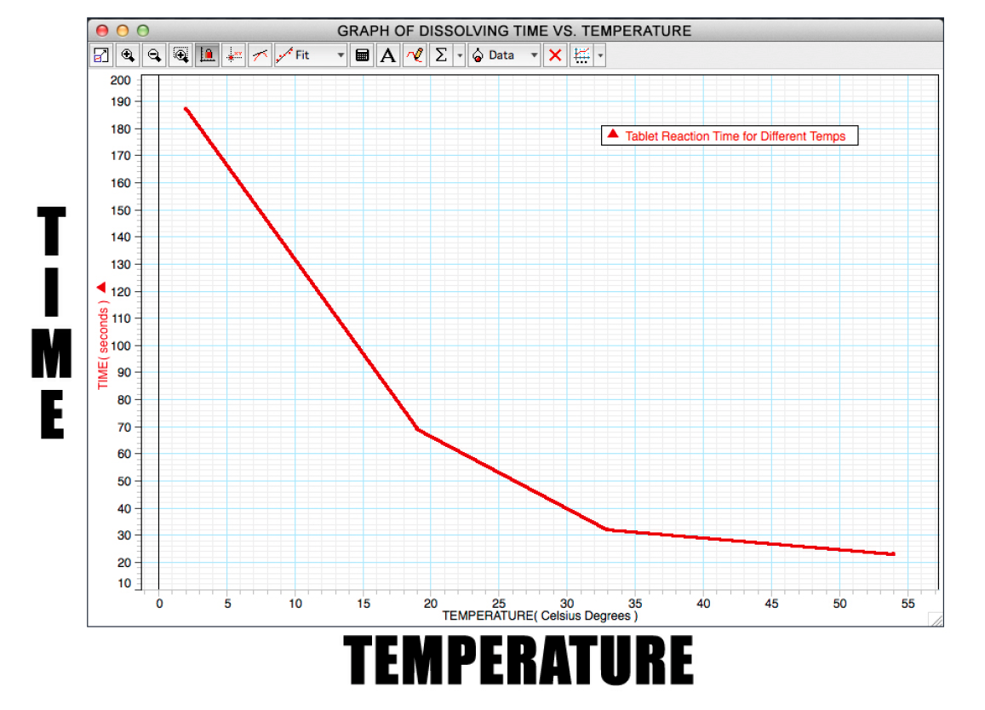

1. How many seconds would it take for one Alka-Seltzer tablet to react with 200 mL of water, when the temperature is 10oC?

*Type your answer here.*

1. What temperature must it be for the tablet to dissolve in 200 mL of water, in 50 seconds?

*Type your answer here.*

**Question 4**

In this experiment, what happens to the rate of reaction as the temperature of the reactants increases?

*Type your answer here.*

**Question 5**

Did a physical change or a chemical change occur when an Alka-Seltzer tablet is added to water? Explain your answer.

*Type your answer here.*

**Congratulations! You have completed this practice worksheet.**

Now it's time to carefully compare your answers to the suggested answers in the online course. When comparing, you should feel free to make changes to your answers or make extra notes.

**Keep this practice worksheet for study purposes.** Using practice worksheets as a study tool to review for exams is a great idea.

**If you unsure about any of the questions or answers, or you just want more feedback, share this practice worksheet with your teacher and ask for assistance.** You can do that by emailing the teacher, or by submitting it in the Course Questions Forum in the online course. If you are using this practice worksheet in Google Drive, don’t forget to change the sharing settings so that anyone can view it before sending the link to your teacher.