**Science 9**

**Unit D: Electrical Principles and Technologies**

**Lesson 15**

**Practice Worksheet 49: Energy Forms and Changes**

Use the link in the online course to open the Energy Forms and Changes simulation.

Experiment with the various options of:

* Energy sources (water tap, sun, tea kettle, bicycle)
* Generation (turbine, solar panel)
* Energy output (water heater, incandescent light bulb, compact fluorescent bulb)

Then, complete the following questions.

*Leave your answers in blue; it will be easier for you and your teacher to see them later.*

**Question 1**

Which **energy sources (input)** cause the turbine (wooden wheel) to spin and generate

electrical energy?

*Type your answer here.*

**Question 2**

Which **energy sources (input)** cause the solar panels to generate electrical energy?

*Type your answer here.*

**Question 3**

Which **energy output** objects work with the turbine?

*Type your answer here.*

**Question 4**

Which **energy output** objects work with the solar panels?

*Type your answer here.*

**Question 5**

On the simulation, test the situations listed in the table. Does the amount of electrical energy generated increase or decrease? Write your answer in the table.

|  |  |
| --- | --- |
| **Situation** | **Effect on Amount of Electrical Energy Generated**  **(Write increase or decrease)** |
| Water faucet on high | *Type your answer here.* |
| Water faucet on low | *Type your answer here.* |
| No clouds | *Type your answer here.* |
| Many clouds | *Type your answer here.* |
| Low heat on the kettle | *Type your answer here.* |
| High heat on the kettle | *Type your answer here.* |
| Girl pedals slowly | *Type your answer here.* |
| Girl pedals quickly | *Type your answer here.* |

**Question 6**

Set up a system of a medium flow faucet moving a turbine connected to a water heater. The system should look like the picture below. Let it run for a while.

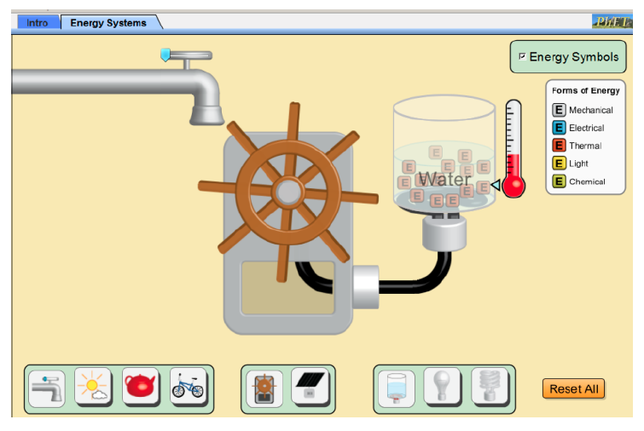

The table describes the order of energy transformations in the system. Complete the table with the correct type of energy at each step. Use the energy symbols in the simulation to help you see the flow of energy within each system.

|  |  |
| --- | --- |
| **Energy Transformations** | **Type of Energy** |
| Energy from the moving water of the faucet that turns the turbine | *Type your answer here.* |
| Energy of the spinning turbine | *Type your answer here.* |
| Energy that the spinning turbine generates | *Type your answer here.* |
| Energy that causes the temperature of the water to increase | *Type your answer here.* |
| Energy that steam adds to the atmosphere | *Type your answer here.* |

**Question 7**

Set up a system of sunlight hitting a solar panel to power an incandescent light bulb. The system should look like the picture below. Let it run for a while.

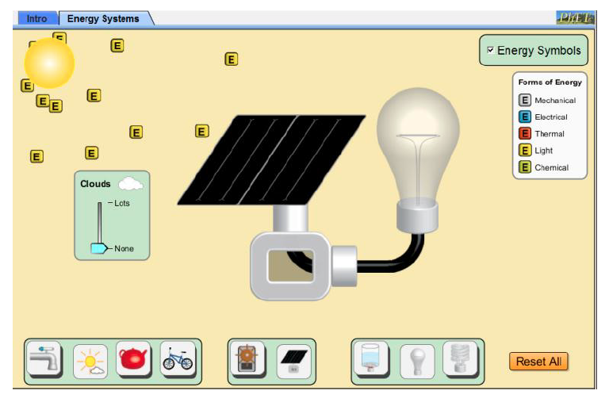

The table describes the order of energy transformations in the system. Complete the table with the correct type of energy at each step. Use the energy symbols in the simulation to help you see the flow of energy within each system.

|  |  |
| --- | --- |
| **Energy Transformations** | **Type of Energy** |
| Energy from the sunlight | *Type your answer here.* |
| Energy produced by the solar panel, that flows into the incandescent light bulb | *Type your answer here.* |
| Two types of energy produced by the incandescent light bulb | *Type your answer here.*  *Type your answer here.* |

**Question 8**

Set up a system of steam moving a turbine connected to a water heater. The system should look like the picture below. Let it run for a while.

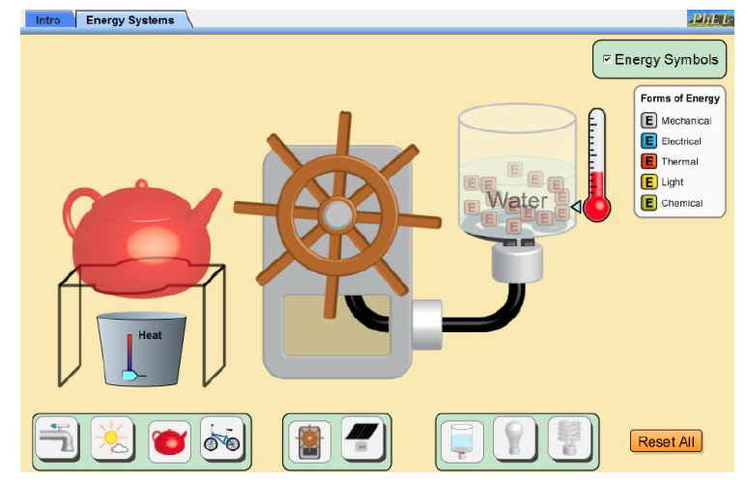

The table describes the order of energy transformations in the system. Complete the table with the correct type of energy at each step. Use the energy symbols in the simulation to help you see the flow of energy within each system.

|  |  |
| --- | --- |
| **Energy Transformations** | **Type of Energy** |
| Energy transferred from the flames of the fire to the kettle, causing the liquid to become steam | *Type your answer here.* |
| Energy of the moving steam that spins the turbine | *Type your answer here.* |
| Energy generated by the turbine that increases the temperature of water, turning it into steam | *Type your answer here.* |
| Energy of the steam that is transferred to the atmosphere | *Type your answer here.* |

**Question 9**

Set up a system of a cyclist pedalling at medium speed moving a turbine connected to a fluorescent light bulb. The system should look like the picture below. Let it run for a while.

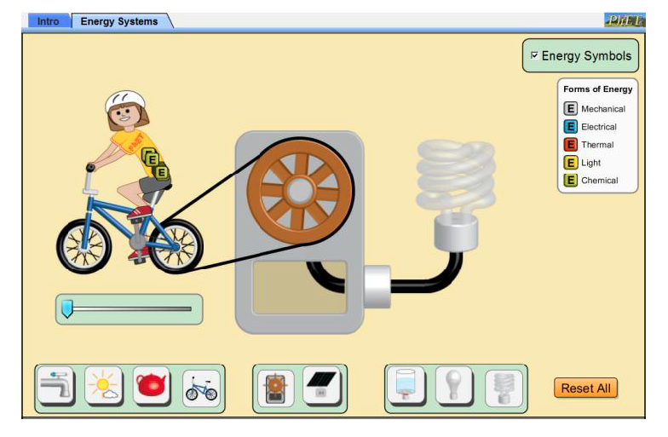

The table describes the order of energy transformations in the system. Complete the table with the correct type of energy at each step. Use the energy symbols in the simulation to help you see the flow of energy within each system.

|  |  |
| --- | --- |
| **Energy Transformations** | **Type of Energy** |
| Energy from the cyclist | *Type your answer here.* |
| Energy from the cyclist is converted to a small amount of this type of energy in the atmosphere | *Type your answer here.* |
| Energy from the cyclist is converted to a large amount of this type of energy in the bicycle wheel | *Type your answer here.* |
| Energy from the turning bicycle wheel that spins the turbine | *Type your answer here.* |
| Energy generated by the turbine | *Type your answer here.* |
| Two types of energy produced by the fluorescent light bulb | *Type your answer here.*  *Type your answer here.* |

**Question 10**

Which bulb is more efficient: the incandescent bulb, or the fluorescent bulb? Why?

*Type your answer here.*

**Congratulations! You have completed this practice worksheet.**

Now it's time to carefully compare your answers to the suggested answers in the online course. When comparing, you should feel free to make changes to your answers or make extra notes.

**Keep this practice worksheet for study purposes.** Using practice worksheets as a study tool to review for exams is a great idea.

**If you unsure about any of the questions or answers, or you just want more feedback, share this practice worksheet with your teacher and ask for assistance.** You can do that by emailing the teacher, or by submitting it in the Course Questions Forum in the online course. If you are using this practice worksheet in Google Drive, don’t forget to change the sharing settings so that anyone can view it before sending the link to your teacher.