Science 9
Unit D: Electrical Principles and Technologies
Lesson 17
Practice Worksheet 50: Electrical Technology

Complete the following chart as you work through the readings and videos in Unit D Lesson 17.

Leave your answers in blue; it will be easier for you and your teacher to see them later.

Electrical Technology Chart
Electrical Device | How does the device impact speed, efficiency, and convenience in your life?
1. Microwave  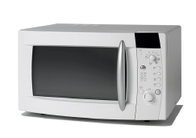 | Type your answer here.
2. Computer | Type your answer here.
3. Refrigerator  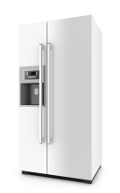 | Type your answer here.
4. Household furnace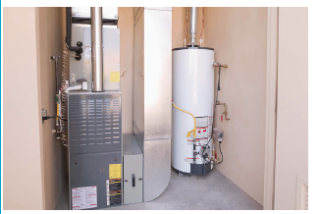 | Type your answer here.

Congratulations! You have completed this practice worksheet.

Now it's time to carefully compare your answers to the suggested answers in the online course. When comparing, you should feel free to make changes to your answers or make extra notes.

Keep this practice worksheet for study purposes. Using practice worksheets as a study tool to review for exams is a great idea.

If you unsure about any of the questions or answers, or you just want more feedback, share this practice worksheet with your teacher and ask for assistance. You can do that by emailing the teacher, or by submitting it in the Course Questions Forum in the online course. If you are using this practice worksheet in Google Drive, don’t forget to change the sharing settings so that anyone can view it before sending the link to your teacher.

