Science 9
Unit E: Space Exploration
Lesson 13
Practice Worksheet 60: Timeline Organizer Chart

Work through the readings and videos in Unit E Lesson 13. Then, complete the timeline organizer chart for Canada’s contributions to space exploration and observation.

- A picture and date is provided for an important contribution.
- Record the name of the technology pictured.
- Write a short description of the technology’s role in the space mission.
- If you need a hint, the link provided will bring you to the Canadian Space Agency’s “Canadian Space Milestones” page.

Leave your answers in blue; it will be easier for you and your teacher to see them later.

Canada’s Contributions to Space Exploration and Observation
Date | Picture | Technology Name | Role in Space Mission | Hints: Website Links
1962 | 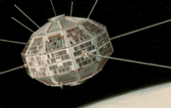 | Type your answer here. | Type your answer here. | http://www.asc-csa.gc.ca/eng/satellites/alouette.asp
1969 | 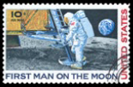 | Type your answer here. | Type your answer here. | http://www.asc-csa.gc.ca/eng/about/milestones.asp
1972 |  | Type your answer here. | Type your answer here. | http://www.asc-csa.gc.ca/eng/50canadaspace-milestones.asp
1981 | 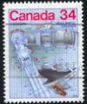 | Type your answer here. | Type your answer here. | http://www.asc-csa.gc.ca/eng/about/milestones.asp
1997 | 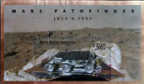 | Type your answer here. | Type your answer here. | http://www.asc-csa.gc.ca/eng/about/milestones.asp

Congratulations! You have completed this practice worksheet.

Now it's time to carefully compare your answers to the suggested answers in the online course. When comparing, you should feel free to make changes to your answers or make extra notes.

Keep this practice worksheet for study purposes. Using practice worksheets as a study tool to review for exams is a great idea.

If you unsure about any of the questions or answers, or you just want more feedback, share this practice worksheet with your teacher and ask for assistance. You can do that by emailing the teacher, or by submitting it in the Course Questions Forum in the online course. If you are using this practice worksheet in Google Drive, don’t forget to change the sharing settings so that anyone can view it before sending the link to your teacher.

