Social Studies 30-1 **Name:** <>

**Assignment 3.2.9 Evolution of Economic Liberalism**

**25 marks**

In this assignment, demonstrate your understanding of how classical liberal economics was fundamentally challenged and changed by the impact of the Great Depression in the 1930s.



Before attempting this assignment, make sure you have read the following pages in your textbook: 147-149, 208-212.

1. Read the following quote and answer the questions below.

In our efforts for recovery we have avoided on the one hand the theory that business should and must be taken over into an all-embracing Government. We have avoided on the other hand the equally untenable theory that it is an interference with liberty to offer reasonable help when private enterprise is in need of help. The course we have followed fits the American practice of Government - a practice of taking action step by step, of regulating only to meet concrete needs - a practice of courageous recognition of change.

-President Franklin Roosevelt, Fireside Chat 6: On Government and Capitalism, Sept 30, 1934

1. What does Roosevelt mean by ‘efforts for recovery’? Provide an example of at least one policy or program that reflects his efforts. (2 marks)

<>

1. How does this quote reflect modern liberalism? (1 mark)

<>

1. Imagine, you have been asked to respond to Roosevelt’s excerpt from the perspective of a classical liberal. Prepare a 3-5 sentence response. (3 marks)

<>

1. Explain how the New Deal was ‘taking action step by step’ to pull the U.S. economy out of the Great Depression. Include at least one specific New Deal program in your answer. (2 marks)

<>

1. Explain how a communist would **most likely** respond to Roosevelt’s speech. (2 marks)

<>

1. Find a political cartoon. It should reflect a classical liberal’s response to Roosevelt’s New Deal. Provide source location and credits in APA format. Include a 3-5 sentence explanation of the cartoonist’s message and/or perspective. (5 marks)

<>

**Part Two: Chart Analysis**

1. Study the following chart and answer the questions below. 10 marks (see rubric on page 5)

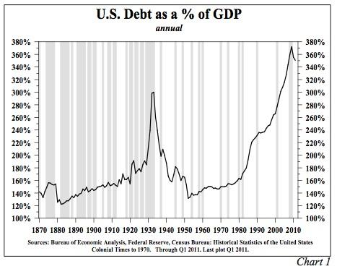

Using the terms below in your response, explain how this chart demonstrates the evolution of economics, from classical liberalism to modern liberalism. You must correctly incorporate the following terms in your response: (Please mention specific points on the graph to emphasize your arguments)

* *Free market economy*
* *laissez-faire capitalism*
* *modern liberalism*
* *Great Depression*
* *boom and bust cycle*
* *demand side economics*
* *Keynesian theory*
* *monetary policy and fiscal policy*

<>

|  |  |  |
| --- | --- | --- |
| **Scoring Criteria:**  **Discussions** | **Ideas and Support**  **7.5** | **Communication of Ideas**  **2.5** |
|  | *The student…* | |
| **Excellent** | * provides thoughtful ideas and thorough explanations * uses support that is specific, relevant, and accurate * demonstrates a confident and perceptive understanding of the assigned task   7.5 | * writes fluently; organizes effectively * uses vocabulary that is precise, accurate, and effective * controls confidently sentence construction, grammar, and mechanics   2.5 |
| **Proficient** | * provides meaningful ideas and appropriate explanations * uses support that is relevant and appropriate but which may contain minor errors * demonstrates a proficient and clear understanding of the assigned task   6 | * writes clearly; organizes proficiently * uses vocabulary that is specific, accurate, and appropriate * controls proficiently sentence construction, grammar, and mechanics   2 |
| **Satisfactory** | * provides straightforward ideas and general explanations * uses support that is relevant but general and/or incompletely developed * demonstrates an acceptable understanding of the assigned task   4.5 | * writes generally clearly; organizes functionally * uses vocabulary that is appropriate and generally accurate, but not specific * controls satisfactorily sentence construction, grammar, and mechanics; minor errors do not interfere seriously with communication   1.5 |
| **Limited** | * provides ideas and/or explanations that are limited and over-generalized * uses support that is superficial and may not be always relevant * demonstrates a limited understanding of the assigned task   3 | * writes unevenly and/or incompletely * use vocabulary that is general and/or imprecise and/or inappropriate * has faltering control of sentence construction, grammar, and mechanics   1 |
| **Poor** | * provides ideas and/or explanations that are minimal and/or tangential * uses support, if present, that is superficial, incomplete, and/or marginally relevant * demonstrates a minimal understanding of the assigned task   1.5 | * writes unclearly; disorganized * uses vocabulary that is ineffective and frequently incorrect * lacks control of sentence construction, grammar, and mechanics   0.5 |