Name: < >
Social Studies 30-1
Assignment 3.3.2 Analyzing Sources
Total 0 marks

The following assignment expects students to deconstruct and analyze sources for a formal written source interpretation. You need to clearly communicate your interpretation of three sources, and demonstrate your understanding of how each source links to liberalism. Then, explain the relationship that exists among all three sources. Make sure you have reviewed the unit pages in the course, as well as read pages 204-212 in your textbook before completing this assignment. This ungraded task is the planning for Assignment 3.3.3.

This written response is the same format for the Midterm and Final exam, as well as Writing Assignment #1 on the Provincial Diploma Exam.

Please note that this task is NOT for marks. This is meant to help prepare you to write Assignment 3.3.3. If you want feedback prior to submitting 3.3.3, please contact your teacher to preview your work.

Analyze the three sources to complete the assignment.

Source I
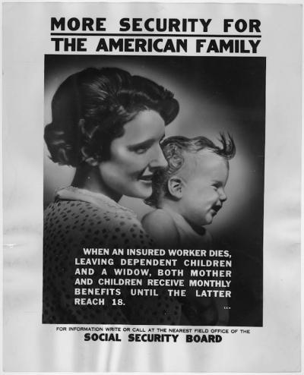
File:Social Security Poster of a Mother and Her Child - NARA - 195886.tif. (2015, March 29). Wikimedia Commons, the free media repository. Retrieved 21:05, April 10, 2019 from https://commons.wikimedia.org/w/index.php?title=File:Social_Security_Poster_of_a_Mother_and_Her_Child_-_NARA_-_195886.tif&oldid=155125925.

Source II
“Government has three primary functions. It should provide for military defense of the nation. It should enforce contracts between individuals. It should protect citizens from crimes against themselves or their property. When government-- in pursuit of good intentions tries to rearrange the economy, legislate morality, or help special interests, the cost come in inefficiency, lack of motivation, and loss of freedom. Government should be a referee, not an active player.”

Forbes cited Friedman from an interview on The Phil Donahue Show, 1979 https://www.forbes.com/sites/realspin/2014/07/31/milton-friedmans-property-rights-legacy/#52da6d7e6635

Source III
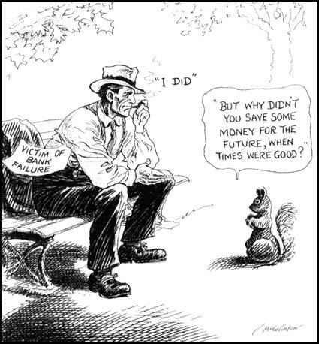
©1931 by John McCutcheon, courtesy Library of Congress
McCutcheon, J. (Artist). (1931). [Political Cartoon]. Chicago, Illinois; Chicago Tribune.
Note: Bank Failure is referring to the aftermath of the Stock Market Crash in 1929

Part One: Analyzing Sources 0 marks

Source I 0 marks

- Complete the planning chart below. (0 marks)
Question | Answer (0 marks each) | How do I know?
What  …is the source about? | < > | < >
Who  …is the source about/potential audience? | < > | < >
When  …date/time occurred or published | < > | < >
Where  …location (origin of source/ country) | < > | < >
Why  …significance or purpose of poster | < > | < >

- Explain the source’s point of view regarding the role of government in society. (0 marks)
< >

- Explain how the source specifically relates to the economic shift towards a mixed economy. (0 marks)
< >

- To what extent does the source support the principles of liberalism (Individualism)? Explain, including reference to specific principles. (0 marks)
< >

Source II 0 marks
- Complete the planning chart below. (0 marks)

Question | Answer (0 marks each) | How do I know?
What  …is the source about? | < > | < >
Who  …is the author? | < > | < >
When  …date/time occurred/ published | < > | < >
Where  is the excerpt or quote from? | < > | < >
Why  …significance or purpose of quote | < > | < >

- Explain the source’s point of view regarding the role of government in society. (0 marks)
< >

- Based on what you learned in this unit, explain the economic ideology that is reflected in the source. (0 marks)
< >
- To what extent does the source support the principles of liberalism (Individualism) ? Explain, including reference to specific principles. (0 marks)
< >

Source III 0 marks
- Complete the planning chart below. (0 marks)

Question | Answer (0 marks each) | How do I know?
What  …is the source about? | < > | < >
Who  …is the source about? Topic | < > | < >
When  …date/time of cartoon | < > | < >
Where  …location  /country | < > | < >
Why  …significance/ purpose of cartoon | < > | < >

- What is the message as it relates to the economic suffering at the time it was published? (0 marks)
< >
- Based on what you learned in this unit, explain the economic ideology that is reflected in the source. (0 marks)
< >
- To what extent does the source support the principles of liberalism (Individualism) ? Explain, including reference to specific principles. (0 marks)
< >

Part Two: Establishing Relationships 0 marks

- Compare the 3 sources in the chart below (0 marks each)

Analyze… | What did you discover? | Explain if there are similarities, patterns or useful comparisons among the sources.
The age or historical time period of each source

The main idea or topic of each source

The ideological perspective of each source

Whether all 3 would agree with the course of action or policy being discussed in one or all of the sources?

(0 marks)
- One overall relationship or theme among all three sources is…

