Name: < >

Social Studies 30-1

**6.2.3 Political Cartoon Assignment**

**Total** **38 marks**

In this unit, you have looked at some of the challenges and opportunities that emerge in mixed economies, as well as the various responses to dealing with these issues. Primarily, whether a demand side Keynesian economic practice or neoconservative responses that include supply side economic policies.



Use the information on Course Web pages 3.2.7 on Keynesian Economics as well as Section One in Unit Six. This includes 6.1.1, 6.1.4, 6.1.5, 6.2.1, 6.2.2

**Part One: Cartoon Analysis 18 marks**

Examine this cartoon to answer the following questions.

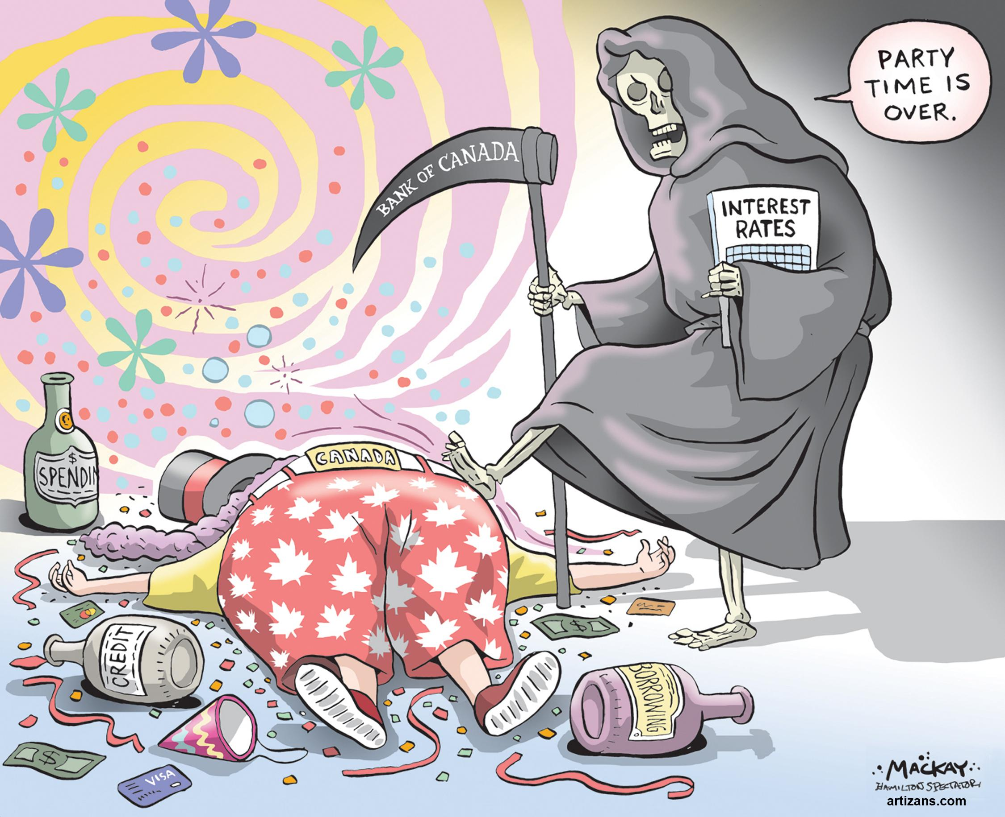

MacKay, G. (Artist). (2017). *Party Time is Over*. [Image of painting]. Hamilton, Ontario; The Hamilton Spectator. Retrieved from <https://i2.wp.com/mackaycartoons.net/wp-content/uploads/2017/07/2017-07-12.jpg?ssl=1>

1. Who is Grim Reaper? Why would the cartoonist select the grim reaper to portray this institution? (2 marks)

< >

1. How is Canada being portrayed in this cartoon? In other words, what is the cartoonist saying about the Canadian government as it relates to the topic? (2 marks)

< >

1. Why is the Grim Reaper declaring the party is over? (2 marks)

< >

1. In terms of the ‘party’ which economic policy is the cartoonist referring to? Why would it be referred to as a party? (2 marks)

< >

1. What is the cartoonist’s point of view regarding this economic policy? What is he (Mackay) trying to say about it? What details in the cartoon reveal this answer? (4 marks)

< >

1. Identify the economic ideology being portrayed in the cartoon. What are the beliefs about the role of government in the economy? (2 marks)

< >

1. To what extent do you agree with the perspective of the cartoonist? Why? (2 marks)

< >

1. Create an accurate title that reflects the essence or meaning of the cartoon as it relates to this economic ideology. (2 marks)

< >



Refer to pages 144-150 and pages 216-221 in your textbook *Perspectives on Ideology.* Consult Moodle Course pages 3.2.7, 3.3.7, 6.1.4 and 6.2.2

**Part Two: Analyze and Apply Economic Theory to a Political Cartoon 20 marks**

In the following cartoon, you will apply **one** of the following economic theorists or politicians and their ideological perspectives as a way to interpret the visual information of the image.

John Maynard Keynes Friedrich Hayek Milton Friedman

Margaret Thatcher Ronald Reagan

Make sure to **describe the theory** and how that theory can both explain the realities of the image and solve the problem presented within it. To guide your response, the man represents an “individual” and the barbel, the “economy”. Additionally consider how the government may choose to, or may choose not to help the man in this image based on the ideological perspective of the individual you are responding to.

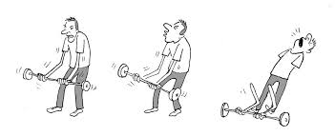

Image Credit: Public Domain

<>

# 

|  |  |  |  |
| --- | --- | --- | --- |
| **Focus** | **Interpretation of Sources**  **8 marks** | **Defense of Position**  **8 marks** | **Communication**  **4 marks** |
| * Quality of the interpretation of each source * Quality of evidence drawn from the sources * Quality of evidence drawn from knowledge of social studies * Understanding of the assigned task | * Quality of argument(s) selected to support the position taken * Quality of evidence selected to support the position taken * Understanding of applicable social studies knowledge and the assigned task | * Organization and coherence * Contribution of stylistic choices to the creation of voice * Vocabulary, sentence construction, grammar, and mechanics |
| **Excellent**  **E** | Interpretations are insightful, comprehensive and address all sources. Evidence is specific and accurate and errors, if present, do not detract from the response. The student demonstrates a thorough and perceptive understanding of applicable social studies knowledge the assigned task. 8 marks | The defense of position is based on one or more convincing, logical arguments. Evidence is specific and accurate, and errors, if present, do not take away from the response. There is a confident and perceptive understanding of appropriate social knowledge and the assigned task. 8 marks | The writing is fluent and effectively organized. Voice is convincing and engaging. Vocabulary is precise. The writing shows a confident control of sentence construction, grammar, and mechanics. Errors, if present, are unimportant. 4 marks |
| **Proficient**  **Pf** | Interpretations are specific and accurate but may not address all sources. Evidence is relevant and appropriate, but may contain some minor factual errors. The student demonstrates a clear understanding of applicable social studies knowledge and the assigned task. 6 marks | The defense of position is based one or more sound arguments. Evidence is appropriate but may contain some minor factual errors. There is a clear understanding of appropriate social knowledge and the assigned task. 6 marks | The writing is straightforward and clearly organized. Voice is distinct. Vocabulary is specific. The writing shows effective control of sentence construction, grammar, and mechanics. Errors do not detract from communication. 3 marks |
| **Satisfactory**  **S** | Interpretations are valid but general and may contain minor conceptions. Interpretations may not address all sources. Evidence is relevant, but general, may be incompletely developed, and/or contain minor errors. The student demonstrates an acceptable understanding of applicable social studies knowledge and the assigned task. 4 marks | The defense of position is based one or more acceptable arguments. Evidence is relevant but general and/or incompletely developed. The evidence may contain errors. There is an acceptable understanding of appropriate social knowledge and the assigned task.4 marks | The writing is generally clear and functionally organized. Voice and vocabulary are adequate. The writing shows basic control of sentence construction, grammar, and mechanics. Errors do not seriously interfere with communication. 2 marks |
| **Limited**  **L** | Interpretations are overgeneralized and may contain substantial misconceptions. Evidence is superficial, may not always be relevant, and may contain significant errors. The student may demonstrate a confused, yet discernable, understanding of applicable social studies knowledge and the assigned task. 2 marks | The defence of position is based on oversimplified arguments and/or questionable logic. Evidence is superficial, may not always be relevant, and may contain large errors. There is a confused, yet visible, understanding of appropriate social knowledge and the assigned task.2 marks | The writing is uneven and incomplete but is somewhat organized. Voice is inappropriate and/or unconvincing. Vocabulary is imprecise and/or inappropriate. The writing shows uncertain control of sentence construction, grammar, and mechanics. Errors reduce communication. 1 mark |
| **Poor**  **P** | Interpretations are mistaken or irrelevant. Evidence, if present, is incomplete and/or marginally relevant and frequently contains significant errors. The student demonstrates minimal understanding of applicable social studies knowledge and the assigned task. 0 | The defence of position is hard to understand, and/or little to no attempt is made to defend it. Evidence, if present, is incomplete and/or barely appropriate with frequent large errors. There is minimal understanding of appropriate social knowledge and the assigned task. 0 | The writing is unclear and disorganized. Voice is unsuitable and/or ineffective. Vocabulary is ineffective and frequently incorrect. There writing shows lack of control of sentence construction, grammar, and mechanics. Errors hurt communication.0. |
| **Zero** | Zero is assigned to a response that fails to meet the minimum requirements of the Poor category. | Zero is assigned to a response that fails to meet the minimum requirements of the Poor category. | Zero is assigned to a response that fails to meet the minimum requirements of the Poor category. |