Name: < >

Social Studies 30-1

**7.1.9 Individual and Collective Rights Assignment**

**Total 30 marks**

In this section, you have considered competing rights around the world, looking at the complex challenges presented to liberal democracies to ensure individual and collective rights are respected in a pluralist society.

In this two-part assignment, you will review some examples of the rejection of liberal principles in **contemporary liberal democracies,** and then complete an interpretation of sources writing assignment.

**Part One: Examples of Illiberalism 10 marks**

Review pages 372 to 404 in your textbook**, *Perspectives on Ideology*.** Describe and identify **five** examples of situations in which our democratic government chose to reject principles of liberalism.

* For **each** example write a brief description of the event, and then
* Identify the specific liberal principle or individual/collective right that was violated. This means specific reference to a Charter right, or PRICES in the right hand column.

|  |  |
| --- | --- |
| **Description of situation** | **Rejected/Violated principle or right** |
|  |  |
|  |  |
|  |  |
|  |  |
|  |  |

**Part Two: Interpretation of Sources 20 marks**

Examine all three sources and complete the assignment below.

|  |
| --- |
| **Source I**  **security**  *Security comes at a cost / Source: CARTOON: Clay Bennett / The Christian Science Monitor* |

**Source II**

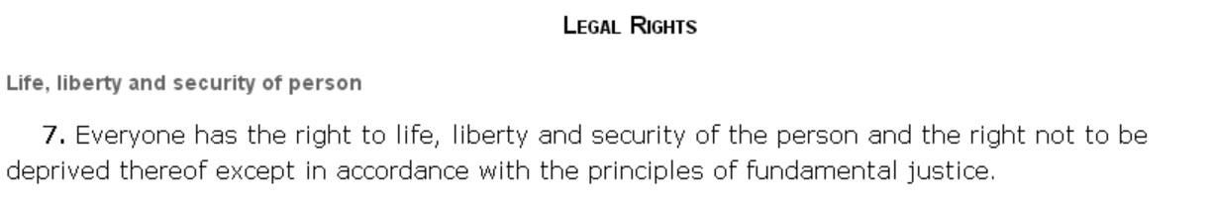

- From *Canadian Charter of Rights and Freedoms*, 1982

**Source III**

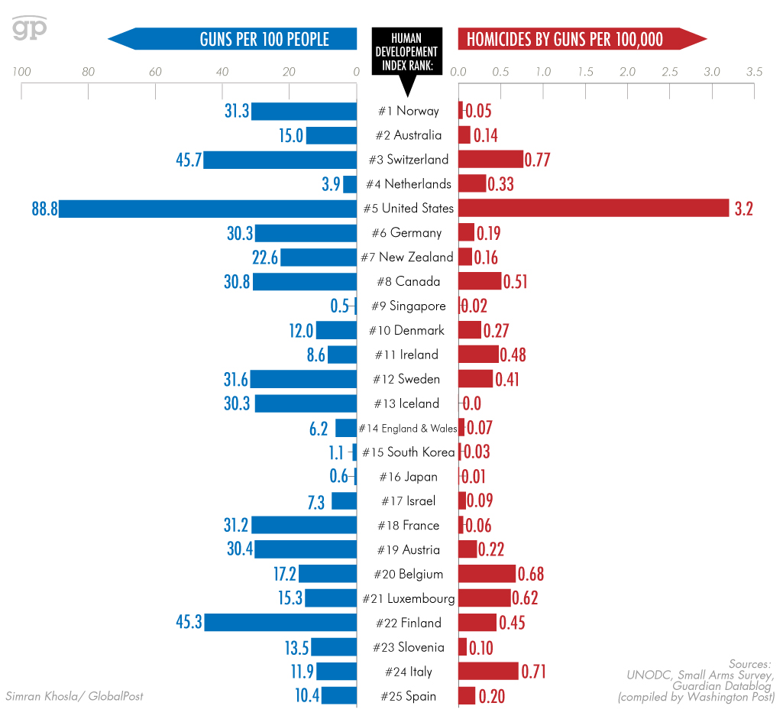

The UNDOC stats as posted in the *Washingon Post* on December 17, 2012

http://www.washingtonpost.com/wp-srv/special/nation/gun-homicides-ownership/table/?noredirect=on

**Assignment**

**Examine each source.**

Write a response in paragraph form in which you;

**interpret** each source to demonstrate your understanding of how each source links to **liberalism**

**AND**

**explain** one or more of the relationships that exist among all **three** sources.

**Reminders for Writing**

* Ensure that each source is thoroughly interpreted, **AND** that
* Each source is clearly and specifically linked to your understanding of liberalism.
* Establish and thoroughly explain at least one overall relationship that exists among all 3 sources.
* Organize your response into a minimum of 4 paragraphs.
* Proofread your response for correct social studies’ vocabulary, spelling and grammar.
* Please review the scoring rubric on the following page before completing your response.



**If you need a more specific planner, please refer to the Course Reference Guide, or contact the lead teacher.**

**Scoring Criteria 20 marks**

This is the same task and rubric used on the midterm, final and diploma exam.

|  |  |  |  |
| --- | --- | --- | --- |
|  | **Interpretation of Sources**  ( 3x 4=12 marks ) | **Relationships**  ( 6 marks ) | **Communicatio**n  ( 2 marks ) |
| **Excellent**  **E** | Interpretation of the source is sophisticated, insightful, and precise, demonstrating a perceptive understanding of links to liberalism.  4 | The explanation of relationship(s) is perceptive and thorough.  6 | Vocabulary is precise and deliberately chosen. Sentence structure is controlled and sophisticated. The writing demonstrates skillful control of mechanics and grammar and is judiciously organized.  2 |
| **Proficient**  **Pf** | Interpretation of the source is logical, specific, and adept, demonstrating a sound understanding of links to liberalism.  3.2 | The explanation of relationship(s) is capable and purposeful.  4.8 | Vocabulary is appropriate and specific. Sentence structure is controlled and effective. The writing demonstrates capable control of mechanics and grammar and is purposely organized  1.6 |
| **Satisfactory**  **S** | Interpretation of the source is adequate, straightforward, and conventional, demonstrating a generalized understanding of links to liberalism.  2.4 | The explanation of relationship(s) is adequate and straightforward.  3.6 | Vocabulary is conventional and generalized. Sentence structure is controlled and straightforward. The writing demonstrates basic control of mechanics and grammar and is adequately organized.  1.2 |
| **Limited**  **L** | Interpretation of the source is incomplete, vague, and simplistic, demonstrating a confused understanding of links to liberalism.  1.6 | The explanation of relationship(s) is superficial, incomplete, redundant, and of questionable accuracy.  2.4 | Vocabulary is imprecise, simplistic, and inappropriate. Sentence structure is awkward. The writing demonstrates a faltering control of mechanics and grammar and is ineffectively organized.  .8 |
| **Poor**  **P** | Interpretation of the source is scant, inaccurate, and irrelevant, demonstrating little or no understanding of links to liberalism.  .8 | The explanation of relationship(s) is scant, illogical, and tangential.  1.2 | Vocabulary is overgeneralized and inaccurate. Sentence structure is uncontrolled. The writing demonstrates a profound lack of control of mechanics and grammar and is haphazardly organized.  .4 |
| **ZERO** | Zero is assigned to a response that fails to meet the minimum requirements of Poor | | |

**Include Typed Response Below.** (Save as **yourname7.1.9_rights**)

< >