TITLE:

Enter text into the fields below.
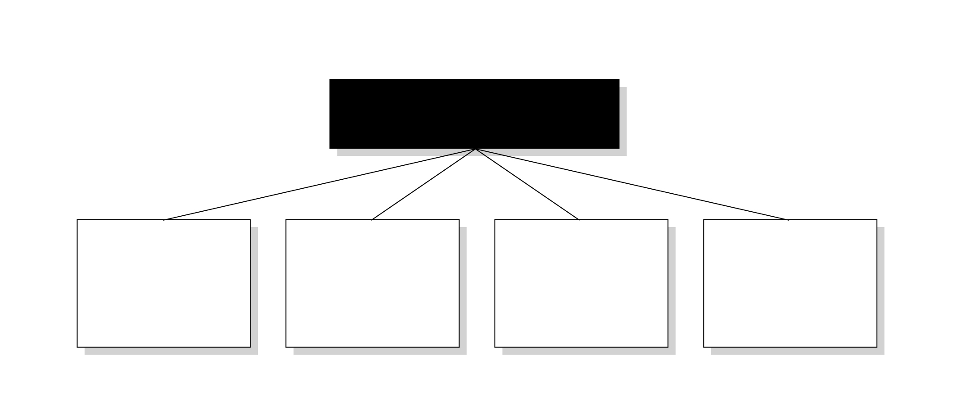
Text…

Text…

Text…

Text…

Text…

