Name: Date:

**Unit 1**

1-1: Using Scale on a map

Download, save, and complete the Using Scale on a Map activity. It is highly recommended that you print the map to measure the distances.

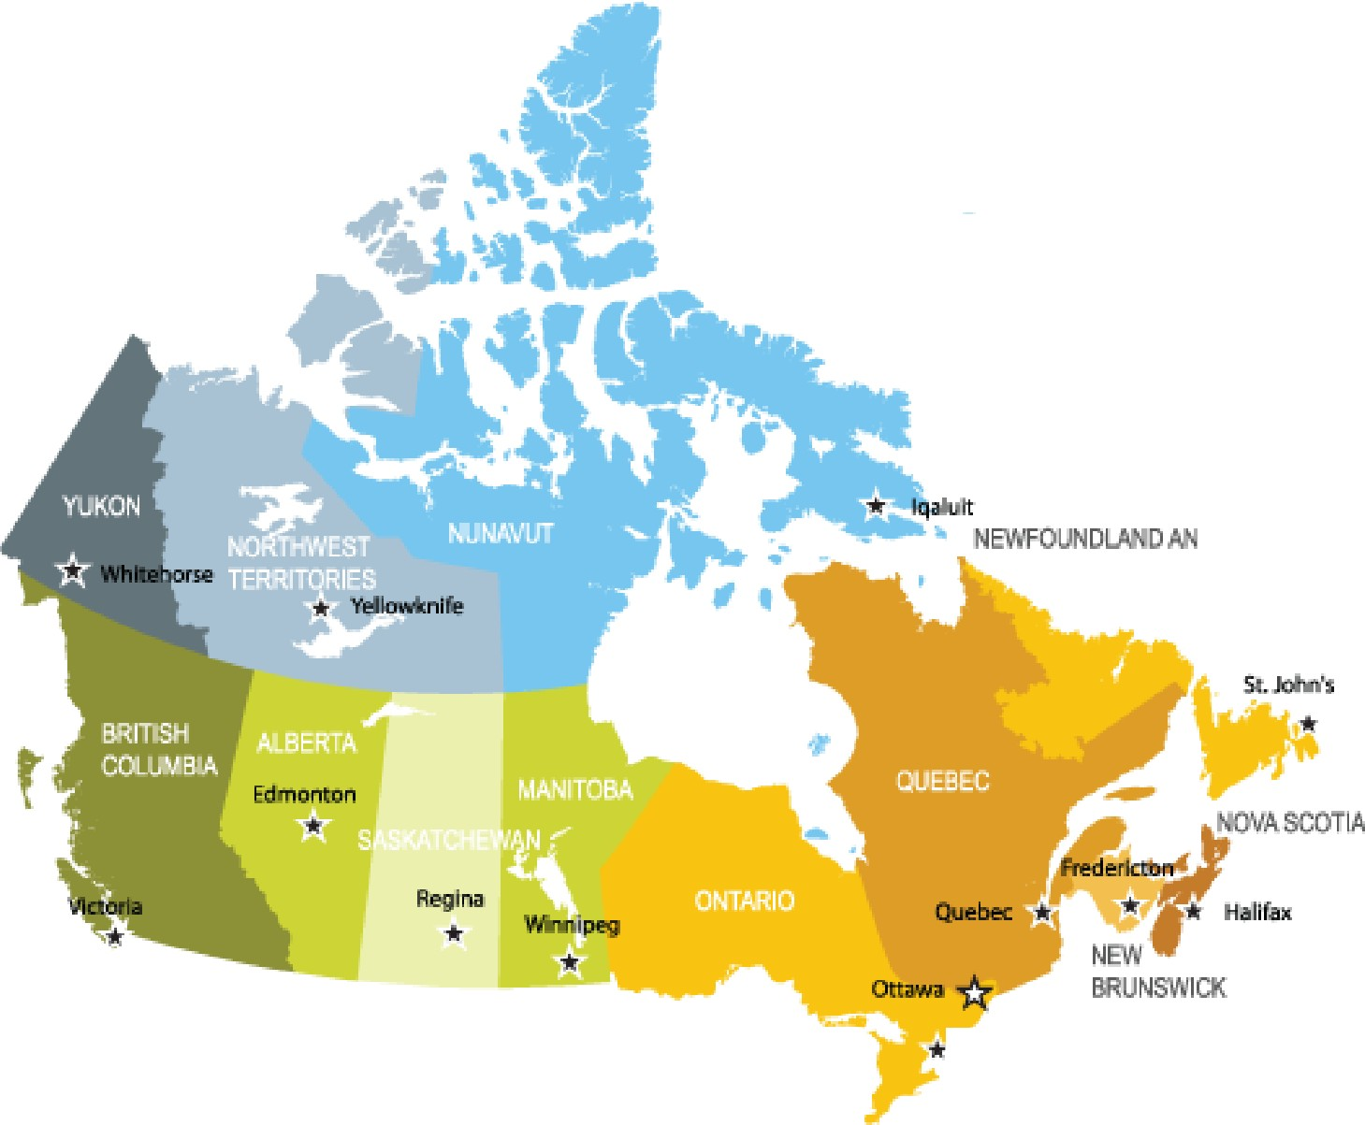

Canada

DLABRAOOR

0 400 800

I I I

kilometres

**Make a paper scale. Then, answer the questions below.**

a) The distance between Ottawa and Quebec is about how many km? (/1 mark)

|  |
| --- |
|  |

b) The distance between Edmonton and Regina is about how many km? (/1 mark)

|  |
| --- |
|  |

c) The distance between Whitehorse and Yellowknife is about how many km? (/1 mark)

|  |
| --- |
|  |

d) The distance between Ottawa and Winnipeg is about how many km? (/1 mark)

|  |
| --- |
|  |

e) Choose two cities and list their names below. What is the approximate distance between these two cities in km? (/1 mark)

|  |
| --- |
|  |

f) What is the scale used on the map? (/1 mark)

|  |
| --- |
|  |

**Overall Total: /6 marks**



**Save Your File**

Name your file in this format: jsmithss5_1-1-scale and save your file to your Unit 1 Notebook folder.