Unit 2 Name:

Date:

2-2: Section 1: Map of the Atlantic Region

On the map of the Atlantic region below, mark each of the following places.

* The Provinces:

1. Newfoundland and Labrador, New Brunswick, Nova Scotia, Prince Edward Island (/5 marks)

* Capitals of the Provinces:

1. Charlottetown, PEI (46° N, 63° W); St. John’s, NL (47° N, 52° W); Halifax, NS (44° N, 64° W); Fredericton, NB (46° N, 67° W) (/4 marks)

* Important Physical Features of the Region:

1. Atlantic Ocean, Grand Banks (Latitude 44° N, Longitude: 50° W), Bay of Fundy, Appalachian Mountains, Cape Breton Island, Bras d’Or Lake, St. John River (NB), Cabot Strait (NL), Gulf of St. Lawrence (/9 marks)

* Important Places which Show the Effect of Humans on the Landscape:

1. Confederation Bridge (46° N, 63° W), Muskrat Falls Labrador Power Station (53° N, 60° W), Halifax Port (/3 marks)

You may use an atlas or online map as a reference, or you may use the coordinates of latitude and longitude provided to mark each location.

Use insert textbox to add a location to the map. On a PDF file, add comment. Or, print the map, label by hand, scan and upload to the submission folder.

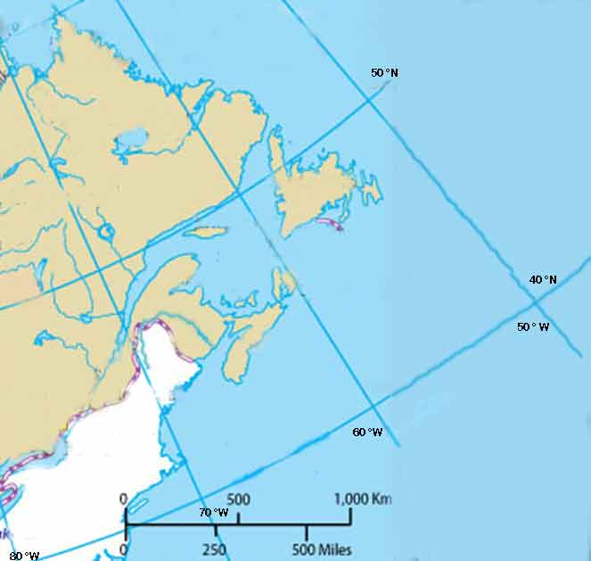

**Total of Section 1: /21 marks**

Section 2: Relative and Absolute Location Questions

1. What is the relative location of the Atlantic region compared to the United States? (/1 mark)

|  |
| --- |
|  |

1. What is the relative location of the Atlantic region compared to the rest of Canada? (/1 mark)

|  |
| --- |
|  |

1. Use the latitude and longitude list below to find these places on the world map.
2. Use the letter code next to each to mark them on the map.
3. Use insert textbox to add a location to the map. On a PDF file, add comment.
4. If you completed this on paper, then you will need to scan a copy of your map onto your computer.

**Name of Place Latitude and Longitude**

G Grand Banks, Newfoundland 44° N, 50° W

PR Port Royal National Historic Site, Nova Scotia 45° N, 66° W

S Madrid Spain:40° N, 4° W

L London, England: 51° N, 1° W

P Paris, France: 49° N, 2° E

N New Orleans, Louisiana: 30° N, 90° W

J Tokyo, Japan: 36° N, 140° E

R Moscow, Russia: 56° N, 38° E

(/8 marks)

Answer these questions. You may do the math from the coordinates or you may use the Google search tool.

1. How far would ships have to travel from Grand Banks to Spain? (/1 mark)

|  |
| --- |
|  |

How far would ships have to travel from Grand Banks to England? (/1 mark)

|  |
| --- |
|  |

How far would ships have to travel from Grand Banks to Japan? (/1 mark)

|  |
| --- |
|  |

How far would ships have to travel from Grand Banks to Russia? (/1 mark)

|  |
| --- |
|  |

Consider the US/Canada population exchange. How far did the Acadians have to move from Historic Port Royal, Nova Scotia to New Orleans, Lousiana (or vice versa – the American Loyalists to move to Nova Scotia)? (/1 mark)

|  |
| --- |
|  |

How far did the Acadians have to travel from Historic Port Royal, Nova Scotia to France? (/1 mark)

|  |
| --- |
|  |

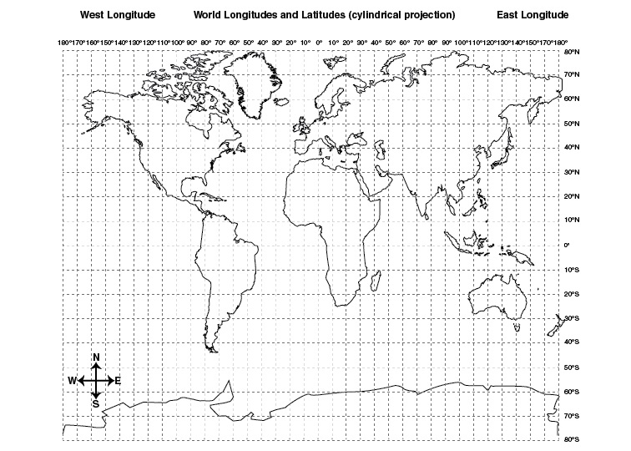

**Total of Section 2: /16 marks**

**Overall Total: /37 marks**



**Save Your File**

Name your file in this format: jsmithss5_2-2-map and save your file to your Notebook Folder