Unit 2 Name:

Date:

2-3: Choice Board Unit 2

Complete the items of your choice below that add up to 10 Points.

|  |  |  |
| --- | --- | --- |
| **1 Point – Definition**  What is the difference between climate and weather?  /1 mark | **3 Points – Cartoon**  Make three-strip cartoon or comic showing how the way of life changed over time for one people group based **use of or conservation of natural resources**: Natives such as Beothuks and the impact cod fishing and settlement had on them; or English settlers, cod fishermen when cod fishing collapsed or coal miners; or French Acadian farmers who were resettled; other.  /10 marks | **2 Points – Venn Diagram**  Make a venn diagram showing five similarities and differences between two people groups for example the Acadians and English or English and Beothuks.  /5 marks |
| **2 Points – Time Zones**  Explain why there a half hour time difference between Newfoundland and the  Atlantic Time Zone when there is a full  hour difference between other adjacent time zones.  /2 marks | **3 Points – Explanation**  Explain how natural resources and the physical geography of the Atlantic Region determine where communities are built.  /3 marks | **2 Points – Map**  Draw the two main ocean currents that affect the climate of the Atlantic region. You can use the blank Canada map you downloaded in Unit 1 or the map below. Explain how the climate affects people’s lives.  /3 marks |
| **3 Points – Research**  Research a Newfoundland or Labrador rescue dog or Sable Island or other famous horse. Write a very short biography or story about the dog or horse. Include information about a landform or weather that played a role in the story.  /10 marks | **5 Points – Letter or Diary Entry**  Imagine you belong to one of the founding Canadian people groups (Native, English, or French Acadian).  All decisions have consequences. What decision have you made? For example, did you decided to leave your home country and travel across the ocean? Did you decide to settle in Acadia? Did you decide to use the tools the fishermen left behind during the winter when they returned to Europe in Newfoundland? What happened as a result? Describe how life is for you now. As you wonder whether or not you have made the right decision(s), discuss the consequences of your choices.  /10 marks | **3 Points – Research**  Identify two natural resources. Explain how they were/are used, and how they are being conserved in the Atlantic region.  /6 marks |

|  |
| --- |
|  |

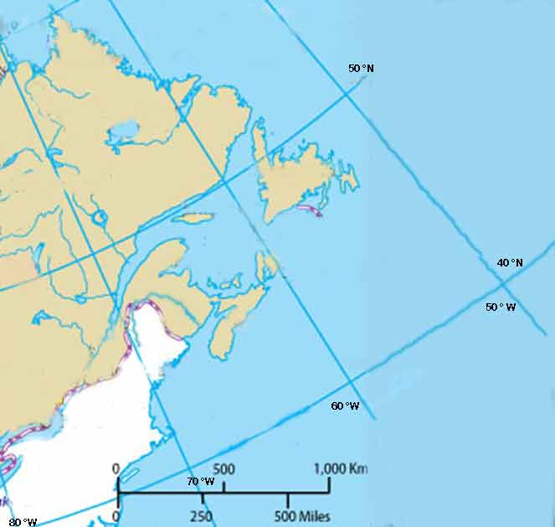

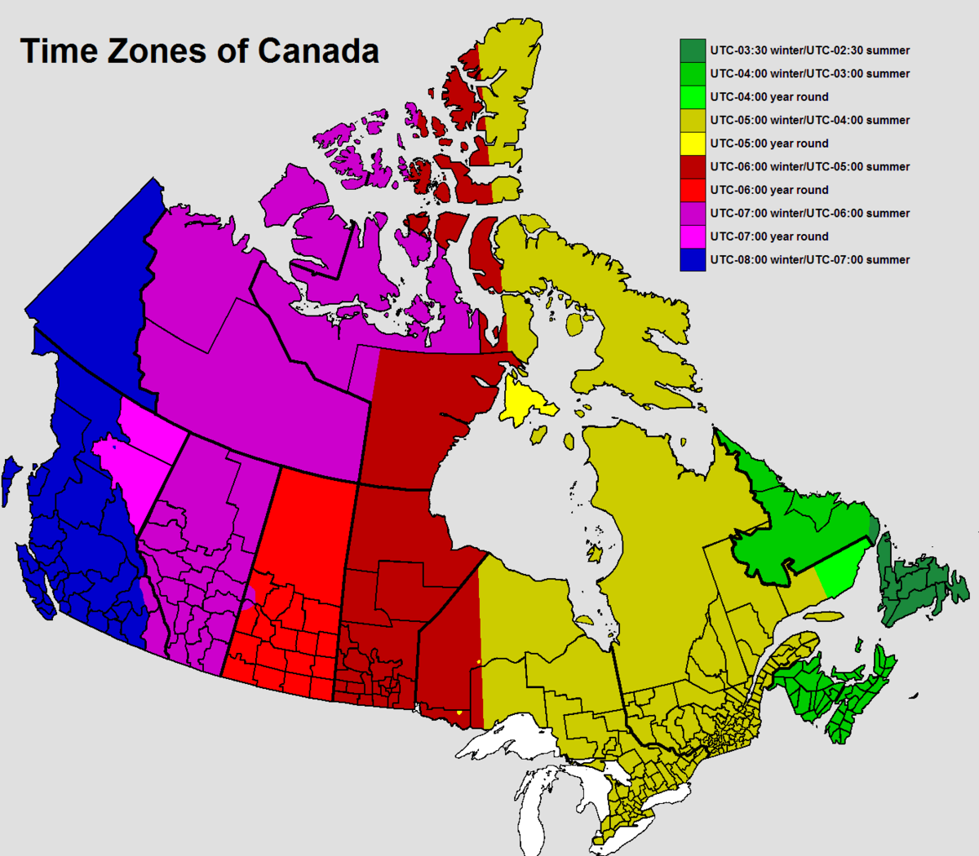

|  |
| --- |
| Written Response (Story/Explanation/Letter/Diary/Cartoon) Atlantic Region Rubric |

|  |  |  |  |  |  |
| --- | --- | --- | --- | --- | --- |
| Criteria | Excellent  5 | | Proficient  4 | Satisfactory  3 | Limited  2 |
| **Content /5** | * I developed *insightful* ideas with *perceptive* information about landforms, natural resources, climate and people and/or animals. * I used *precise* details. | | * I developed *thoughtful* ideas with *reasonable* information about landforms, natural resources, climate and people and/or animals. * I used *logical* details. | * I developed *appropriate* ideas with *basic* information about landforms, natural resources, climate and people and/or animals. * I used *general* details. | * I *underdeveloped superficial* ideas with *limited* information about landforms, natural resources, climate and people and/or animals. * I used *vague* details. |
| **Presentation /5** | * I communicated *effectively* and *accurately*. | | * I communicated *thoughtfully* with *few* errors. | * I communicated *clearly* with *some* errors. | * I communicated *ineffectively* with *many* errors. |
| **Insufficient** | Your attempt to respond is *insufficient*. **Contact your teacher** to discuss suggestions for improvement. | | | | |
| **Total: /10** | | | | | |
| **Assessment** | | **Areas of Strength:** | | | |
| **Target for Improvement:** | | | |

**Overall Total: /? Will depend on student choice**



**Save Your File**

Name your file in this format: jsmithss5_2-3-choiceboard and save your file to your Notebook Folder