Unit 3 Name:

Date:

3-2: Map of the Great Lakes-St. Lawrence Lowlands Region

On the map of the Great Lakes-St. Lawrence Lowlands region below, mark each of the following places.

* The Provinces:

1. Quebec and Ontario (/2 marks)

* Capitals of the Provinces:

1. Toronto, Ontario; Ottawa, Ontario (capital of Canada); Quebec City, Quebec; include Montreal, Quebec which is not a capital, but an important city. Larger cities have larger dots on the map. Show how large these four cities are with the size of the dots on the map. (/4 marks)

* Important Physical Features of the Region:

1. Niagara Falls, Niagara Escarpment (bottom of a cliff which shows two different types of land), Lake Huron, Lake Ontario, Lake Michigan, Lake Erie, Lake Superior, Long Point Beach (/8 marks)

* Important Places which Show the Effect of Humans on the Landscape:

St. Lawrence Seaway; Port of Montreal; Detroit-Windsor Tunnel (/3 marks)

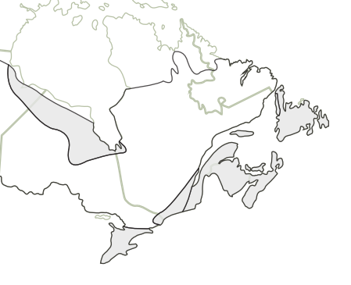

**Total of Section 1: /16 marks**

Section 2: Upper and Lower Canada

1. On the map below identify the Plains of Abraham, L’Anse-au-Foulon cliff, Quebec (3 miles away), the St. Lawrence River, Montcalm and his First Nations allies. Identify Wolf and his First Nations allies. Identify the American colonists. Insert textboxes on the image. Ensure your font is readable. (/6 marks)

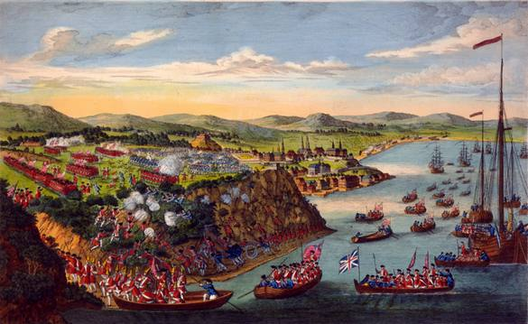

This 1797 engraving is based on a sketch made by Hervey Smyth, General Wolfe's aide-de-camp during the siege of Quebec. A view of the taking of Quebec, 13th September 1759. Image via Wikicommons.

1. 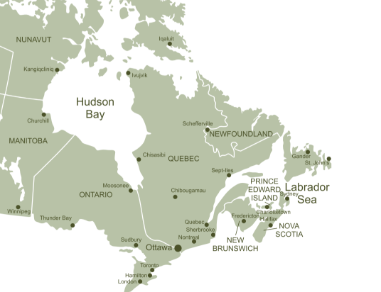Circle Upper and Lower Canada on the map below. Insert textboxes, to label them on the image. Ensure your font is readable. (/2 marks)
2. How did the Royal Proclamation in 1763 by King George III affect North America? (Hint: It limited something.) (/2 marks)

|  |
| --- |
|  |

1. How did the Quebec Act of 1774 by King George III affect North America? (/2 marks)

|  |
| --- |
|  |

1. Why might historical documents like these documents, drawings and maps be important? (/2 marks)

|  |
| --- |
|  |

**Total of Section 2: /14 marks**

**Overall Total: /30 marks**



**Save Your File**

Name your file in this format: jsmithss5_3-2-map and save your file to your Notebook Folder