Unit 3 Name:

Date:

3-3: Choice Board Unit 3

Complete the items of your choice below that add up to 10 Points.

|  |  |  |
| --- | --- | --- |
| **2 Points – Poster**  Construct a poster in which you name the explorers who mapped and settled the Great Lakes-St. Lawrence region and show what challenges they faced because of geography.  /3 marks | **3 Points -- Opinion**  Imagine you are a French citizen who has the opportunity to speak to King Louis XV (15) or later, Napoleon. Will you recommend giving up the Canadian colony of Quebec? Why or why not? Provide three reasons for your response.  (/4 marks) | **2 Points –Pie Graph**  Construct a pie graph showing Canadian industries (primary, secondary, tertiary, quaternary, quinary). What does this show about Canadian wealth?  **How to make a pie chart.** A pie chart shows how a whole is cut up into parts. There are 360 degrees in a circle.  Draw a circle using a compass. Put a dot exactly in the middle of the circle. Draw a straight line from the middle (radius).  If you know that a primary industry is 30 percent of the whole (or 0.30), then you're calculating 30% of 360 which is 108.  Place your protractor on the circle. Align the 0 with your radius (straight line). Find the number you are looking for such as 108. Draw a straight line at 108. This “piece of pie” represents a primary industry of 30%. Draw each section division. Colour each segment. Label your graph.  Check your work. Add up the number of degrees you calculated for each data point. They should add up to 100%.  <https://www.mathsisfun.com/data/pie-charts.html>  <http://www.wikihow.com/Make-a-Pie-Chart-in-Excel>  /6 marks |
| **2 Points – Explanation**  Discuss the Seven Years war. Which groups were fighting? Why? What happened in the end? Why did France give up Quebec, Acadia, and Lousiana?  /10 marks | **4 Points – Immigration Restaurant Menu**  Construct a Menu showing an immigrant people group. The menu will have three sections.   1. The Appetizer section will be a map showing the route the immigrant traveled to come to Canada. 2. The Main Course section will be about the way of life of this immigrant group in the region. 3. The Dessert section will be about how this immigrant group contributed to Canada.   /10 marks | **4 Points – Letter to a Friend**  You and your family are French Canadiens, British colonists, or Black Loyalists. You have been living in New France or Upper Canada for more than a year now.  You receive a letter from your best friend in either England, France, or a slave state in America stating that he or she is coming to Canada.  You wish to provide information to your friend about what living in Upper or Lower Canada is like.  In New France discuss   * the Seigneury system * habitants * missionaries * Grey Nuns * courier de bois or voyageurs * farming * food   You may use this website for more information: [http://teacherweb.com](http://teacherweb.com/ON/LakeheadUniversity/NewFranceWQ/index.html)  /ON/LakeheadUniversity.html  /NewFranceWQ/index  Or, in Upper Canada discuss   * food * farming * immigration centre at Montreal or a US border crossing * weather * the journey to arrive * laws (such as how you will be treated when you arrive)   You may use Susanna Moodie’s writing as a reference.  Use friendly letter format. You can identify this format in the course under Friendly Letter Format Writing Skills or on  <http://www.readwritethink.org>  /classroom-resources/student-interactives/letter-generator-30005.html  /10 marks |
| **2 Points - Explanation**  Explain how natural resources and the physical geography of the Great Lakes-St. Lawrence Lowlands Region determined where communities would be built.  (/3 marks) | **3 Points – Explanation**  What was the Royal Proclamation. Explain its effects. For example, why did it become an important document for Native people?  (/3 marks) | **3 Points – Identification and Application**  Explain what each type of industry does and give examples of one job for each of the five major types of industries – primary, secondary, tertiary, quaternary, and quinary. Identify one industry that has changed or developed in the Great Lakes region.  /11 marks |

|  |
| --- |
| Written Response (Opinion/Menu/Letter/Explanation) Great Lakes-St. Lawrence Lowlands Region Rubric |

|  |  |  |  |  |  |
| --- | --- | --- | --- | --- | --- |
| Criteria | Excellent  5 | | Proficient  4 | Satisfactory  3 | Limited  2 |
| **Content /5** | * I developed *insightful* ideas with *perceptive* information about landforms, natural resources, climate and people and history. * I used *precise* details. | | * I developed *thoughtful* ideas with *reasonable* information about landforms, natural resources, climate and people and history * I used *logical* details. | * I developed *appropriate* ideas with *basic* information about landforms, natural resources, climate and people and history. * I used *general* details. | * I *underdeveloped superficial* ideas with *limited* information about landforms, natural resources, climate and people and history. * I used *vague* details. |
| **Presentation /5** | * I communicated *effectively* and *accurately*. | | * I communicated *thoughtfully* with *few* errors. | * I communicated *clearly* with *some* errors. | * I communicated *ineffectively* with *many* errors. |
| **Insufficient** | Your attempt to respond is *insufficient*. **Contact your teacher** to discuss suggestions for improvement. | | | | |
| **Total: /10** | | | | | |
| **Assessment** | | **Areas of Strength:** | | | |
| **Target for Improvement:** | | | |

**Sample Menu**

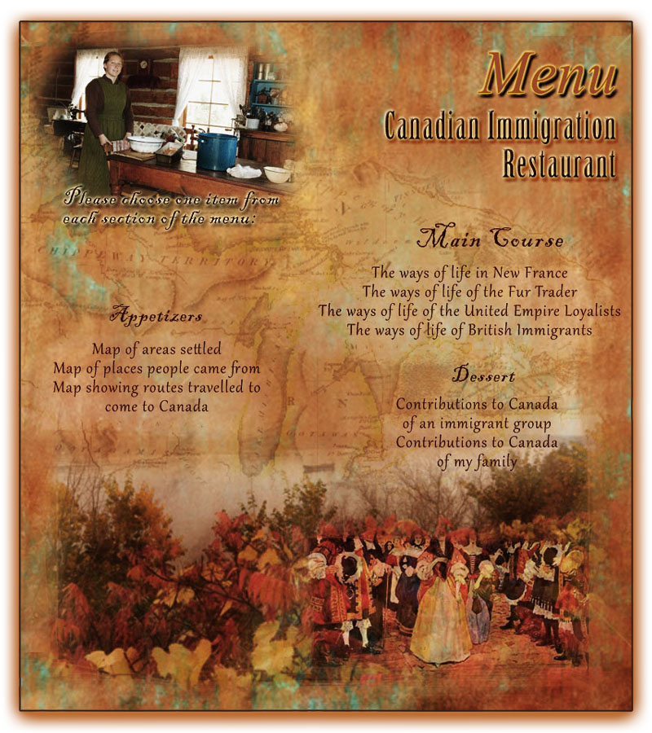

|  |
| --- |
|  |

**Overall Total: /? Will depend on student choice**



**Save Your File**

Name your file in this format: jsmithss5_3-3-choiceboard and save your file to your Notebook Folder