Unit 4 Name:

Date:

4-1: Section 1: Map of the Canadian Shield Region

On the map of the Canadian Shield region below, mark each of the following places.

* The Provinces and Territories:

1. Quebec, Ontario, Manitoba, Saskatchewan, Alberta, Labrador, North West Territories, Nunavut (/8 marks)

* Capitals of the Provinces and Canada:

1. Toronto, Ontario; Ottawa, Ontario (capital of Canada); Quebec City, Quebec; Winnipeg, Manitoba; Regina, Saskatchewan; Edmonton, Alberta; Yellowknife, NWT; St. Johns, NLD; Iqaluit, Nunavut (/9 marks)

* Important Physical Features of the Region:

1. Hudson Bay, Lake Athabasca, Great Slave Lake, Great Bear Lake (/4 marks)

* Important Places which Show the Effect of Humans on the Landscape:

Sudbury, Ontario mines, Red River Floodway (/2 marks)

Use Insert textbox in Word to add these locations to the map. Use Add comment to add text to the PDF. Or, print, write on the map, scan and upload to the submission folder.

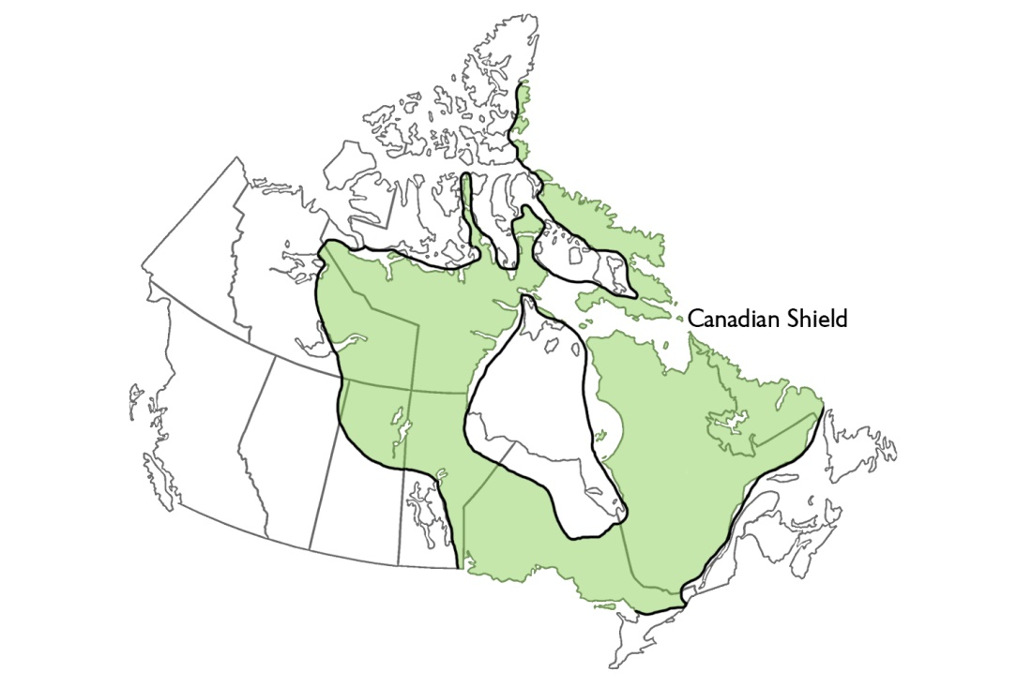

**Total of Section 1: /23 marks**

Section 2: Map of Fur Trade Routes

1. What was the Western Canadian Shield area called? (/1 mark)

|  |
| --- |
|  |

1. Which company had the right to use the land in the Western area of the Canadian shield? (/1 mark)

|  |
| --- |
|  |

**Total of Section 2: /2 marks**

**Overall Total: /25 marks**



**Save Your File**

Name your file in this format: jsmithss5_4-1-map and save your file to your Notebook Folder