|  |  |  |  |
| --- | --- | --- | --- |
| |  |  | | --- | --- | | **Unit 4** | Name: Date: | |  |

**The Canadian Shield Today**

Inquiry

**Focus on this question:**

1 What is life like today in the Canadian Shield?

Resources for Inquiry

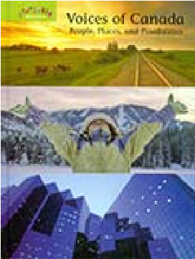TextbookLibrary Books

* Pages 115 to 117 *Shields,* pages 26 and 27

Websites

Access the website links fro the online course.

* **Canadian Shield**

Use the **Shield Today Web** on the following page to keep note of information you find as you complete your inquiry.

Shield Today Web

The Shield Today

What jobs do people have?

Are they connected to

resources?

Are the rivers/bodies of

water connected to

settlements?

What other resources are

connected to settlements?