Unit 5 Name:

Date:

5-1: Section 1: Map of the Interior Plains Region

On the map of the Interior Plains region below, mark each of the following places. You will need a legend.

* The Provinces and Territories:

1. Manitoba, Saskatchewan, Alberta, Yukon, and North West Territories, (/5 marks)

* Capitals of the appropriate Provinces:

1. Winnipeg, Manitoba; Regina, Saskatchewan; Edmonton, Alberta; Whitehorse, Yukon; Yellowknife, NWT along with other important cities, Saskatoon, Calgary, Lethbridge (/8 marks)

* Important Physical Features of the Region:

1. Banff National Park, Jasper National Park, Lake Winnipeg, Lake Manitoba, Great Slave Lake, Lake Athabasca, Peace River, Athabasca River, North and South Saskatchewan Rivers, Red Deer River, Bow River, Battle River, Dinosaur Provincial Park (/14 marks)

* Important Places which Show the Effect of Humans on the Landscape:

Red River Floodway, Fort McMurray Oil Sands, Fort Saskatchewan, Alberta and Estevan, Saskatchewan Boundary Dam Carbon Capture sites (/4 marks)

Use Insert textbox in Word to add these locations to the map. Use Add comment to add text to the PDF. Or, print, write on the map, scan and upload to the submission folder.

1. What is the latitude of the border between Canada and the United States? (/1 mark)

|  |
| --- |
|  |

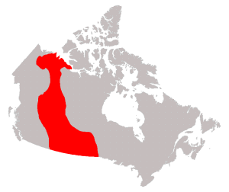

**Overall Total: /32 marks**



**Save Your File**

Name your file in this format: jsmithss5_5-1-map and save your file to your Notebook Folder