Unit 5 Name:

Date:

6-1: Section 1: Map of the Cordillera Region

On the map of the Cordillera region below, mark each of the following places. You will need a legend.

* The Provinces and Territories:

1. British Columbia, and the Yukon (/2 marks)

* Capitals of the appropriate Provinces:

1. Victoria, British Columbia; Whitehorse, Yukon; along with other important cities Vancouver, Kelowna, Penticton, and Dawson City (/6 marks)

* Important Physical Features of the Region:

1. Pacific Ocean, Rocky Mountains, Vancouver Island, Haida Gwaii, English Bay, Mount Robson, Mount Logan, Fraser River, Columbia River, Howe Sound (fjord), Great Bear Rainforest (/11 marks)

* Important Places which Show the Effect of Humans on the Landscape:

Trans-Canada Highway (/1 marks)

Use Insert textbox in Word to add these locations to the map. Use Add comment to add text to the PDF. Or, print, write on the map, scan and upload to the submission folder.

1. What is the latitude of the border between Canada and the United States? (/1 mark)

|  |
| --- |
|  |

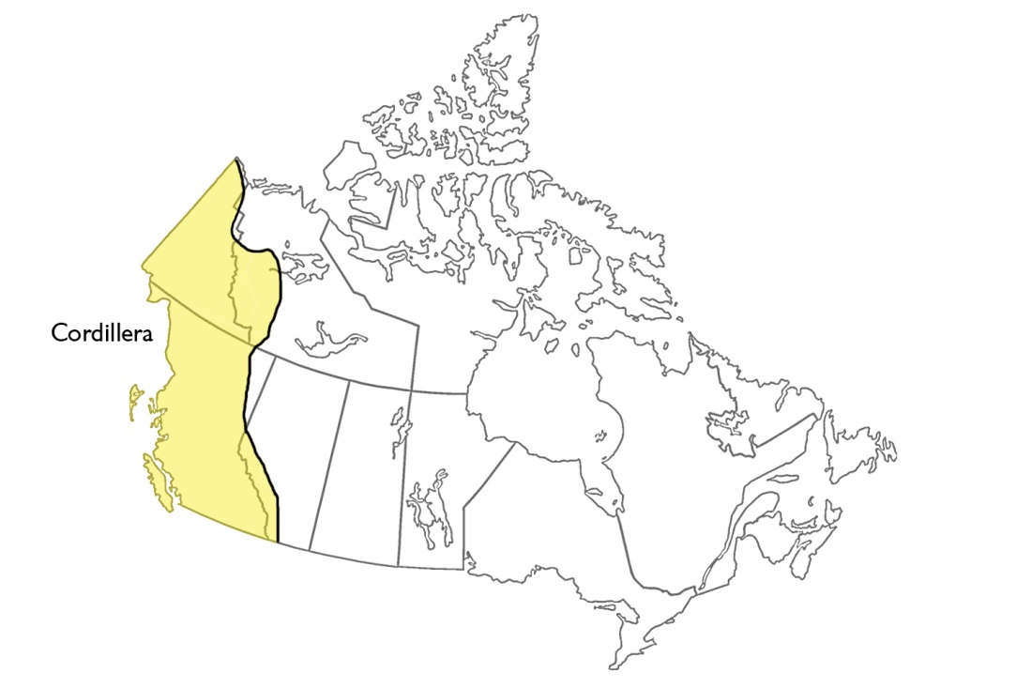

**Overall Total: /21 marks**



**Save Your File**

Name your file in this format: jsmithss5_6-1-map and save your file to your Notebook Folder