Unit 6 Name:

Date:

6-2: Section 1: Cordillera Region Tourism

**Inquiry**

A family in China has contacted you about a vacation in the Cordillera region. They have seen pictures of British Columbia, and they want to see the various types of geography in the region.

You are to set up an itinerary (a plan of where to go) that will include at least one stop, in any order, in each of these places in the Cordillera. (Note: one stop may include multiple landforms or industries such as mountains and mining).

* an island on the Pacific ocean
* the mountains
* the rainforest
* a logging area
* an orchard
* a fishery
* a mining area
* aluminum smelter in Kitimat
* a service industry location such as the film industry
* a knowledge industry location (consider cell phones, Okanagan aerospace, defense, or Whitewater West in Okanagan which builds fibreglass waterslides)

The family’s plane will land in Vancouver, and they will rent a car for their vacation.

They will leave from Vancouver to return home, so their trip should start and end there.

Use the **Template** below.

Criteria

1. Include nine photographs or drawings depicting different Cordillera physical features, natural resources, and climate. Provide a caption or title for each picture.
2. Use image(s) from the Cordillera region of Canada.
3. As a travel agent, you must include the following in your response to the family:

The itinerary: Include the name of each place the family will visit and the kind of geography they will see at each stop.

* + physical features (landforms, bodies of water, etc.) and how the feature affects the people
  + the climate of the area and how it affects the people
  + natural resources of the area and how they affect the people
  + consider types of industries

A map of the region: Include a line on the map to show the family the order in which they will visit the places you choose and where each stop will be. Be sure you plan the trip in such a way that the family does not waste time in unnecessary driving. Also, remember that the beginning and end of the trip is Vancouver.

|  |
| --- |
| Cordillera Region Rubric |

|  |  |  |  |  |  |
| --- | --- | --- | --- | --- | --- |
| Criteria | Excellent  5 | | Proficient  4 | Satisfactory  3 | Limited  2 |
| **Content /5** | * I had *insightful* ideas about how Cordillera climate, landforms, and natural resources affect people. * I used *precise* details to demonstrate *comprehensive* knowledge of the Cordillera region. | | * I had *thoughtful* ideas about how Cordillera climate, landforms, and natural resources affect people. * I used *logical* details to demonstrate *reasonable* knowledge of the Cordillera region. | * I had *appropriate* ideas about how Cordillera climate, landforms, and natural resources affect people. * I used *general* details to demonstrate *basic* knowledge of the Cordillera region. | * I had *underdeveloped* ideas about how Cordillera climate, landforms, and natural resources affect people. * I used *vague* details to demonstrate *limited* knowledge of the Cordillera region. |
| **Presentation /5** | * I communicated *effectively* using *compelling* image(s). * I communicated *accurately* using *precise* words. | | * I communicated *thoughtfully* using *relevant* image(s). * I communicated *reasonably* using *logical* words. | * I communicated *simply* using *appropriate* image(s). * I communicated *clearly* using *general* words. | * I communicated *ineffectively* using *irrelevant* image(s). * I communicated un*clearly* using *vague* words. |
| **Insufficient** | Your attempt to respond is *insufficient*. **Contact your teacher** to discuss suggestions for improvement. | | | | |
| **Total: /10** | | | | | |
| **Assessment** | | **Areas of Strength:** | | | |
| **Target for Improvement:** | | | |

Template

|  |
| --- |
| Cordillera Travel Guide |
|  |

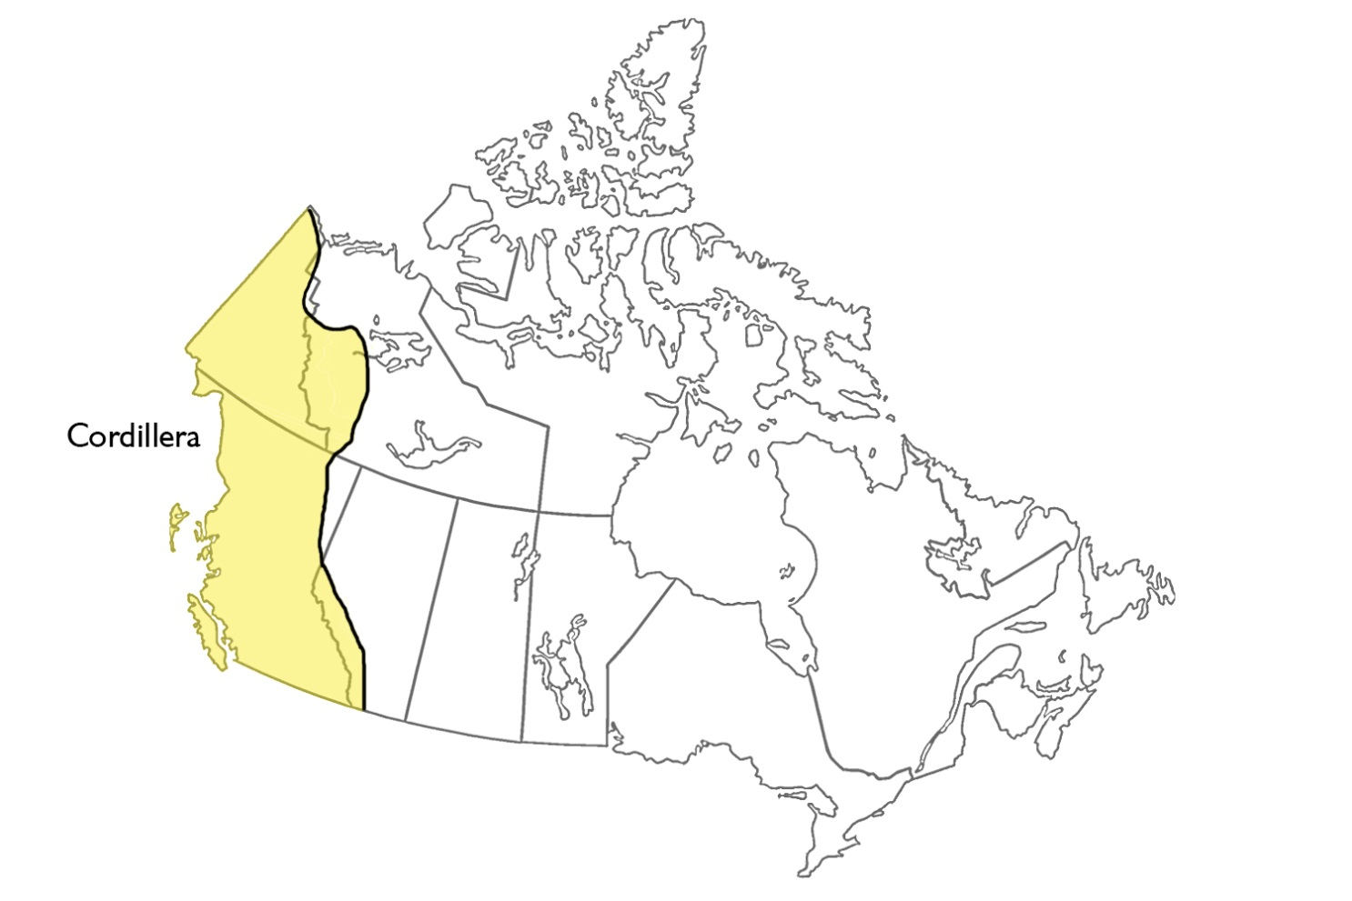

Total: /10 marks



**Save Your File**

Name your file in this format: jsmithss5_6-2-itinerary and save your file to your Notebook Folder.