Name: Date:
Unit 7

Inquiry: The Arctic Region

First Inhabitants Mind Map


Inquiry

Focus on this question:
1 How has technology changed Northern Canadian quality of life?

Resources for Inquiry

Textbook
- Page 131, chart

Instructions

- Reread and study the chart on p. 131 of the textbook Voices of Canada about understanding historical photographs at the bottom of page.

- At the bottom of this Assignment page, look at the photographs from Wikicommons.

- Select four photographs of past and present (two from either food, transportation, or housing categories) to examine.

- Answer the questions about four photographs on the Historical Photographs on the following page.

Housing

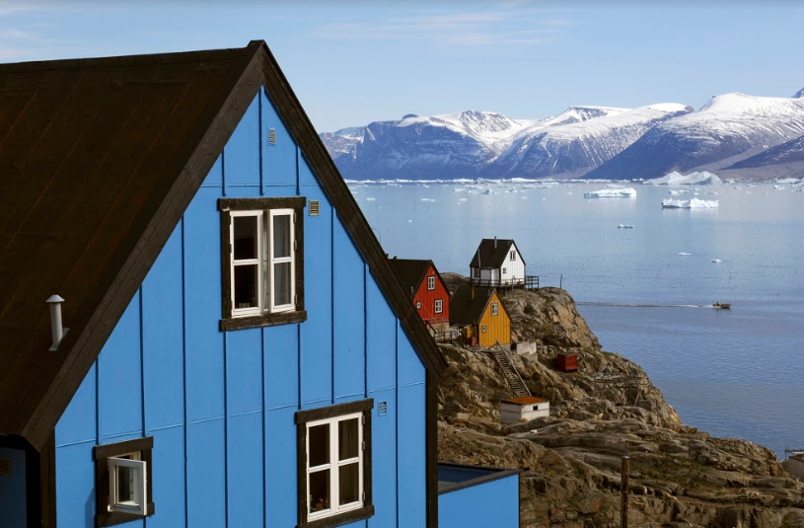  Iqaluit, homes | 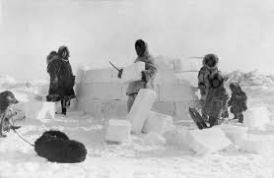  Igloo, 1924
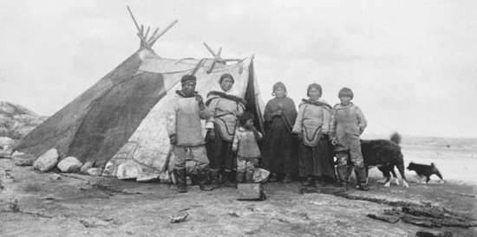  Tupic, Fort Chimo, Que. 1896 | 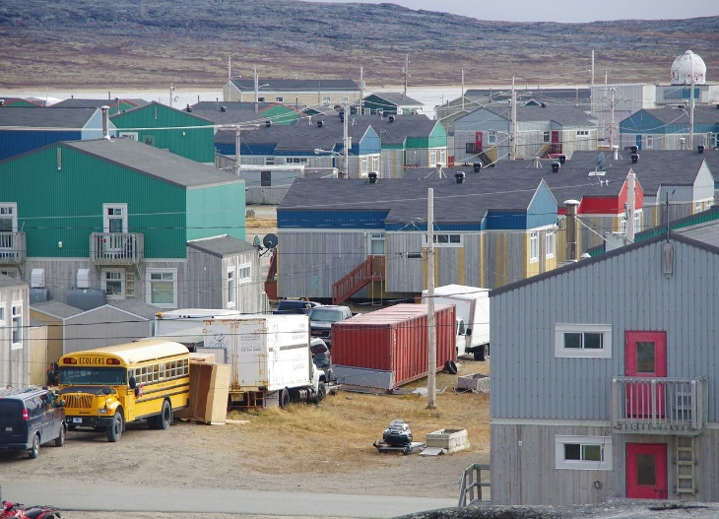  Inukjuak, Que. Oct 12, 2014 by Ian Schofield

Transportation

  Boeing 737-200, Airplane | 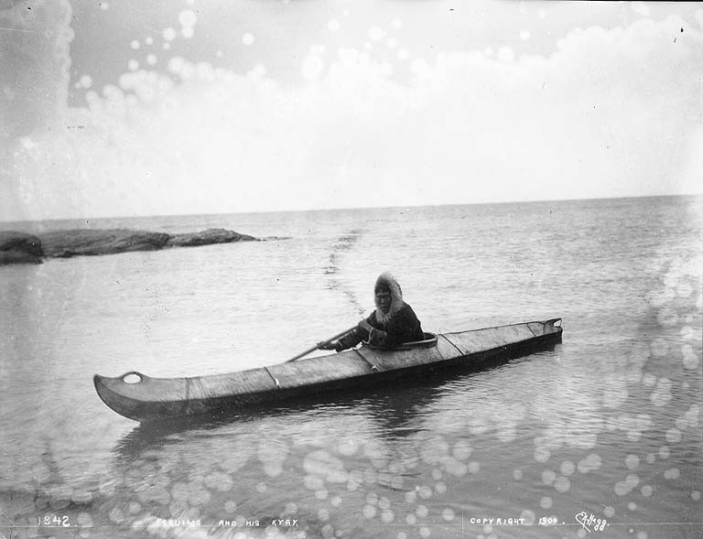  Kayak, probably Alaska, US, 1900
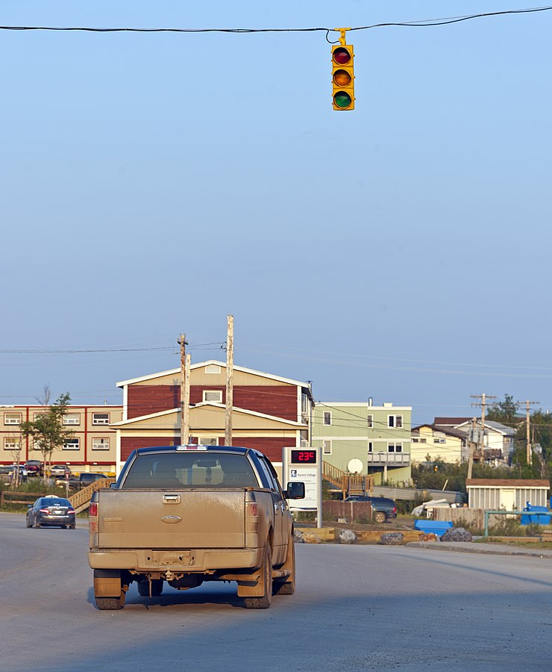  Inuvik, NT, 30 June 2015 by Daniel Case | 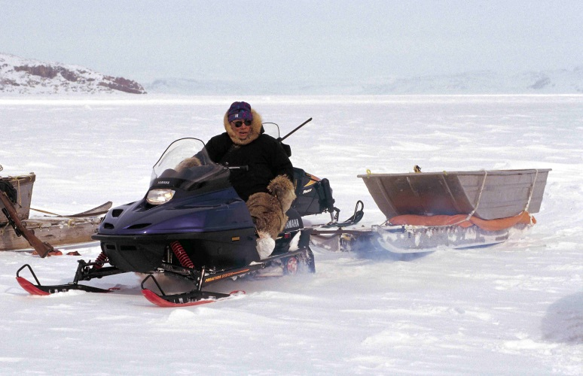  Seal hunter at the floe edge near Cape Dorset (Nunavut Territory, Canada) April 03, 1999 by Ansgar Walk
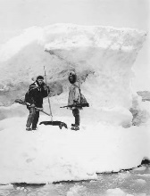  Two hunters (one Eskimo) with rifles and harpooned seal on ice floe, Seward Peninsula, circa 1908-1915 | 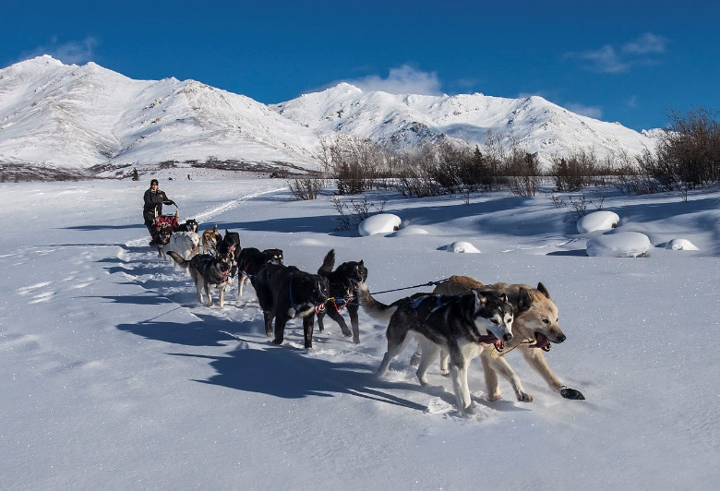  Denali National Park, Corrie Mile 9 Landscape, Alaska  Feb 24, 2013 by Jacob W. Frank
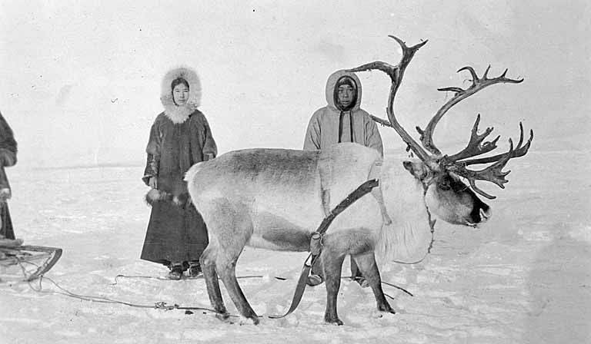
Reindeer, Alaska, 1899 by Arthur Churchill Warner

Food

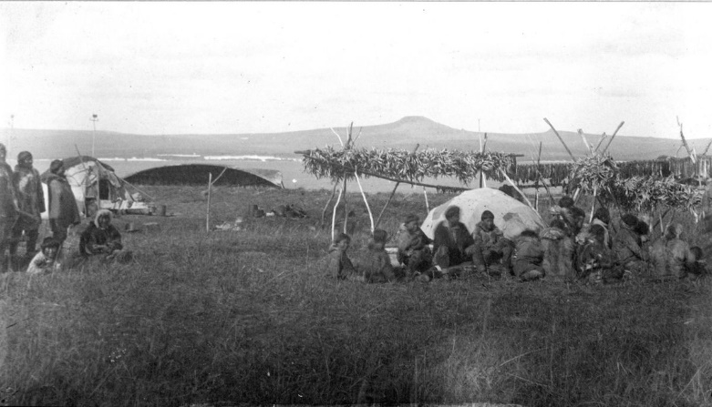  Inuit drying fish at Grantley Harbor. Seward Peninsula region, Alaska. cc 1885. | 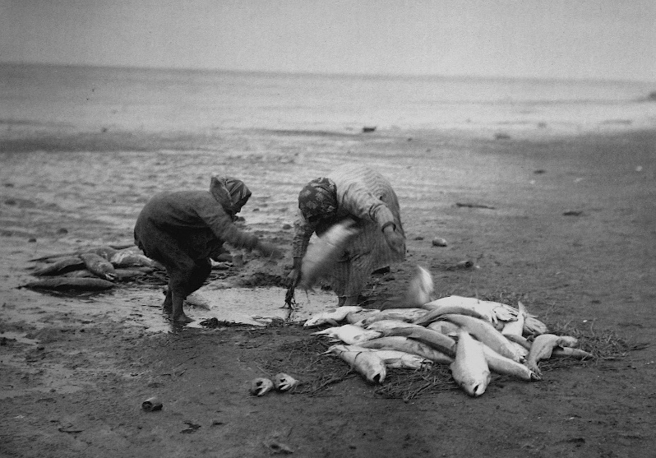  Moser, Jefferson F. (1902) Salmon Investigations of the Steamer Albatross in the Summer of 1900, Bulletin of the United States Fish Commission, vol.21, 1901, Washington, DC: Government Printing Office, p. 186
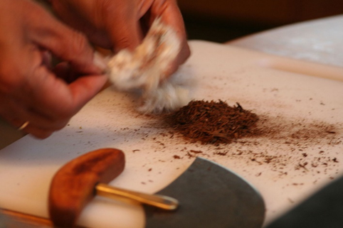  Ulu knife, Aug 1, 2009 by Lindsay Nicole Terry | 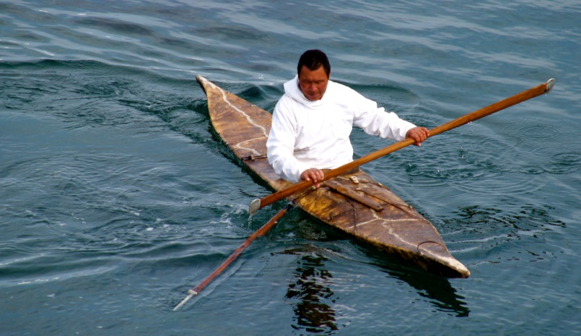  Inuit seal hunter in a kayak with a harpoon, Kulusuk, Greenland, July 25, 2006

Photographs of the Arctic
Questions | Selected Photograph 1 Past | Selected Photograph 2 Present
Where could the
photo have been
taken? How can you
tell?
In what season was
the photo taken?
How can you tell?
What is happening in the photograph? What key features of Inuit life are recorded?
How are the historical
photos different from
the modern photos?
What do the photos
tell you about how
life has changed for
the Inuit people in the
Arctic region?
Questions | Selected Photograph 3 Past | Selected Photograph 4 Present
Where could the
photo have been
taken? How can you
tell?
In what season was
the photo taken?
How can you tell?
What is happening in the photograph? What key features of Inuit life are recorded?
How are the historical
photos different from
the modern photos?
What do the photos
tell you about how
life has changed for
the Inuit people in the
Arctic region?


Save Your Files
Save your Historical Photograph Comparison as jsmithss5_7-2-photos to your Unit 7 Notebook folder. Submit Assessment 7-2 to the appropriate online folder.

