ASSIGNMENT BOOKLET B1
SCIENCE 20: UNIT B
CHAPTER 1 ASSIGNMENT

This Assignment Booklet is worth 68 marks out of the total 104 marks for the assignments in Unit B. The value of each assignment and each question is stated in the left margin.

Read all parts of your assignment carefully, and record your answers in the appropriate places. If you have difficulty with an assignment, go back to the textbook and review the appropriate lesson. Be sure to proofread your answers carefully before submitting your Assignment Booklet.

(68 marks) | Chapter 1 Assignment: Describing Motion  For questions 1 to 4, read each question carefully. Decide which of the choices BEST answers the question. Place your answer in the blank space given.

(1 mark) | 1. | Which of the following is a scalar quantity?  A. 45 km, north  B. 248 mL  C. 250 km[W]  D. 500 m[up]

Answer:

(1 mark) | 2. | Which of the following is not a scalar quantity?  A. 0.20 m  B. 5.0 m/s  C. 10.0 m/s[E]  D. 110 km/h

Answer:

(1 mark) | 3. | The sound from a bolt of lightning travelled 4.08 km in 12.0 s. What was the speed of the sound in metres per second?  A. 0.340 m/s  B. 49.0 m/s  C. 340 m/s  D. 343 m/s

Answer:

(1 mark) | 4. | A vehicle is travelling 1.0 × 10² km/h. What is the speed of the vehicle in metres  per second?  A. 28 m/s  B. 27.8 m/s  C. 3.6 × 10² m/s  D. 1.0 × 10⁴ m/s

Answer:

(2 marks) | 5. | What is the difference between average speed and instantaneous speed?

Answer:

Return to page 2 of the Distance Learning Student Guide, and begin Lesson 1.2.

For questions 6 to 8, read each question carefully. Decide which of the choices BEST completes the statement or answers the question. Place your answer in the blank space given.

(1 mark) | 6. | A driver took 1.5 s to scan the instrument panel. During this time, the car was travelling at a speed of 105 km/h. The distance the car travelled while the driver scanned the panel was  A. 44 m  B. 49 m  C. 70 m  D. 73 m

Answer:

(1 mark) | 7. | A car is travelling 90 km/h at night. The motorist spots a deer on the road 55 m in front of the car. If the speed and direction of the car remains the same, how long will it take for the car to reach the deer’s position?  A. 0.62 s  B. 0.80 s  C. 1.6 s  D. 2.2 s

Answer:

(1 mark) | 8. | Some vehicles are equipped with high-intensity discharge (HID) headlights. Some stakeholders have taken the following stance:  HID headlights should be banned from use on public roads.  Which stakeholder would most likely disagree with this point of view?  A. manufacturers of HID technology  B. manufacturers of halogen technology  C. drivers who mainly travel during daylight hours  D. drivers of vehicles facing HID headlights in oncoming traffic

Answer:

 | 9. | The use of HID headlights in automobiles involves risks and benefits.

(2 marks) |  | a. Describe two risks associated with the use of HID headlights.

Answer:

(2 marks) |  | b. Describe two benefits associated with the use of HID headlights.

Answer:

Return to page 3 of the Distance Learning Student Guide, and begin Lesson 1.3.

For questions 10 and 11, read each question carefully. Decide which of the choices BEST answers the question. Place your answer in the blank space given.

Use the following information to answer questions 10 and 11.

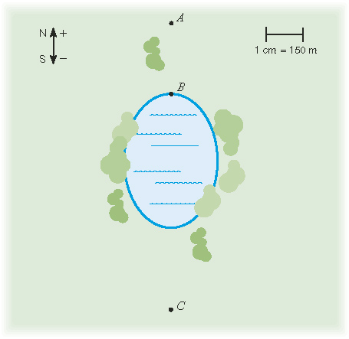

(1 mark) | 10. | What is the position of C in terms of A?  A. 900 m[N]  B. 900 m[S]  C. 1200 m[N]  D. 1200 m[S]

Answer:

(1 mark) | 11. | What is the displacement in going from A to C to B?  A. 300 m[N]  B. 300 m[S]  C. 2100 m[N]  D. 2100 m[S]

Answer:

(2 marks) | 12. | Match each description with the appropriate term listed. Place your answer in the blank space given.
 |  | i. | average speed |  |  | ii. | average velocity
 |  | iii. | displacement |  |  | iv. | vector
 |  |  |  | a. | a vector quantity describing the change in position over a specified time
 |  |  |  | b. | a vector quantity describing the length and direction in a straight line from the starting position to the final position
 |  |  |  | c. | a quantity consisting of magnitude and direction
 |  |  |  | d. | the distance travelled over a specified time

For questions 13 to 17, read each question carefully. Decide which of the choices BEST completes the statement or answers the question. Place your answer in the blank space given.

(1 mark) | 13. | Within the Gaetz Lake Sanctuary in Red Deer, Alberta, is a looped trail that is  4 km long. Suppose a person walked all the way around the looped trail in 1 h, ending where he or she started. Which statement best describes this person’s motion over this time interval?  A. The person moved with an average speed of 0 and an average velocity of  +4 km/h.  B. The person moved with an average speed of −4 km/h and an average velocity  of −4 km/h.  C. The person moved with an average speed of 4 km/h and an average velocity of 0.  D. The person moved with an average speed of 4 km/h and an average velocity of  +4 km/h.

Answer:

For questions 14 and 15, refer to Figure B1.15 on page 179 of the textbook.

(1 mark) | 14. | The displacement from John Creek crossing to Kaleigh Creek crossing is  A. 4.7 km[N]  B. 4.7 km[S]  C. 5.0 km[N]  D. 5.0 km[S]

Answer:

(1 mark) | 15. | Beni travelled from base camp to Scalzo Creek crossing. Then Beni reversed his direction and travelled to John Creek crossing. If Beni took 5.0 h to complete this journey, his average velocity was  A. 1.0 km/h[N]  B. 1.0 km/h[S]  C. 3.0 km/h[N]  D. 15 km

Answer:

(1 mark) | 16. | A car travels for 30 min. The resulting displacement of the vehicle is  A. +48 km  B. −48 km  C. +192 km  D. −192 km

Answer:

(1 mark) | 17. | In adding two vectors, a student used the head-to-tail method. The student  first drew and then drew starting from the head of . . The resultant vector  should be drawn from  A. the head of to the tail of  B. the tail of to the head of  C. the head of to the tail of  D. the tail of to the head of

Answer:

(2 marks) | 18. | For many journeys, the magnitude of the average velocity is less than the average speed. Describe a situation where this relationship is true.

Answer:

Return to page 4 of the Distance Learning Student Guide, and begin Lesson 1.4.

For questions 19 to 24, read each question carefully. Decide which of the choices BEST completes the statement or answers the question. Place your answer in the blank space given.

(1 mark) | 19. | Which position–time graph most closely represents an object moving with uniform motion?  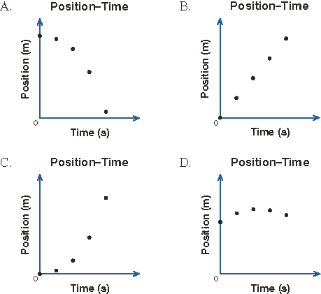

Answer:

(1 mark) | 20. | Examine the position–time graph given. If north is positive and south is negative, what is the average velocity of the object for the first 10 s?  A. 3.2 m/s[N]  B. 3.2 m/s[S]  C. 32 m/s[N]  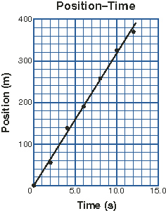  D. 32 m/s[S]

Answer:

Use the following graph to answer questions 21 and 22.

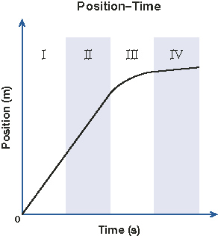

(1 mark) | 21. | During which interval(s) did the robot arm move with uniform motion?  A. I only  B. I and II  C. I, II, and III  D. I, II, and IV

Answer:

(1 mark) | 22. | During which interval did the robot arm move the slowest?  A. I  B. II  C. III  D. IV

Answer:

(1 mark) | 23. | A group of students collected the following data from a toy bulldozer moving at a constant speed in a straight line.  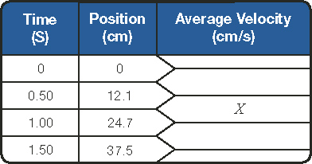  The value of X in the table is  A. +6.0 cm/s  B. +12 cm/s  C. +25 cm/s  D. +29 cm/s

Answer:

(1 mark) | 24. | Examine the velocity–time graph of an object travelling with uniform motion. The displacement  of the object over the 25-s time interval is  A. +300 m  B. +475 m  C. +517 m  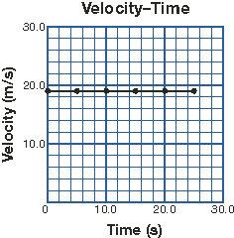  D. +600 m

Answer:

 | 25. | The following graph shows the motion of a locomotive.  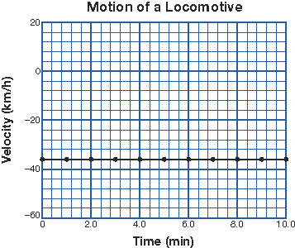

(3 marks) |  | a. Describe the motion of the locomotive in terms of how fast, its direction, and the type of motion.

Answer:

(2 marks) |  | b. Calculate the displacement of the locomotive in the first 6.0 min of the motion represented by the graph.

Answer:

Return to page 5 of the Distance Learning Student Guide, and begin Lesson 1.5.

For questions 26 to 30, read each question carefully. Decide which of the choices BEST completes the statement or answers the question. Place your answer in the blank space given.

Use the following graph to answer questions 26 and 27.

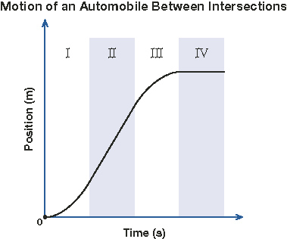

(1 mark) | 26. | During which interval(s) is the automobile accelerating?  A. I  B. I and III  C. II and IV  D. IV

Answer:

(1 mark) | 27. | During which interval(s) does the automobile remain stationary?  A. I  B. II  C. II and III  D. IV

Answer:

(1 mark) | 28. | 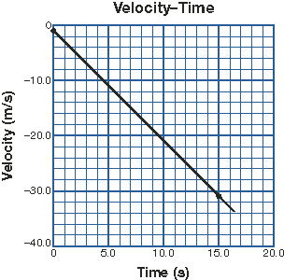  Based on the velocity–time graph given, the acceleration of the object is  A. +3.0 m/s²  B. +2.0 m/s²  C. −2.0 m/s²  D. −2.1 m/s²

Answer:

(1 mark) | 29. | A group of students collected data from a dynamics cart moving down a ramp.  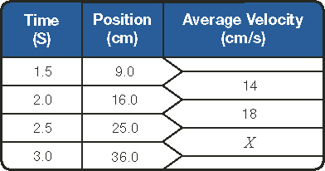  The value of X in the table is  A. +25 cm/s  B. +22 cm/s  C. +18 cm/s  D. +14 cm/s

Answer:

(1 mark) | 30. | Starting from rest, an object rolls down a long ramp with a constant acceleration of 1.72 m/s². After rolling for 4.75 s, what is the magnitude of the ball’s final velocity?  A. 9.81 m/s  B. 8.17 m/s  C. 6.30 m/s  D. 4.09 m/s

Answer:

Return to page 7 of the Distance Learning Student Guide, and begin Lesson 1.6.

For questions 31 to 34, read each question carefully. Decide which of the choices BEST answers the question. Place your answer in the blank space given.

(1 mark) | 31. | 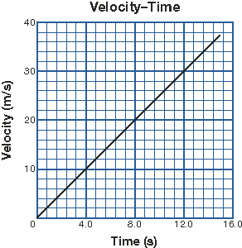  The graph given shows the velocity of an automobile as it accelerates uniformly to its cruising speed. What is the displacement of the car in the first 12 s of acceleration?  A. +90 m  B. +100 m  C. +180 m  D. +360 m

Answer:

(1 mark) | 32. | The graph given shows the acceleration over a 10-s interval of a car merging into highway traffic from an acceleration lane. How far did the car travel during this time interval?  A. 100 m  B. 170 m  C. 240 m  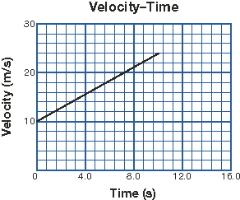  D. 340 m

Answer:

(1 mark) | 33. | A traffic-safety engineer is designing a deceleration lane. She is basing the length of this lane on the distance needed to slow down from 126 km/h to 65 km/h in 8.0 s. How long should the deceleration lane be?  A. 2.1 × 10² m  B. 3.8 × 10² m  C. 4.2 × 10² m  D. 7.6 × 10² m

Answer:

(1 mark) | 34. | A baseball flew 19.6 m straight up into the air after being hit by a bat. How long will it take for the ball to return from its maximum height?  A. 1.02 s  B. 1.91 s  C. 2.00 s  D. 3.99 s

Answer:

(2 marks) | 35. | A skydiver steps out of a helicopter hovering thousands of metres above ground. After 3.5 s of free fall the skydiver pulls the rip cord. What is the skydiver’s displacement during the 3.5 s of free fall?

Answer:

Return to page 8 of the Distance Learning Student Guide, and begin Lesson 1.7.

For questions 36 to 39, read each question carefully. Decide which of the choices BEST completes the statement or answers the question. Place your answer in the blank space given.

(1 mark) | 36. | The area of no return at one intersection was calculated to be 59.0 m. What is the minimum length of time the traffic light should be yellow so a vehicle just entering the area of no return can clear the area while maintaining a speed of 70.0 km/h?  A. 3.03 s  B. 6.07 s  C. 9.10 s  D. 11.9 s

Answer:

(1 mark) | 37. | To avoid a potential collision with wildlife crossing the road, the driver of a car travelling 105 km/h fully applies the brakes to stop as quickly as possible. If the car stops 3.8 s after the brakes are applied, what is the braking distance?  A. 1.1 × 10² m  B. 95 m  C. 78 m  D. 55 m

Answer:

(1 mark) | 38. | A vehicle comes to a stop 10.0 s after the brakes are applied. While the brakes were applied, the vehicle travelled a distance of 75.0 m. If the vehicle’s acceleration remained constant during the braking, what was the vehicle’s initial speed?  A. 15.0 km/h  B. 54.0 km/h  C. 108 km/h  D. 111 km/h

Answer:

(1 mark) | 39. | Based on a reaction time of 1.50 s and a braking rate of −5.85 m/s², the stopping distance of a vehicle initially travelling 90 km/h would be  A. 37.5 m  B. 53.4 m  C. 75.0 m  D. 90.9 m

Answer:

(2 marks) | 40. | A group of students are designing a field study to investigate the length of time a traffic light remains yellow. In the interests of safety, one of the students suggested the following rules:  - Study the traffic lights at intersections where the speed limit is 70 km/h or less.  - Avoid rush hour. Study traffic lights outside of times when people are going to and from work and school.  Indicate how each of these rules may limit the useful data that comes out of the investigation.

Answer:

Return to page 9 of the Distance Learning Student Guide, and begin Lesson 1.8.

(2 marks) | 41. | Match each description with the appropriate term listed. Place your answer in the blank space given.
 |  | i. | force of friction |  |  | ii. | net force
 |  | iii. | unit of force |  |  | iv. | unit of mass
 |  |  |  | a. | a contact force between two surfaces that acts to oppose the motion of one surface past the other
 |  |  |  | b. | the vector sum of all forces acting on an object
 |  |  |  | c. | kilogram
 |  |  |  | d. | newton

For questions 42 and 43, read each question carefully. Decide which of the choices BEST answers the question. Place your answer in the blank space given.

(1 mark) | 42. | Which statement correctly describes the relationship among acceleration, net force, and mass?  A. The magnitude of a vehicle’s acceleration increases if the magnitude of the net force increases or if the mass of the vehicle increases.  B. The magnitude of a vehicle’s acceleration increases if the magnitude of the net force increases or if the mass of the vehicle decreases.  C. The magnitude of a vehicle’s acceleration increases if the magnitude of the net force decreases or if the mass of the vehicle increases.  D. The magnitude of a vehicle’s acceleration increases if the magnitude of the net force decreases or if the mass of the vehicle decreases.

Answer:

(1 mark) | 43. | A high-performance car initially travelling 97.2 km/h came to a stop in just 2.9 s. The mass of the car and its contents was 1850 kg. What was the magnitude of the average net force (braking force) on the car while it decelerated?  A. 1.7 × 10⁴ m  B. 1.8 × 10⁴ m  C. 4.9 × 10⁴ m  D. 5.9 × 10⁴ m

Answer:

(2 marks) | 44. | Explain why the “no zone” in front of a large transport truck is longer when the truck is fully loaded.

Answer:

Return to page 10 of the Distance Learning Student Guide, and begin Lesson 1.9.

For questions 45 to 47, read each question carefully. Decide which of the choices BEST completes the statement or answers the question. Place your answer in the blank space given.

(1 mark) | 45. | The applied force on a vehicle as it increased in speed was +4500 N. The force of friction was −1000 N. The net force on the vehicle was  A. +5500 N  B. +3500 N  C. −3500 N  D. −5500 N

Answer:

(1 mark) | 46. | A vehicle is travelling with uniform velocity along a straight, level stretch of highway. The combined force due to the rolling friction and air resistance is  −5000 N. What is the applied force on the vehicle as it moves?  A. +10 000 N  B. +5000 N  C. −5000 N  D. 0

Answer:

(1 mark) | 47. | A motorcycle and its rider have a combined mass of 230 kg. The engine generates an applied force of 1000 N[E]. If the force of friction opposing the motorcycle is  320 N[W], what is the acceleration of the motorcycle and its rider?  A. 2.96 m/s²[E]  B. 2.96 m/s²[W]  C. 5.74 m/s²[E]  D. 5.74 m/s²[W]

Answer:

(4 marks) | 48. | A headrest can prevent whiplash injuries during a rear-end collision. Use Newton’s laws of motion to explain the role of headrests in preventing such injuries.

Answer:

(3 marks) | 49. | Some drivers do not wear their seat belts and do not have air bags in their vehicles. Explain why head injuries are common for such drivers when they are involved in a front-end collision.

Answer:

Submit your completed Assignment Booklet B1 to your teacher for assessment. Then return to page 12 of the Distance Learning Student Guide,
and begin the Chapter 1 Summary.

